ADA Barriers

What follows is a summary and sample of the statewide ADA barrier inventory performed by Michael Baker, Inc. (MBI) on behalf of KYTC. In 2019 and 2020, MBI surveyed the known sidewalk locations with mobile LIDAR to collect ADA related sidewalk ramp, and crosswalk data. From this data, barriers were identified using the following criteria.

ADA Barrier | Condition | Instances in Sample
Detectable Warnings | Absent | 135
Crosswalk Width | Less than 48 inches | 0
Curb Ramp Running Slop | Not between 5% and 8.3% | 193
Curb Ramp Cross Slope | Greater than 2% | 88
Curb Ramp Flares | Greater than 10% | 4
Curb Ramp Landing Slope | Greater than 2% | 28
Pedestrian Push Button Height | Not between 42 and 48 inches | 41
Sidewalk Width | Clear Width less than 48 inches | 3191
Sidewalk Discontinuity | Discontinuous Slope | 3
Sidewalk Stairs | Stairs Present | 6

For each barrier type above there is a sample of the assembled data and an accompanying map to clarify the location data. The balance of the Mount Washington and statewide barrier data will be provided in an appendix as they become available.

Crosswalk Width Tabular Data:
There were no locations where the crosswalk width is less than 48 inches.

Detectable Warning Surface (DWS) Tabular Data:
At the following locations, a detectable warning surface is not present.

Detectable Warning ID | Route | MP | Detectable Warning Surface
30 | 015-KY-2673 | 0.4 | Not Present
229 | 015-KY-2673 | 0.4 | Not Present
236 | 015-KY-2673 | 0.4 | Not Present
262 | 015-KY-2673 | 0.4 | Not Present

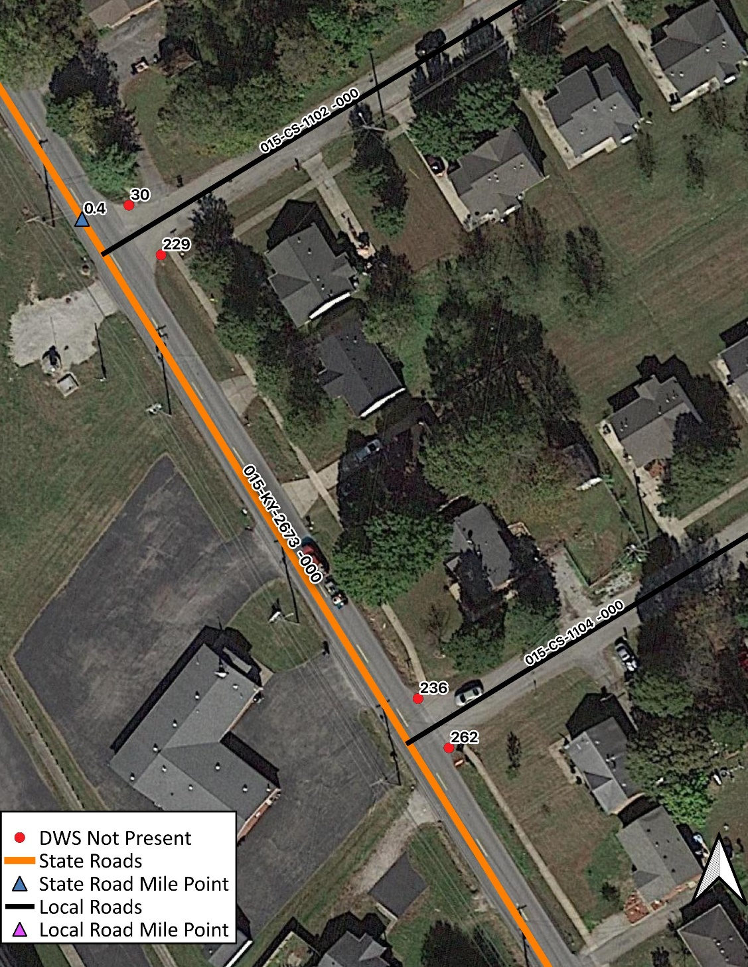

Curb Ramp Running Slope Tabular Data:
At the following locations, the curb ramp running slope is either below 5% or above 8.3%.

Running Slope ID | Route | MP | Running Slope
142 | 015-KY-0061 | 14.3 | 4.1%
144 | 015-KY-0061 | 14.3 | 1.5%
241 | 015-KY-0061 | 14.3 | 12.3%
242 | 015-KY-0061 | 14.3 | 1.5%

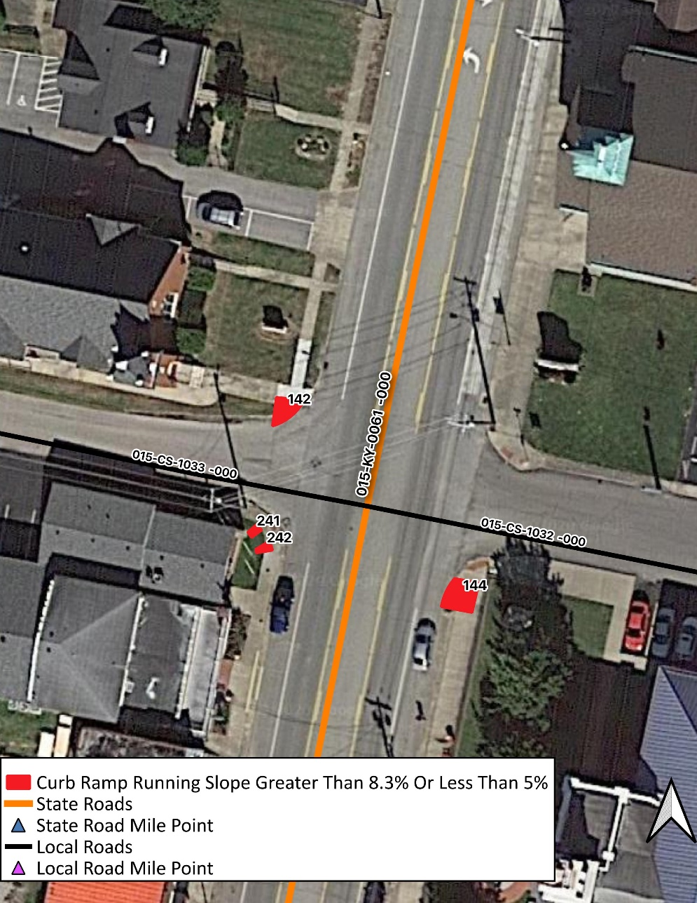

Curb Ramp Cross Slope Tabular Data:
At the following locations, the Curb Ramp Cross Slope exceeds 2%

CR Cross Slope ID | Route | MP | Running Slope
169 | 015-KY-0480C | 0.3 | 2.2%
221 | 015-KY-0480C | 0.3 | 5.6%

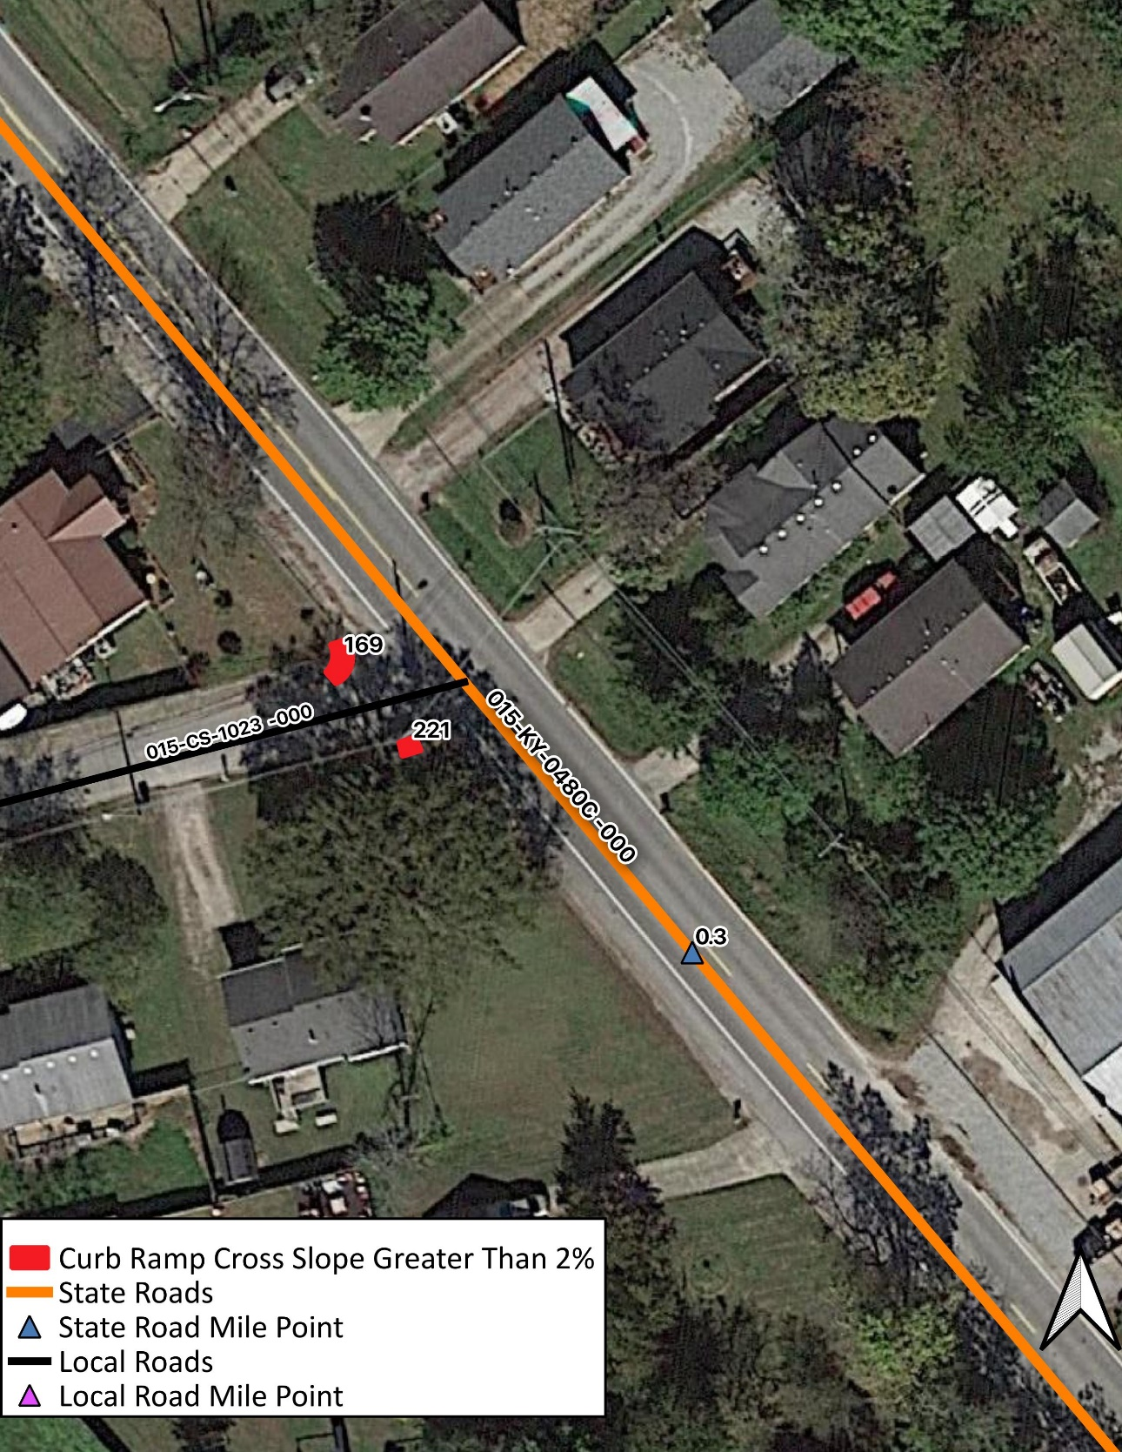

Curb Ramp Flares Tabular Data:
At the following locations, the Curb Ramp Flare exceeds 10%.

Ramp Flare ID | Route | MP | Running Slope
27 | 015-US-0031EX | 0.68 | 12.1%
49 | 015-US-0031EX | 0.68 | 10.2%

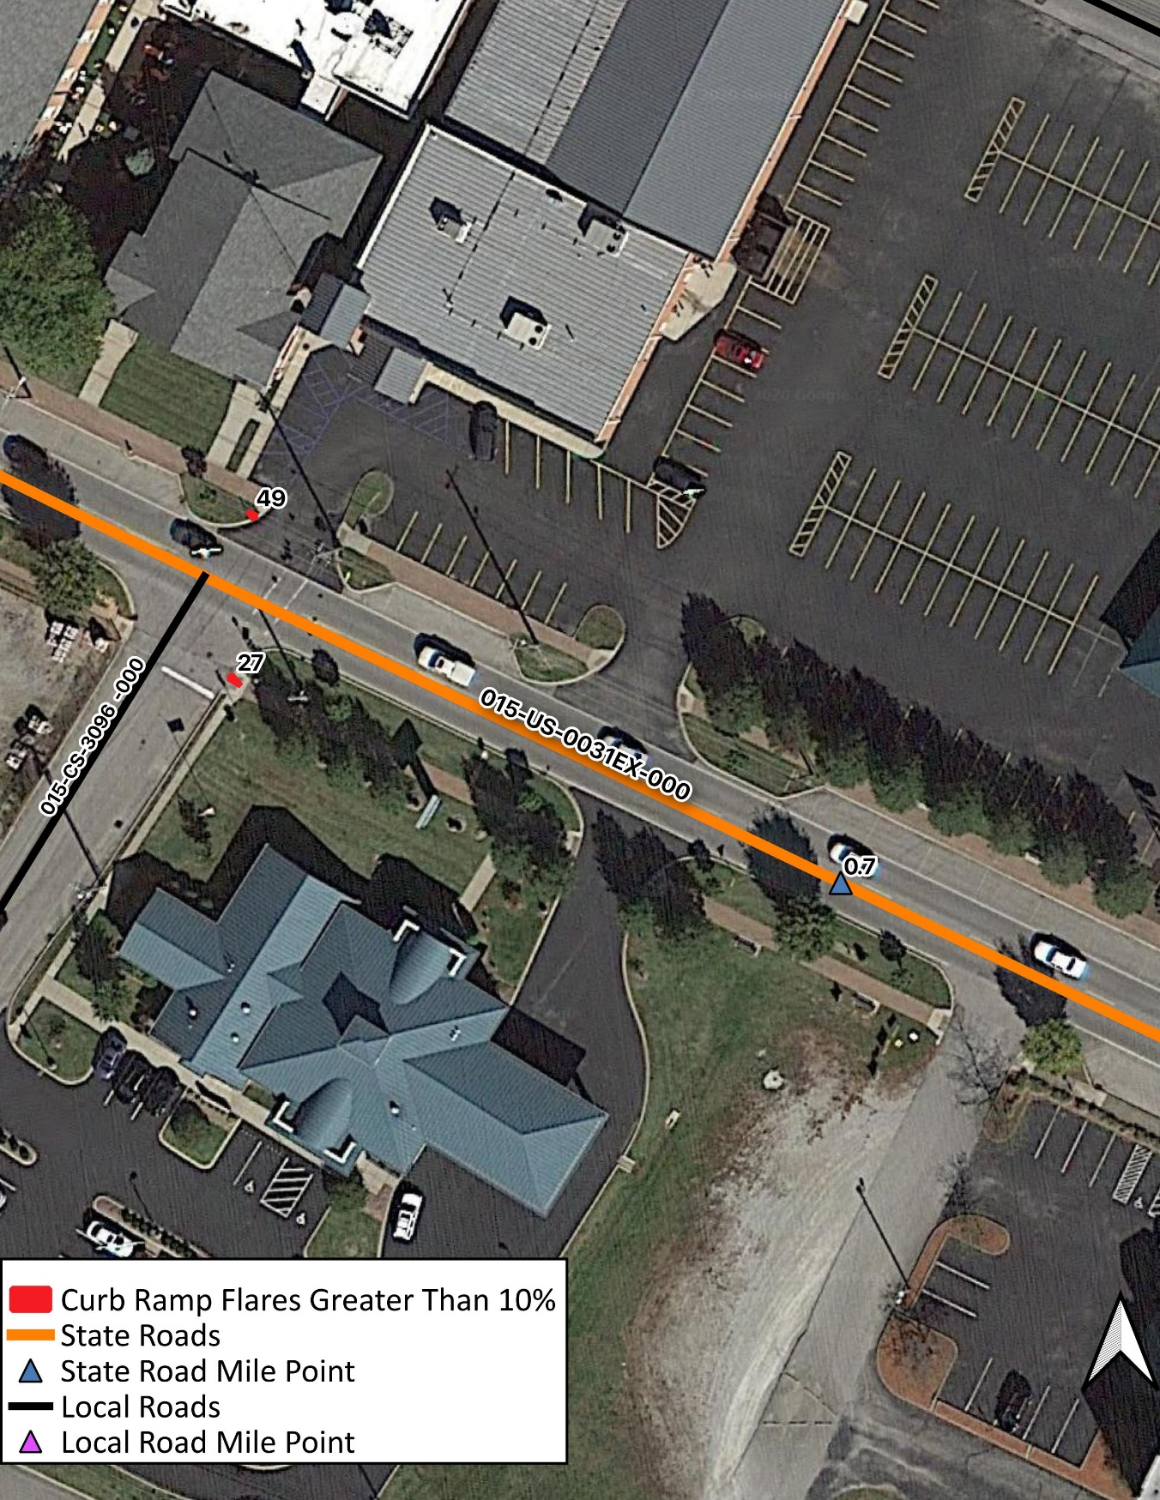

Curb Ramp Landing Slope:
At the following locations, the Curb Ramp Landing Slope exceeds 2%.

Landing Slope ID | Route | MP | Landing Slope
96 | 015-KY-434 | 1.8 | 4.5%
103 | 015-KY-434 | 1.8 | 8.4%

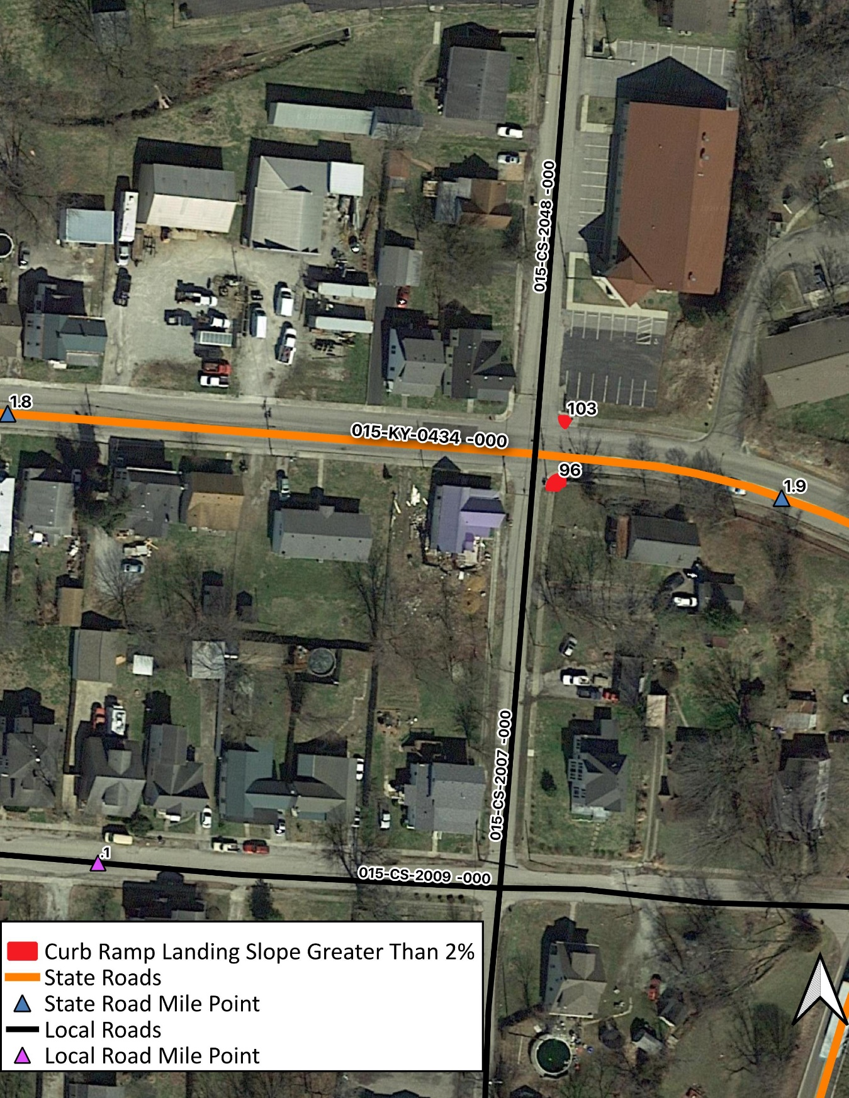

Pedestrian Push Button Height:
At the following locations, the pedestrian push button is not between 42 and 48 inches.

Ped. Button ID | Route | MP | Button Height
1 | 015-US-31EX | 1.6 | 36.2
2 | 015-US-31EX | 1.6 | 32.7

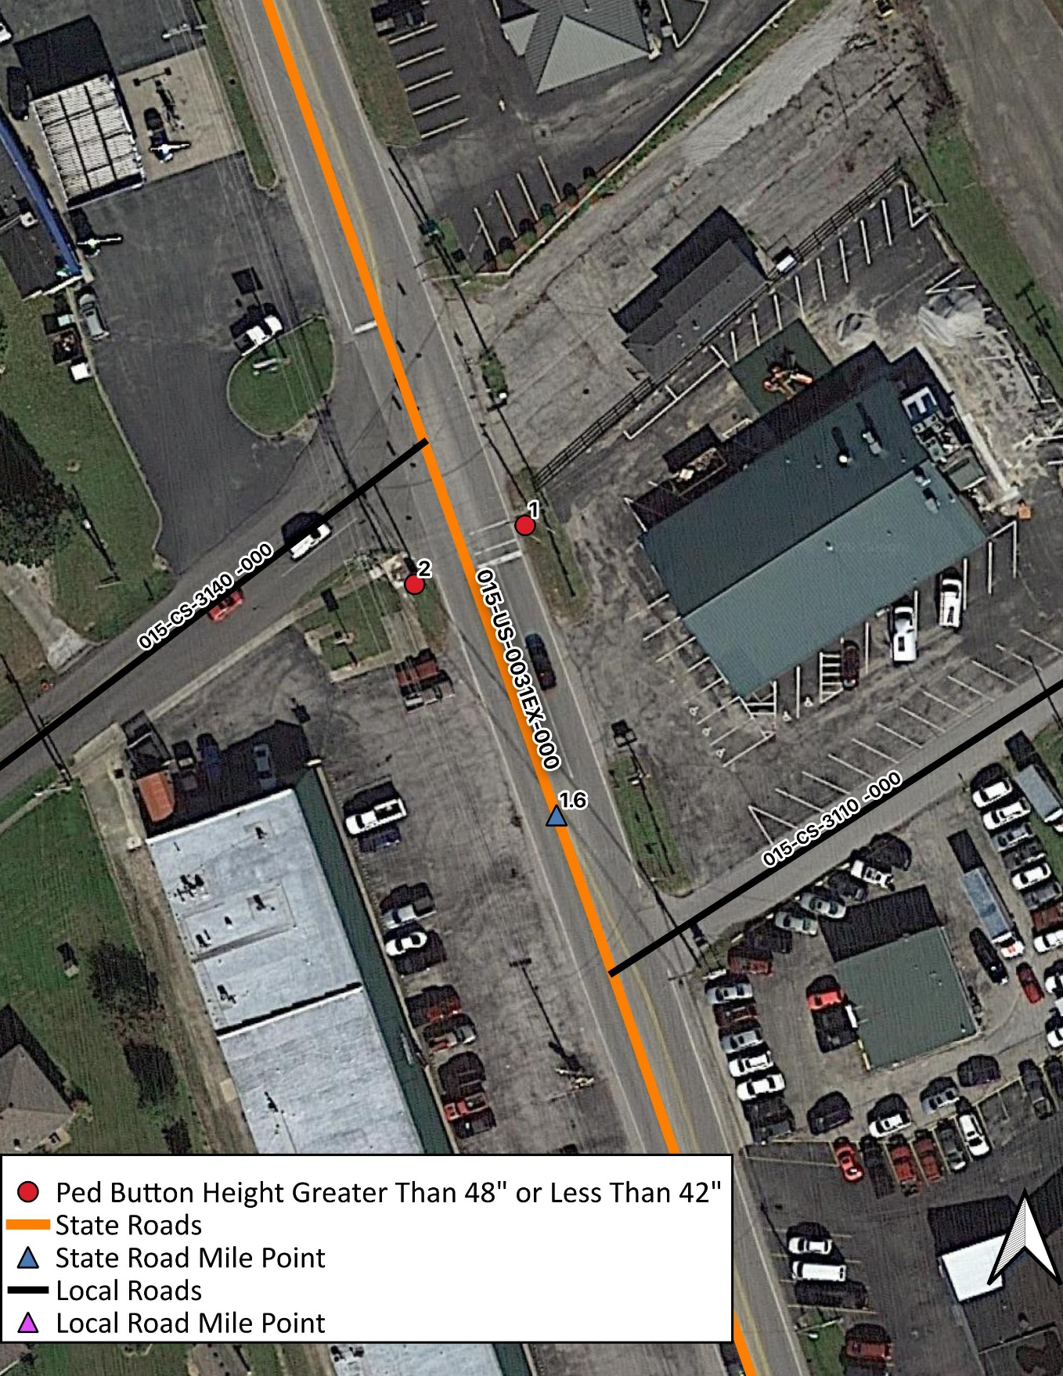

Sidewalk Width:
At the following locations, the Sidewalk Width is less than 48 inches.

SW Width ID | Route | MP | Width (in)
4 | 015-KY-0044 | 23.4 | 33.4
3 | 015-KY-0044 | 23.4 | 34.6
5 | 015-KY-0044 | 23.4 | 32.0
1 | 015-KY-0044 | 23.4 | 35.2
2 | 015-KY-0044 | 23.4 | 34.7
7 | 015-KY-0044 | 23.4 | 31.6
6 | 015-KY-0044 | 23.4 | 32.0
8 | 015-KY-0044 | 23.4 | 31.6

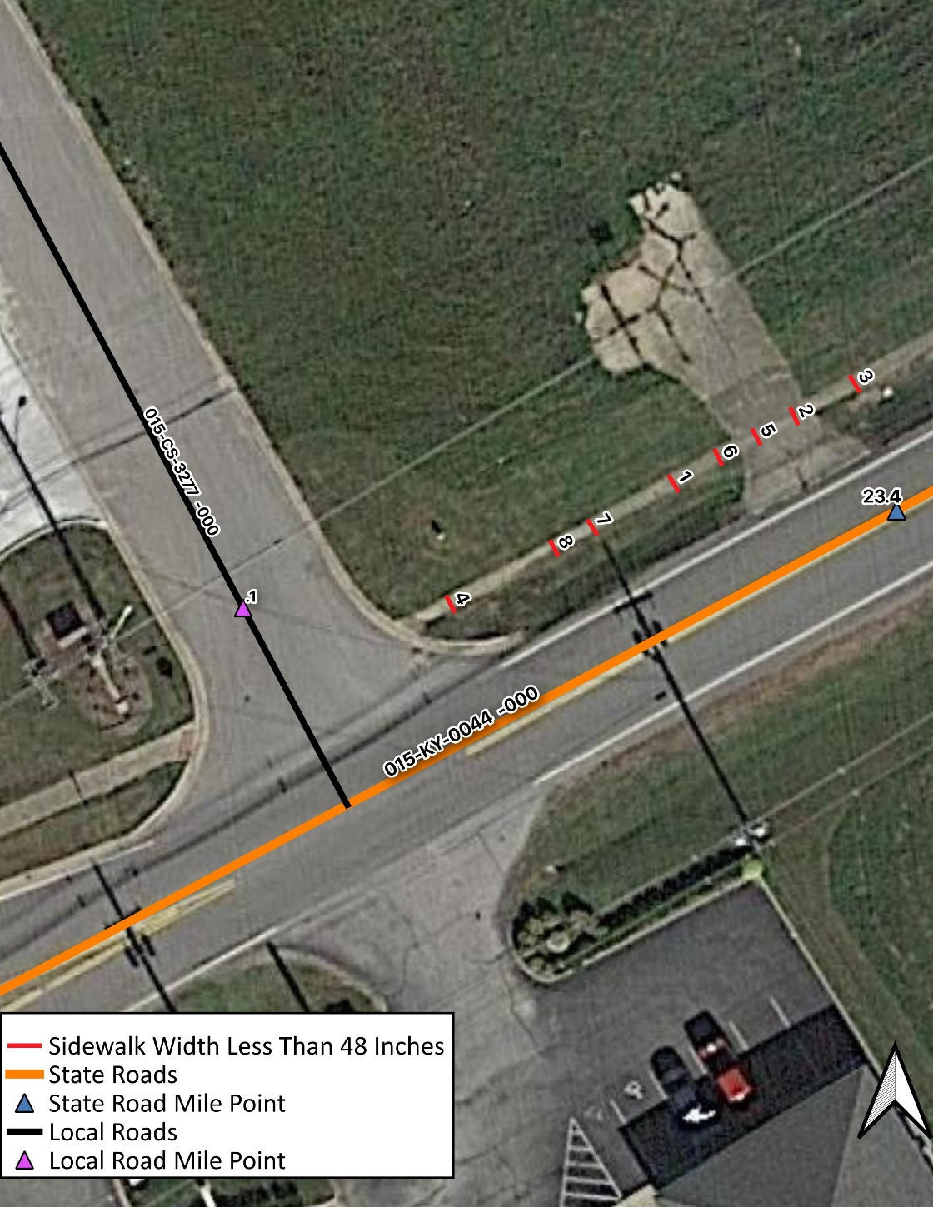

Sidewalk Discontinuity:
The following location has a sidewalk discontinuity.

SW Obstruct ID | Route | MP | Obstruction
38 | 015-KY-0044 | 12.7 | Cement Lifted

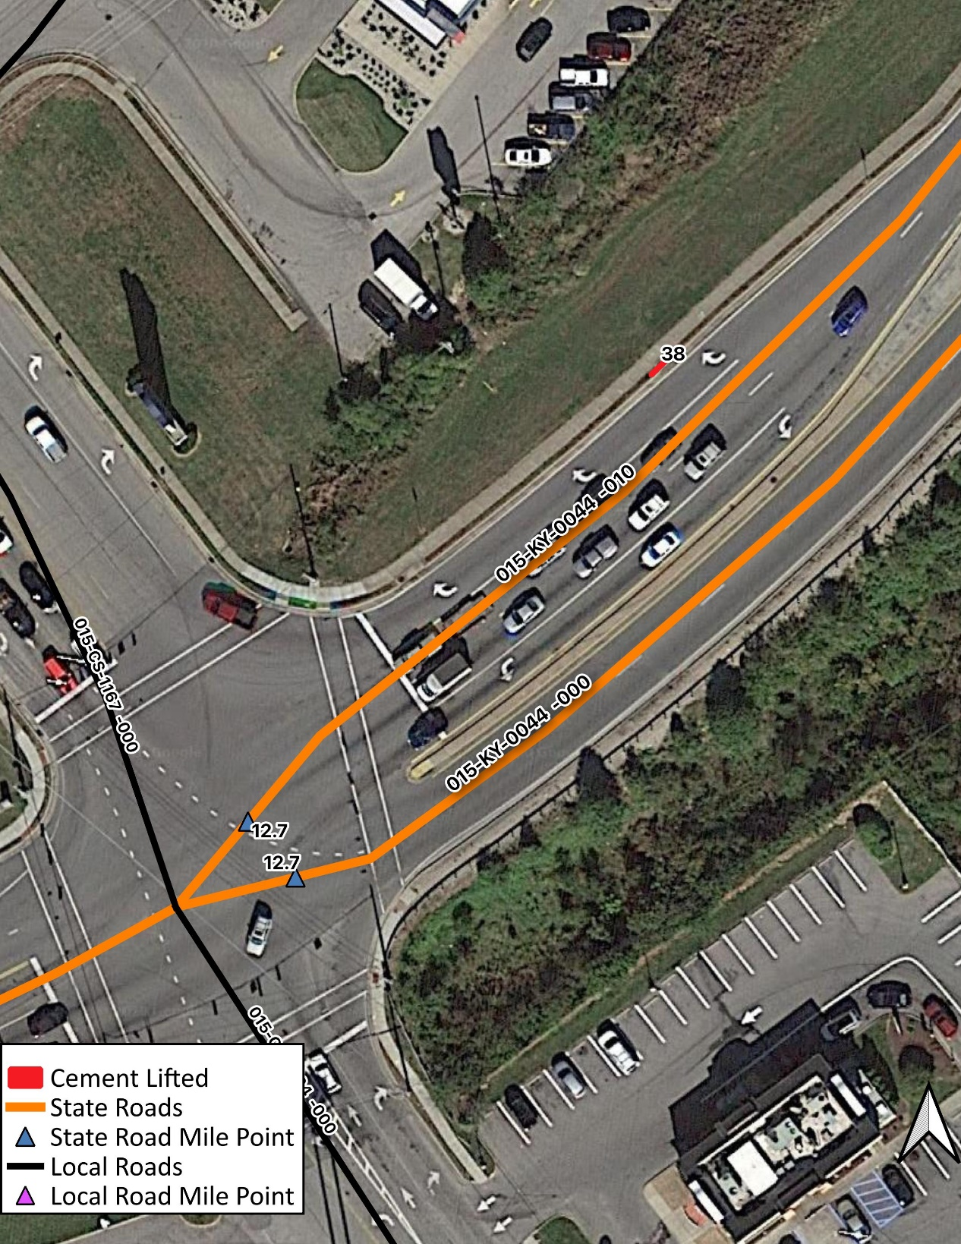

Sidewalk Stairs:
At the following locations, there is a sidewalk obstruction due to stairs along the sidewalk.

SW Stairs ID | Route | MP | Obstruction
2 | 015-KY-0044 | 13.5 | Stairs
3 | 015-KY-0044 | 13.5 | Stairs
4 | 015-KY-0044 | 13.5 | Stairs
1 | 015-KY-0044 | 13.5 | Stairs

