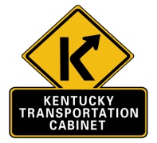 | Kentucky Transportation Cabinet  Federal Highway Administration  No Effect Finding |  |  |  | 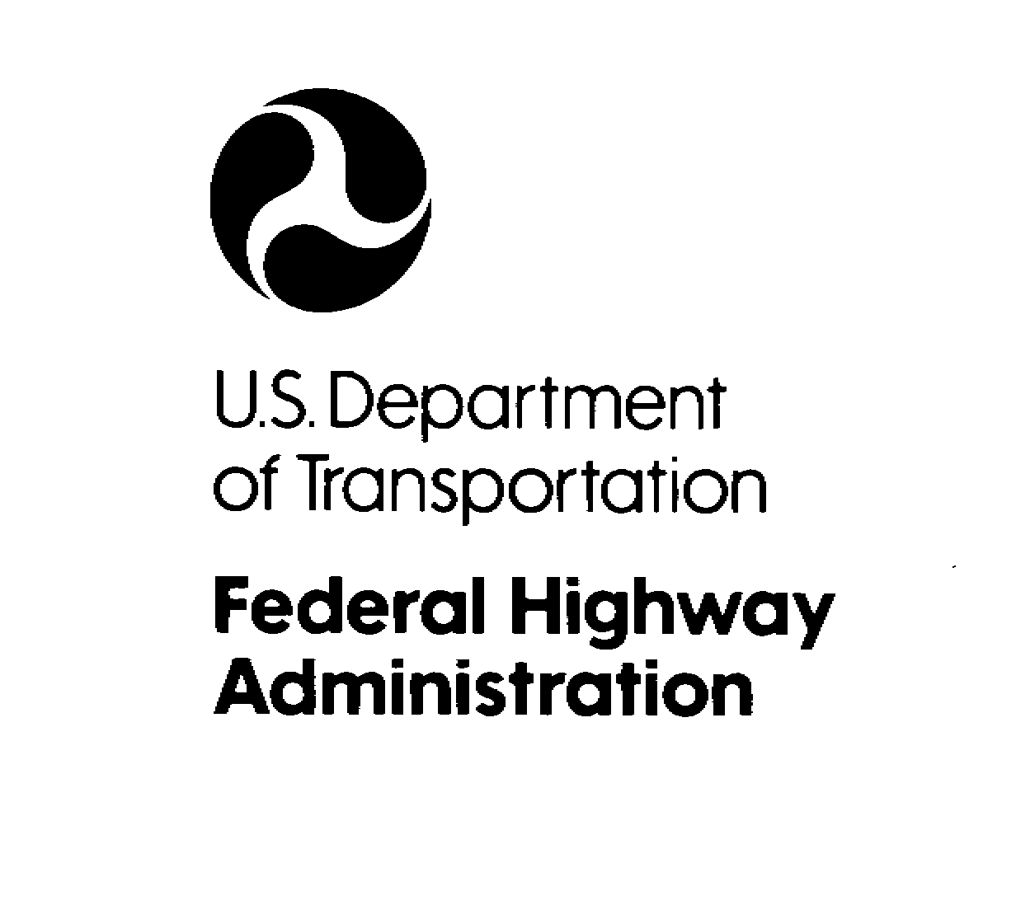
KYTC Item No: |  |  |  | Route(s):
County(ies):
Project Description: (Type of improvement, areas to be impacted, crossroad improvements, easements, etc.)
USFWS IPaC LISTED SPP FOR PROJECT SITE:

IB will be addressed per the 2020 Programmatic BO including a contribution to the IBCF, as appropriate. The NLEB will be addressed via the final 4(d) rule and the 2016 Programmatic BO for the final 4(d) rule, as appropriate.
Methodologies: (Methods of assessment, who, what, when, resources, etc.)
Biologist reviewed literature on listed species and used GIS mapping to investigate the conditions of the project area. (Please indicate if site evaluation was performed.)
Results: (Compare habitat used by listed species with available habitat)
Determinations:
The project has been assessed in accordance with the provisions of Section 7 of the Endangered Species Act. As a designated representative of the FHWA, the KYTC has determined that the project will have No Effect on any listed species or their critical habitat, and further Section 7(a)(2) consultation with the Service is not required.

 | KYTC Signature |  |  |  | Date
 | Print Name
E.A.T.S. Milestones updated
 |  |  |  | Name | Date

ATTACHED: Project Photos & Agency Species List(s) Ver: 3.22

