Seller Error in Title Application Flow
When searching for Dealer Number in the Title Application flow, the incorrect dealer name is sometimes being populated and is causing a “One of more Sellers contain errors” message.
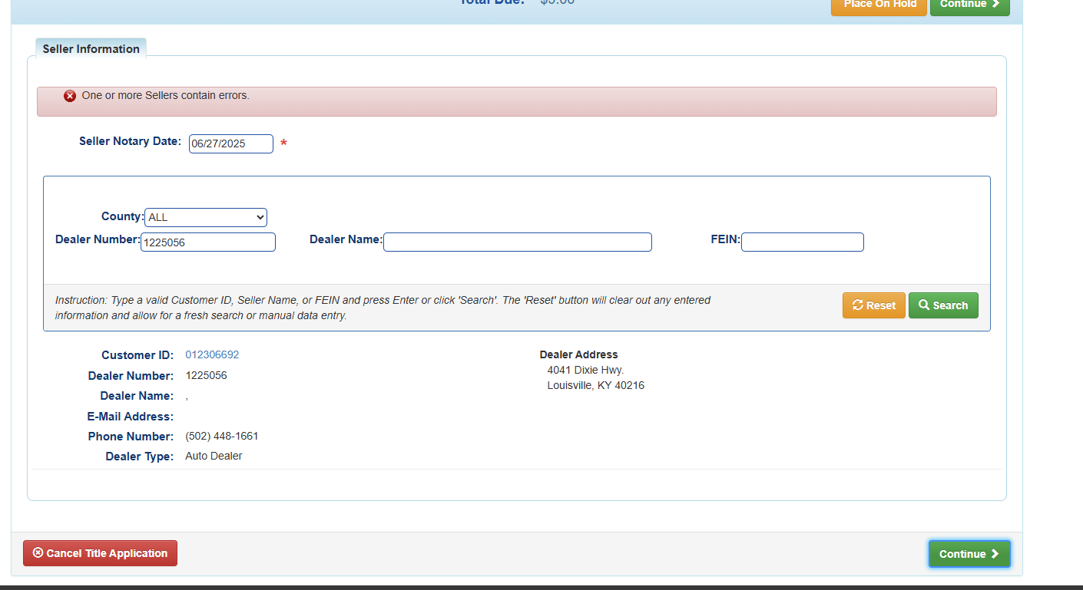
Workaround:
Search by the Dealer Name instead of the Dealer Number and you will may not get this error, although it still occurs for some dealers. We are working on a fix and will update KAVIS as soon as we are able

