QUICK REFERENCE GUIDE FOR EV PHEV FEES IN KAVIS

- KAVIS will collect EV Fees systematically for eligible vehicles during New Title Application or Manage action for below registration actions for registration period of 2026 to 2027 and future:
  - Renewal
  - First Time (does not include Reissue of Plates)
  - Plate Change and Weight Change – only if there is an extension in registration dates via the action.
  - Reissue of an eligible plate from Gasoline to Electric/PHEV Vehicle.
- For a 12 month renewal from 2026 to 2027, KAVIS will systematically add EV State and Clerk Fees.
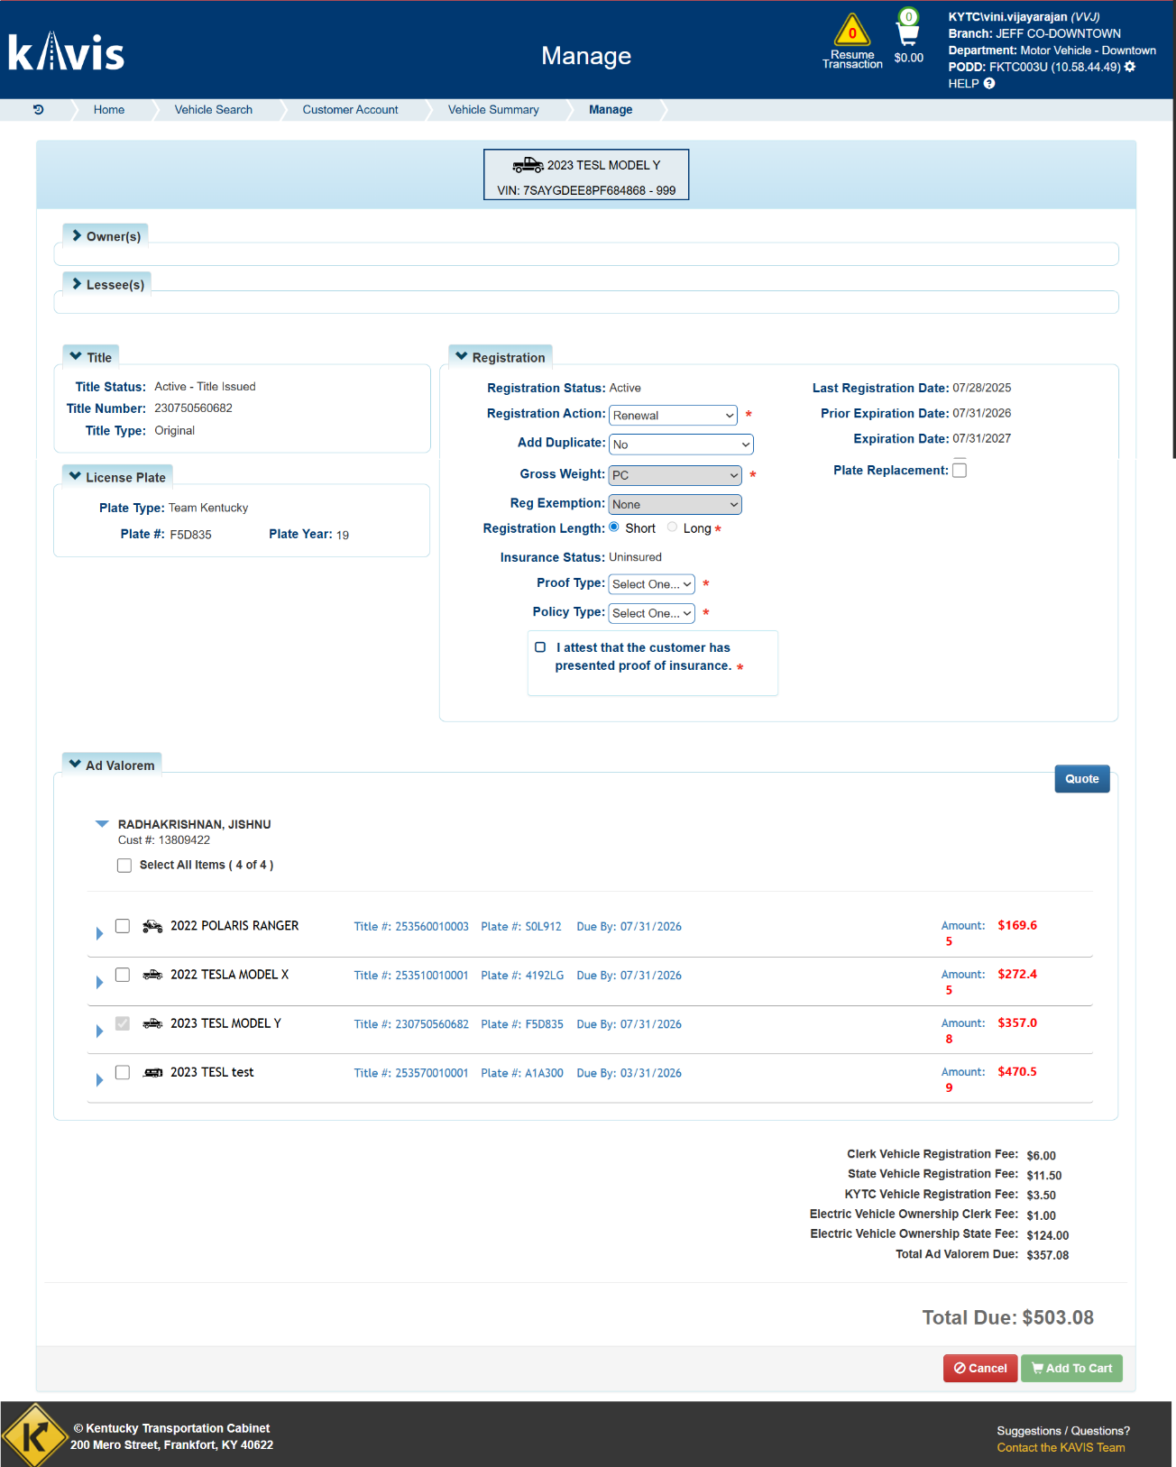
- For the below registration periods, Clerks should manually add miscellaneous keys as defined.
  - Registration Period 2024 to 2025 Clerk should manually add miscellaneous key for 2024 EV Fees.
  - Registration Period 2025 to 2026 Clerk should manually add miscellaneous keys for 2025 EV fees State and Clerk portions.
  - Registration Period 2026 to 2027 KAVIS will systematically collect 2026 Fees.
- If a customer has a vehicle expired in year 2023 and is being renewed to catch upto 2026. Note:
  - Clerk will select ‘Renew’ as ‘Registration Action’ and Registration Length as ‘Short’.
  - Years being renewed in this scenario:
    - 2023 to 2024
      - EV fees are not applicable since KRS is effective from Jan 1st 2024.
    - 2024 to 2025
      - Clerk should add 2024 EV miscellaneous fee in Shopping Cart.
    - 2025 to 2026
      - Clerk should add 2025 EV miscellaneous fees for State and Clerk portions in Shopping Cart.
- If a customer has a vehicle expired in year 2023 and is being renewed to catch upto 2027.
  - Clerk will select ‘Renew’ as ‘Registration Action’ and Registration Length as ‘Long’.
  - If Customer does NOT provide TC 96-191 affidavit, then years being renewed in this scenario:
    - 2023 to 2024
      - EV fees are not applicable since KRS is effective from Jan 1st 2024.
    - 2024 to 2025
      - Clerk should add 2024 EV miscellaneous fee in Shopping Cart.
    - 2025 to 2026
      - Clerk should add 2025 EV miscellaneous fees for State and Clerk portions in Shopping Cart.
    - 2026 to 2027
      - KAVIS will systematically add 2026 EV Fees State and Clerk portion.
- If Customer provides TC 96-191 affidavit, then most recent year registration fee and EV fee should be collected. If most recent year being renewed is 2026 to 2027, then KAVIS will systematically add EV State and Clerk Fees.
- During ‘First Time’ registration action being added after 1st Jan 2026, KAVIS will systematically collect 2026 EV State and Clerk Fees.
- During Plate Change and Weight Change actions, if there are months being added to current Registration Expiration date, then KAVIS will systematically add EV State and Clerk Fees.
- For ‘Reissue’ registration action, currently KAVIS does not charge EV Fees systematically. When Customer is reissuing plate from a non EV/PHEV vehicle to a EV/PHEV Vehicle, then as of 26th Jan 2025, please collect EV PHEV fees using the miscellaneous fee provided for all counties.
- For any registration period having registration expiration date less than or as 2026, KAVIS will not systematically charge EV Fees systematically.

