Bug - Merge Summary from Customer Edit page navigates to Duplicate page incorrectly
When editing the SSN and/or DL on an unverified customer account, users are seeing this message when the SSN or matches a verified customer:
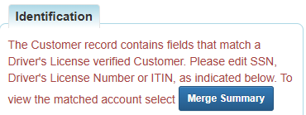
When they click the Merge Summary button, they are incorrectly sent to this screen. This is a bug.
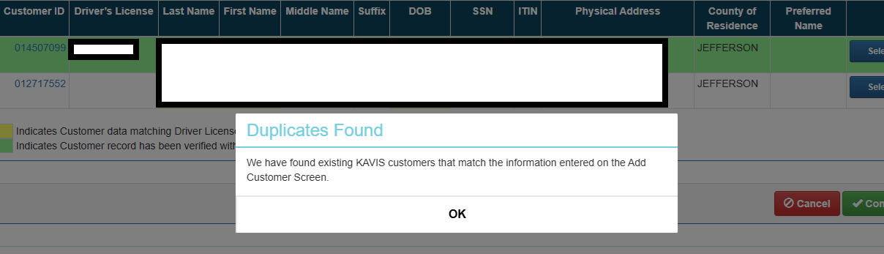
Workaround:
When users hit the Duplicates Found screen they should follow these steps:
- Note the Customer ID of the DL Verified Account for later use
- Navigate back to the Customer Account page for the unverified customer account
- Enter the correct SSN, but mark and save it as Incorrect SSN
  - 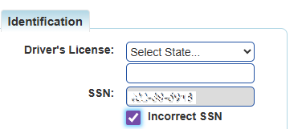

- Navigate to the DL Verified Customer Account page noted in step 1
- You should see a prompt for a merge in the Action Center. Click the link and complete the merge as you normally would

