LIEN EXTRACT FILE CHANGES – 20th NOVEMBER 2025 RELEASE

KAVIS made changes to Lien Extract File format and location as part of 20th November 2025 release.
- For Counties using Third Party vendors such as SMI, i3Verticals, DRMS, Courthouse Computer Systems, there is no change as KAVIS team has communicated location and file format changes with the above mentioned vendors and completed testing with test files.
- If a County is unable to view Lien Extract file and using above mentioned Lien management softwares, please do reach out to your vendor contacts.
- Lien Extract File new location details:
- FTP Location:
Server: ftp.ky.gov
Folder: /Distribution/KyAgencies/KYTransportation/RealTimeData/Kavis/PROD/LienData/[County Name]
For example: /Distribution/KyAgencies/KYTransportation/RealTimeData/Kavis/PROD/LienData/FRANKLIN
File name: DT.AIS.P052.A5070.cnty{County ID}
The county ID will be prefixed with 0s
For example: DT.AIS.P052.A5070.cnty001 for Adair county
Protocol: SFTP or FTPS. Preferred protocol is SFTP
Port: 990
- File Share location (same as before)
\\eas.ds.ky.gov\dfs\CoClerk\[County Name] County\Data\!LienFiles\

In the past, Clerks had to reach out to COT/KAVIS/AVIS to regenerate a missed Lien Extract File. To resolve this concern and hassle for Clerks, KAVIS has provided ability for Clerks to be able to generate Lien Extract file for any date using KAVIS reports page as defined hereafter.

To generate missed Lien Extract File
- Navigate to KAVIS Home page and select ‘Reports’ tile.
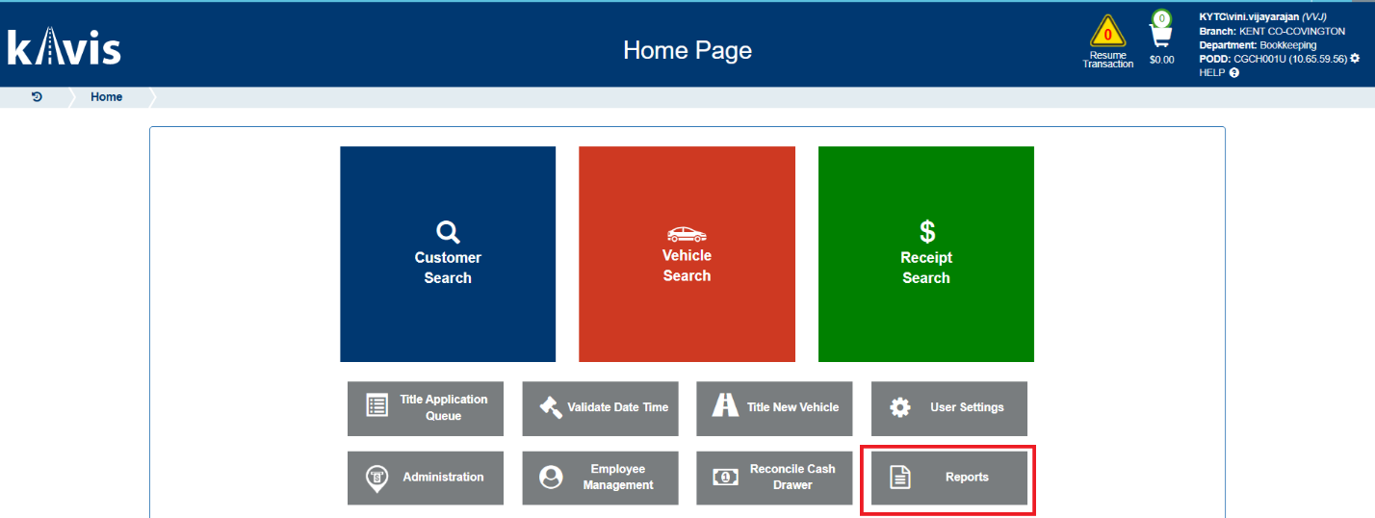

- From sub tile layout, select ‘KAVIS’ tile.
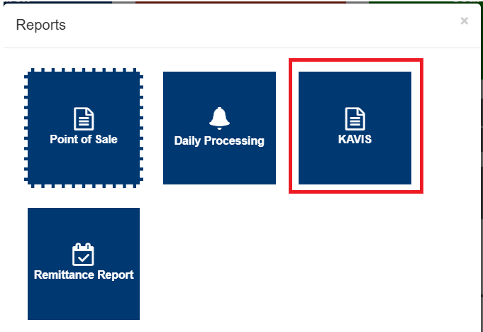

- On Reports UI page, choose ‘Start Date’ and ‘End Date’ as required Lien Extract file date.
  - For eg, if Lien Extract file is missing for 20th November 2025, then choose ‘Start Date’ and ‘End Date’ as ‘11/20/2025’.

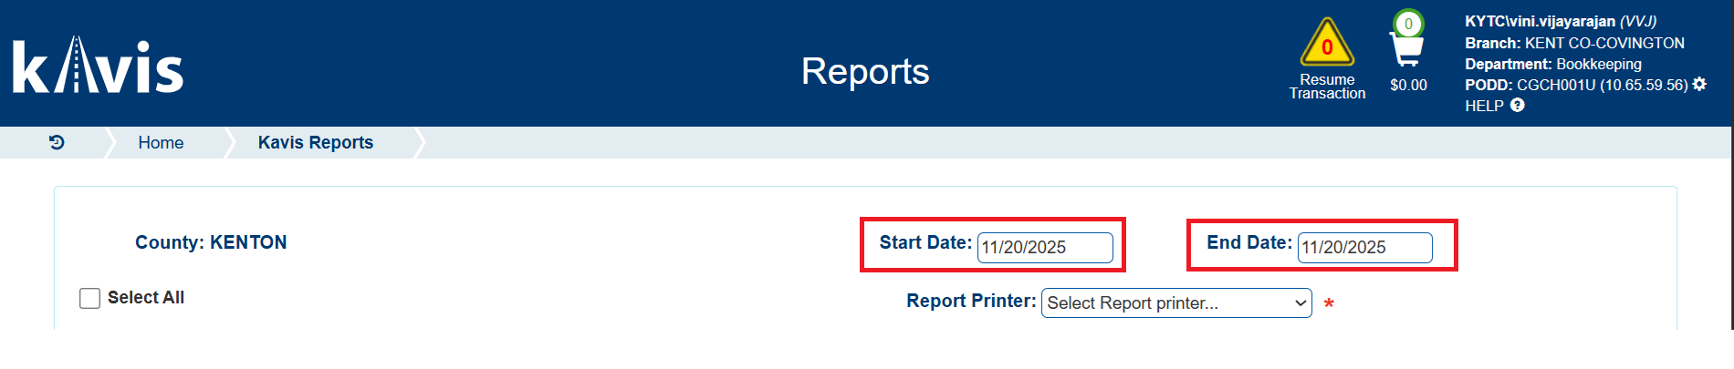

- Select ‘Generate’ for ‘Lien Extract File’.
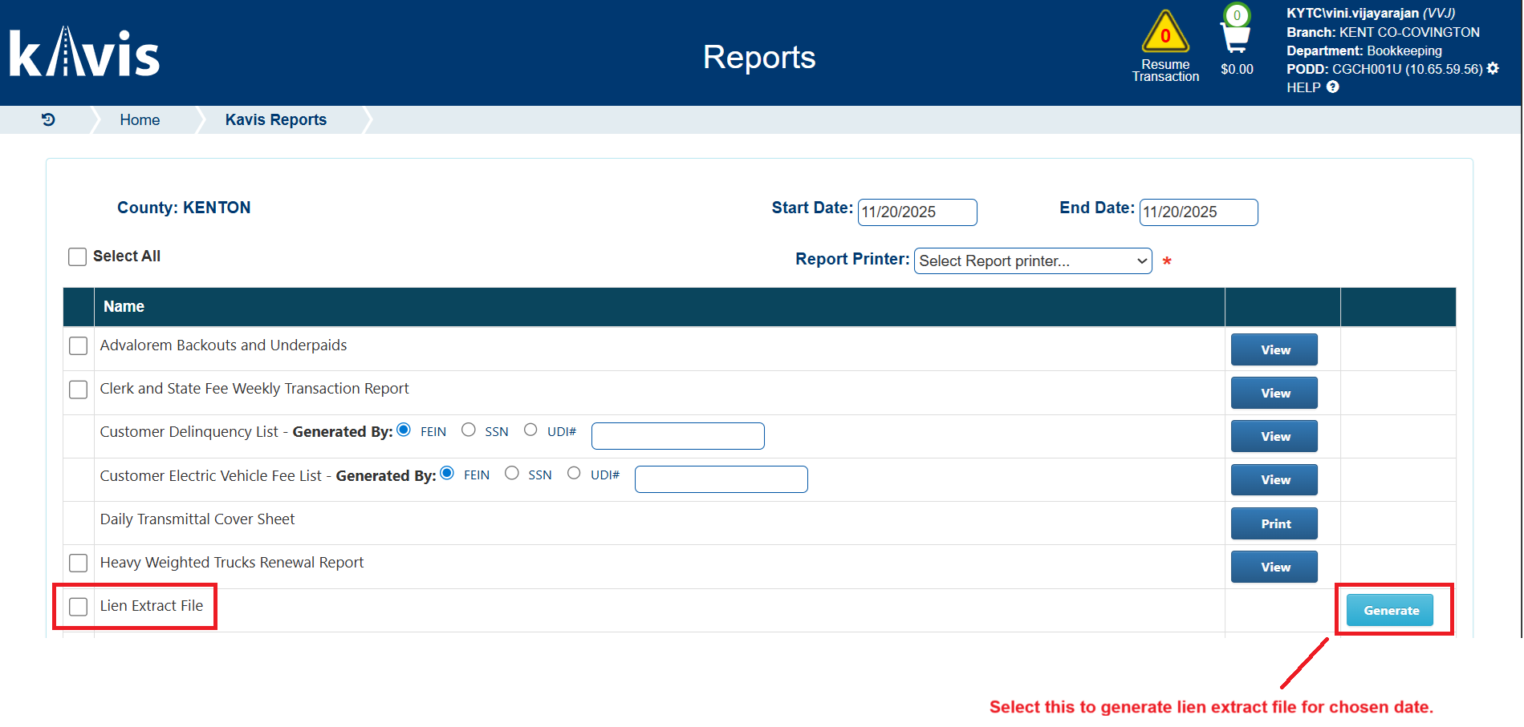

- This will place lien extract file for chosen date range in both FTP and file share locations currently being used by the County.

