Boat Transfers Blocked by Gender Bug
We currently have a bug in the KAVIS system that is not pulling over the gender from the driver’s license system. Consequently, newly created customers are blocked from having a boat transferred into their name (gender is required for boats but no other vehicle types).
Blocked Boat Transfer:
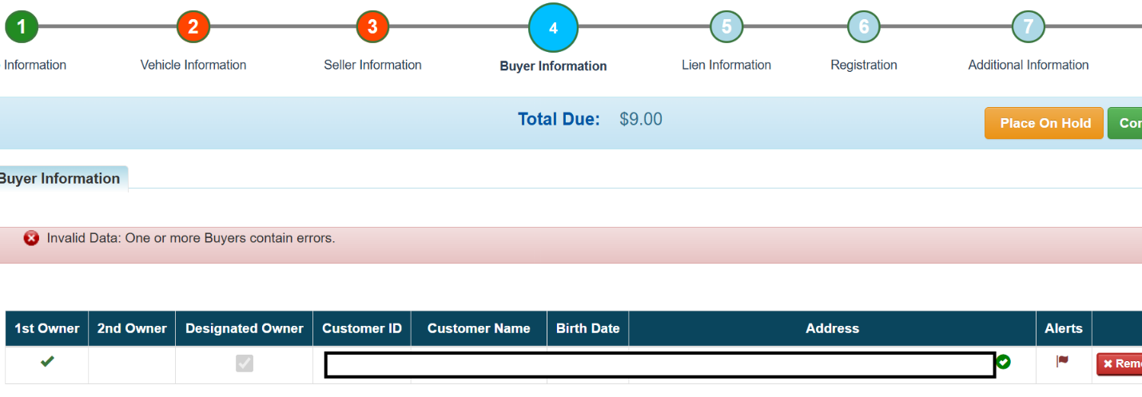
If you have created a customer that was affected by this bug and are now blocked from a boat transfer, please email KAVIS@ky.gov with the customer number and the gender that needs to be added. We will work on a manual update to add the gender for the affected customers as soon as possible.
Thank you

