**SPECIAL NOTE FOR REPAIR OF EXISTING BLOW-UP**

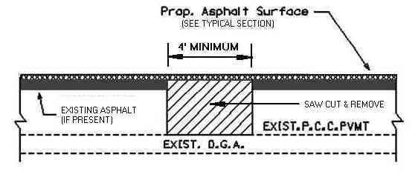

The Engineer will determine the location of blow-up repairs at the time of construction. Saw cut the existing PCC Pavement, and asphalt overlay if present, full depth to allow for the removal of the existing PCC Pavement, down to the existing DGA and back to solid concrete, a minimum of 2 feet either side of the transverse centerline of the blowup. Dispose of removed materials off the Right-of-way at sites obtained by the Contractor at no additional cost to the Department. See the Special Provision for Waste and Borrow Sites. Fill the removed area with Class __ Asphalt Base 1.00D PG__-22 in lifts not to exceed __ inches. Compact the asphalt base to the compaction required by Section 403. Seal the asphalt base with leveling and wedging. Perform all blow-up repairs in such a manner that removal and replacement are completed on the same day. Complete this work as one of the Contractor’s first operations in order to allow further compaction by traffic. Do not mill or place new asphalt surface over repaired blow-up areas until a minimum of 14 calendar days have elapsed after placement of the final course of asphalt base. After the 14 calendar day waiting period, and/or when the Engineer determines the blow-up repair areas have sufficiently stabilized, begin milling and/or resurfacing operations. Prior to milling and/or constructing the new asphalt surface, level and wedge any settlement of the repair areas.

The bidder must draw his or her own conclusions as to the conditions to be encountered. The Department does not give any guarantee as to the accuracy of the data and will not consider any claim for additional compensation if the materials encountered are not in accord with the classification shown.

Accept payment at the Contract unit prices per square yard for Repair Existing Blow-Up and per ton for Leveling and Wedging as full compensation for all labor, materials, equipment, and incidentals for saw cutting and removing pavement and disposing of the materials, furnishing and placing asphalt base, leveling and wedging, and all other items necessary to complete the work according to these notes to the satisfaction of the Engineer.