**BRIDGE DETAIL FOR PAVING PROJECT**

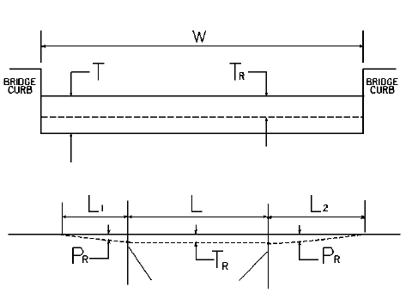

W = bridge width curb to curb

T = thickness of existing asphalt overlay

L = length of bridge

L1 & L2 = length of approach pavement to be removed

TR = thickness to be removed and replaced on bridge

PR = thickness to be removed and replaced on pavement

Note: L1 & L2 lengths shall be determined by using a transition rate of 100 ft/in of thickness

|  |  |  |  |  |  |  |  |  |  |
| --- | --- | --- | --- | --- | --- | --- | --- | --- | --- |
| Route | Bridge No. | MP | W (ft) | T (in) | L1 (ft) | L2 (ft) | TR (in) | L (ft) | PR (in) |
|  |  |  |  |  |  |  |  |  |  |
|  |  |  |  |  |  |  |  |  |  |
|  |  |  |  |  |  |  |  |  |  |
|  |  |  |  |  |  |  |  |  |  |
|  |  |  |  |  |  |  |  |  |  |
|  |  |  |  |  |  |  |  |  |  |
|  |  |  |  |  |  |  |  |  |  |
|  |  |  |  |  |  |  |  |  |  |
|  |  |  |  |  |  |  |  |  |  |