BRIDGE DETAIL FOR PAVING PROJECT

**BRIDGE NUMBER**

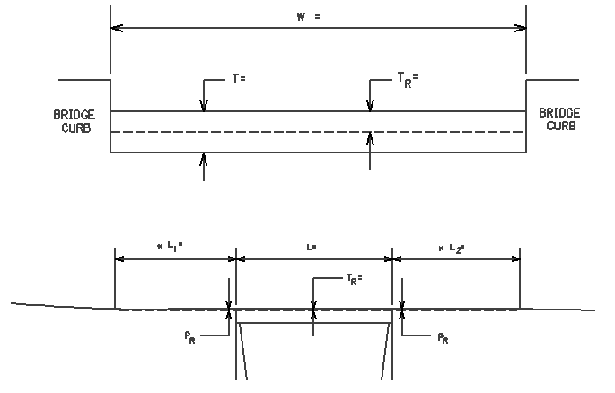

**DIMENSIONS** **ELEVATION**

W= W = bridge width curb to curb

T = _0” T = thickness of existing bituminous overlay

L1 =

L1 & L2 = length of approach pavement to be removed

L2 =

TR = TR = thickness to be removed and replaced on bridge

L = L = length of bridge

PR = PR = thickness to be removed and replaced on pavement

Notes: 1. The Engineer will determine lengths L1 & L2  by using a transition rate of 100 ft/inch of thickness.

2. The Department will place One Step Membrane Water Proofing System Prior to Bridge Overlay.

1-98331 bridgedetailsheetonestepdepartment

01/02/2012