**SPECIAL NOTE FOR EDGE KEY FOR**

**BRIDGE DECK OVERLAY**

After constructing the bridge deck overlay, Construct Edge Keys at each end of the bridge, as applicable. Cut out the existing asphalt surface to the required depth and width shown on the drawing. Transition asphalt surface from the bridge deck overlay and heel new surface into the existing surface. The Department will pay for this work at the contract unit price per ton for “Asphalt Pavement Milling and Texturing”, which shall be full compensation for all labor, materials, equipment, and incidentals for removal and disposal of the existing asphalt surface required to construct the edge key.

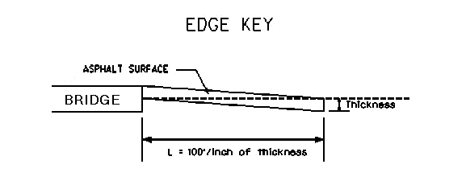

**Thickness = Inches**

**L = LF**

**L = Length of Edge Key in Linear Feet**

1-3305 Edge Key Bridge Deck

01/02/2012