**SPECIAL NOTE FOR EDGE KEY**

Construct Edge Keys at the beginning of project, end of project, at railroad crossings, and at intersections with ramps, as applicable. Unless specified in the Contract or directed by the Engineer, do not construct edge keys at intersecting streets, roads, alleys, or entrances. Cut out the existing asphalt surface to the required depth and width shown on the drawing and heel the new surface into the existing surface. The Department will measure the Edge Key at the joint as the width of the pavement perpendicular to the centerline in linear feet. The Department will pay for this work at the Contract unit price per linear foot, which shall be full compensation for all labor, materials, equipment, and incidentals for removal and disposal of the existing asphalt surface required to construct the edge key.

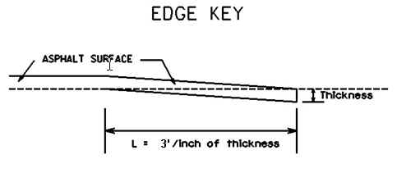

**Thickness =**  **Inches**

**L =**  **LF**

**L = Length of Edge Key**