**SPECIAL NOTE FOR EDGE KEY**

Construct Edge Keys at the beginning of project, end of project, at railroad crossings, and at ramps, as applicable. Unless specified in the Contract or directed by the Engineer, do not construct edge keys at intersecting streets, roads, alleys, or entrances. Cut out the existing asphalt surface to the required depth and width shown on the drawing and heel the new surface into the existing surface. The Department will make payment for this work at the Contract unit price per ton for Asphalt Pavement Milling and Texturing, which shall be full compensation for all labor, materials, equipment, and incidentals for removal and disposal of the existing asphalt surface required to construct the edge key.

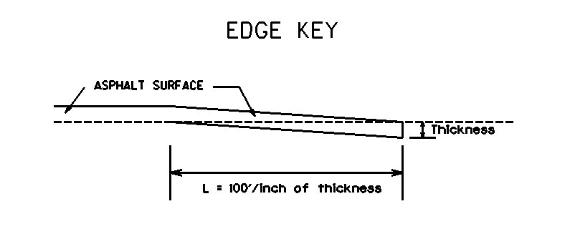

**50’**

**Thickness = Inches**

**L =**  **LF**

**L = Length of Edge Key**