**GUARDRAIL ON BRIDGE, CASE II**

**GUARDRAIL ON TOP OF BRIDGE CURB**

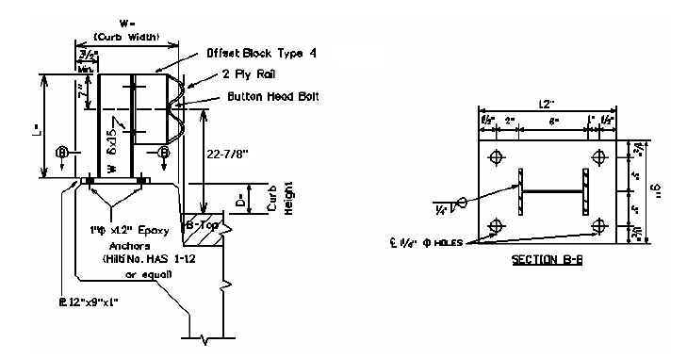

24-7/8”

|  |  |  |  |  |  |
| --- | --- | --- | --- | --- | --- |
| Bridge MP | D = | W = | L = | No. Posts | LF of 2 PLY Rail |
|  |  |  |  |  |  |
|  |  |  |  |  |  |
|  |  |  |  |  |  |
|  |  |  |  |  |  |
|  |  |  |  |  |  |
|  |  |  |  |  |  |

D = Curb Height W = Width of Bridge Curb L = Length of Guardrail Post

**Warrants:** When guardrail can be bolted to the top of the bridge curb and curb width is 12 inches or greater, remove existing concrete and/or guardrail bridge rail and use Case II Bridge Guardrail.

**NOTES:**

1. If the clear distance between the faces of the guardrail for the Case II guardrail is less than 22 feet, delete the offset block.
2. When Case II Guardrail is used without the offset block, use a Precast Concrete Bridge Block at the ends of the bridge which face opposing traffic. See detail drawing for Precast Concrete Bridge Block.