**BRIDGE GUARDRAIL CASE I B**

**DETERIORATED CURBS**

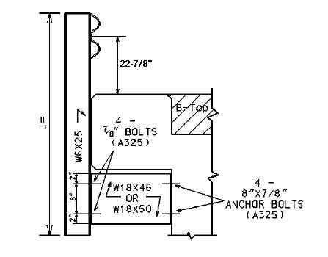

24-7/8”

|  |  |  |  |  |  |
| --- | --- | --- | --- | --- | --- |
| Bridge MP | D = | W = | L = | No. Posts | LF of 2 PLY Rail |
|  |  |  |  |  |  |
|  |  |  |  |  |  |
|  |  |  |  |  |  |
|  |  |  |  |  |  |
|  |  |  |  |  |  |
|  |  |  |  |  |  |

D = Curb Height W = Width of Bridge Curb L = Length of Guardrail Post

**Warrants**: Use Case I-B where the bridge curb is deteriorated and Case I or I-A cannot be used, and the bridge curb width is less than 12 Inches.

**NOTES:**

1. When Case I-B Guardrail is used, use a Precast Concrete Bridge Block at the ends of the bridge which face opposing traffic. See detail drawing for Precast Concrete Bridge Block.
2. If concrete bridge rail needs to be removed from the bridge, include a bid item for Remove Concrete Masonry.