**GUARDRAIL ON BRIDGE, CASE I-A**

**CURB HEIGHT GREATER THAN 2 INCHES**

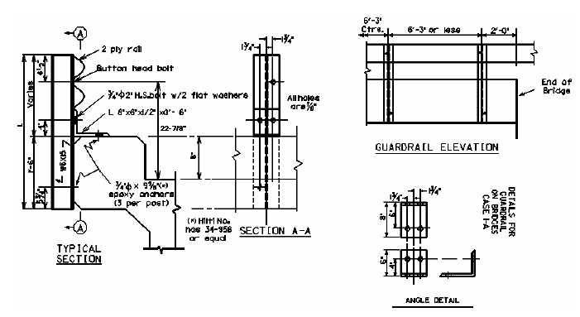

24-7/8”

|  |  |  |  |  |  |
| --- | --- | --- | --- | --- | --- |
| Bridge MP | D = | W = | L = | No. Posts | LF of 2 PLY Rail |
|  |  |  |  |  |  |
|  |  |  |  |  |  |
|  |  |  |  |  |  |
|  |  |  |  |  |  |
|  |  |  |  |  |  |
|  |  |  |  |  |  |

D = Curb Height W = Width of Bridge Curb L = Length of Guardrail Post

**WARRANTS:** When the dimension from the top of the existing riding surface to the top of the curb is greater than 2 inches and where the clear distance between the faces of the guardrail is less than 20 feet or the curb width is less than 12 inches, remove existing concrete and/or guardrail bridge rail and use Case I-A Bridge Guardrail.

**NOTES:**

1. When using Case I-A Bridge Guardrail, do not pave the bridge surface flush to the top of the curb.
2. When Case I-A Bridge Guardrail is used, use a Precast Concrete Bridge Block at the ends of the bridge which face opposing traffic. See detail drawing for Precast Concrete Bridge Block.