**GUARDRAIL ON BRIDGE, CASE I**

**BLACKTOP FLUSH WITH CURB OR ABOVE**

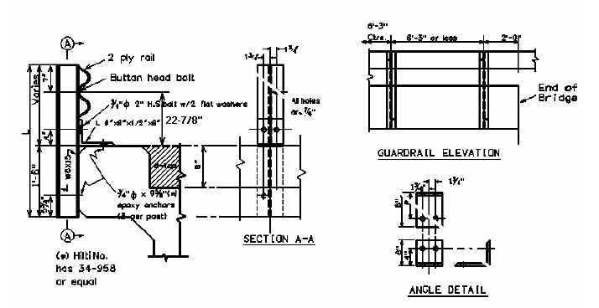

24-7/8”

|  |  |  |  |  |  |
| --- | --- | --- | --- | --- | --- |
| Bridge MP | D = | W = | L = | No. Posts | LF of 2 PLY Rail |
|  |  |  |  |  |  |
|  |  |  |  |  |  |
|  |  |  |  |  |  |
|  |  |  |  |  |  |
|  |  |  |  |  |  |
|  |  |  |  |  |  |

D = Curb Height W = Width of Bridge Curb L = Length of Guardrail Post

**WARRANTS:** When guardrail can be bolted to the back of the bridge curb, and where the bridge surface is flush with the top of curb or above, and where the clear distance between the faces of the guardrail is less than 20 Feet, remove existing concrete and/or guardrail bridge rail and use Case I Bridge Guardrail.

**NOTES:**

1. If asphalt paving is included in the Contract and the dimension from the top of the existing riding surface to the top of the curb is 2 inches or less, pave the new surface flush to the top of the curb, and use Case I Bridge Guardrail.
2. Do not use Case I Bridge Guardrail if the existing pavement is not flush with the top of curb and asphalt pavement is not included in the Contract or if the dimension from the top of the existing riding surface to the top of the curb is greater than 2 inches.