**YIELD BAR PAVEMENT MARKING DETAIL**

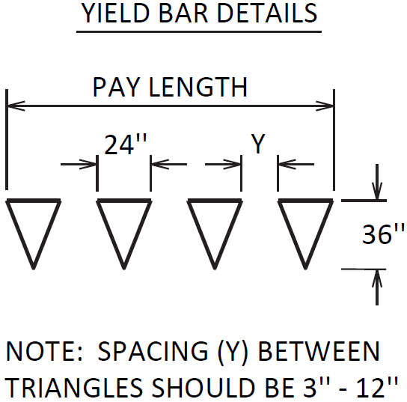

Triangles should be evenly spaced. The spacing (Y) between triangles will depend on the width of the lane the yield bar is for. Unless otherwise directed by the Engineer, space the triangles according to the lane width as follows:

Lane Width

9’

10’

11’

12’

13’

14’

15’

16’

# of Triangles

4

4

5

5

5

6

6

7

Spacing (Y)

4”

8”

3”

6”

9”

4”

7”

4”

In the event of larger lane widths, install triangles on equal spacing, as close to the 3” minimum as possible.

Refer to Section 717 of the Standard Specifications for Road and Bridge Construction, current edition, for more information concerning Material and Construction specifications.

The Department will measure Yield Bars in Linear Feet. The measurement will include the void space between triangles. See Section 717.04 for additional measurement information.

The Department will make payment for the completed and accepted quantities under the following:

Code Pay Item Pay Unit

22520EN Pave Marking-Thermo Yield Bar-36 Inch Linear Foot

26165ES717 Pave Mark TY 1 Tape Yield Bar-36 Inch Linear Foot