**LONGITUDINAL STYLE CROSSWALK DETAIL**

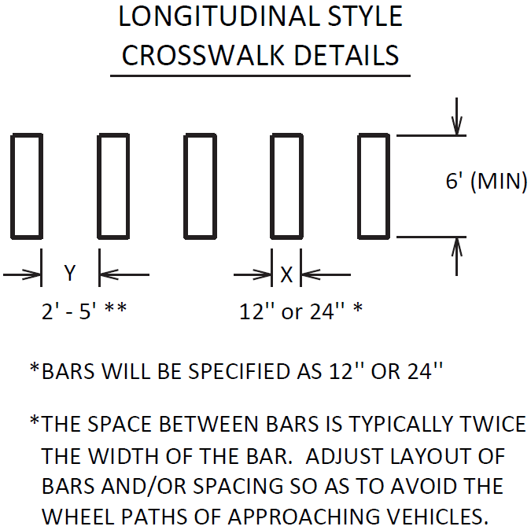

The longitudinal crosswalk bar width (X) will be specified in the bid item descriptions, summary sheets, and/or plans. The spacing (Y) between the longitudinal cross walk bars should be twice the bar width, unless otherwise specified, or otherwise directed by the Engineer:

Refer to Section 717 of the Standard Specifications for Road and Bridge Construction, current edition, for more information concerning Material and Construction specifications.

The Department will measure the sum of the lengths of all the longitudinal crosswalk bars in Linear Feet. See Section 717.04 for additional measurement information.

When listed in the bid items, the Department will make payment for the completed and accepted quantities of longitudinal style crosswalks under the following:

Code Pay Item Pay Unit

06566 Pave Marking-Thermo X-Walk-12 Inch Linear Foot

23261EC Pave Mark-Thermo-X-Walk-24 Inch Linear Foot

23264ES717 Pave Mark TY 1 Tape X-Walk-12 Inch Linear Foot

26164ES717 Pave Mark TY 1 Tape X-Walk-24 Inch Linear Foot