**LADDER STYLE CROSSWALK DETAIL**

RUNG WIDTH (X)

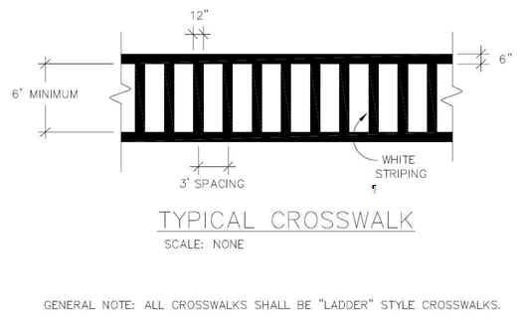

WHITE

MARKINGS

RUNG SPACING (Y)

RAIL WIDTH (Z)

CROSSWALK WIDTH (W)

(6’ Minimum)

Ladder Style Crosswalks consist of white markings that produce rails and rungs. The overall crosswalk width (W), rung width (X), rung spacing (Y), and rail width (Z) are to be installed as specified above or as specified on the plans and/or summary sheets (the latter case is typically because there are multiple crosswalks with different dimensions). If this detail, the plans, and/or summary sheets do not specify the dimensions, then construct the Ladder Style Crosswalks as directed by the District Traffic Engineer and/or the Engineer.

Refer to Section 717 of the Standard Specifications for Road and Bridge Construction, current edition, for more information concerning Material and Construction specifications.

The Department will measure the sum of the lengths of the rails in linear feet and make payment under the X-Walk bid item with a description containing the applicable rail width and material type.

The Department will measure the sum of the lengths of the rungs in linear feet and make payment under the X-Walk bid item with a description containing the applicable rung width and material type.

When listed in the bid items, the Department will make payment for the completed and accepted quantities of Ladder Style Crosswalks under the following:

Code Pay Item Pay Unit

06565 Pave Marking-Thermo X-Walk-6 Inch Linear Foot

06566 Pave Marking-Thermo X-Walk-12 Inch Linear Foot

23261EC Pave Mark-Thermo-X-Walk-24 Inch Linear Foot

23251ES717 Pave Mark TY 1 Tape X-Walk-6 Inch Linear Foot

23264ES717 Pave Mark TY 1 Tape X-Walk-12 Inch Linear Foot

26164ES717 Pave Mark TY 1 Tape X-Walk-24 Inch Linear Foot