**CROSS-HATCH PAVEMENT MARKINGS DETAIL**

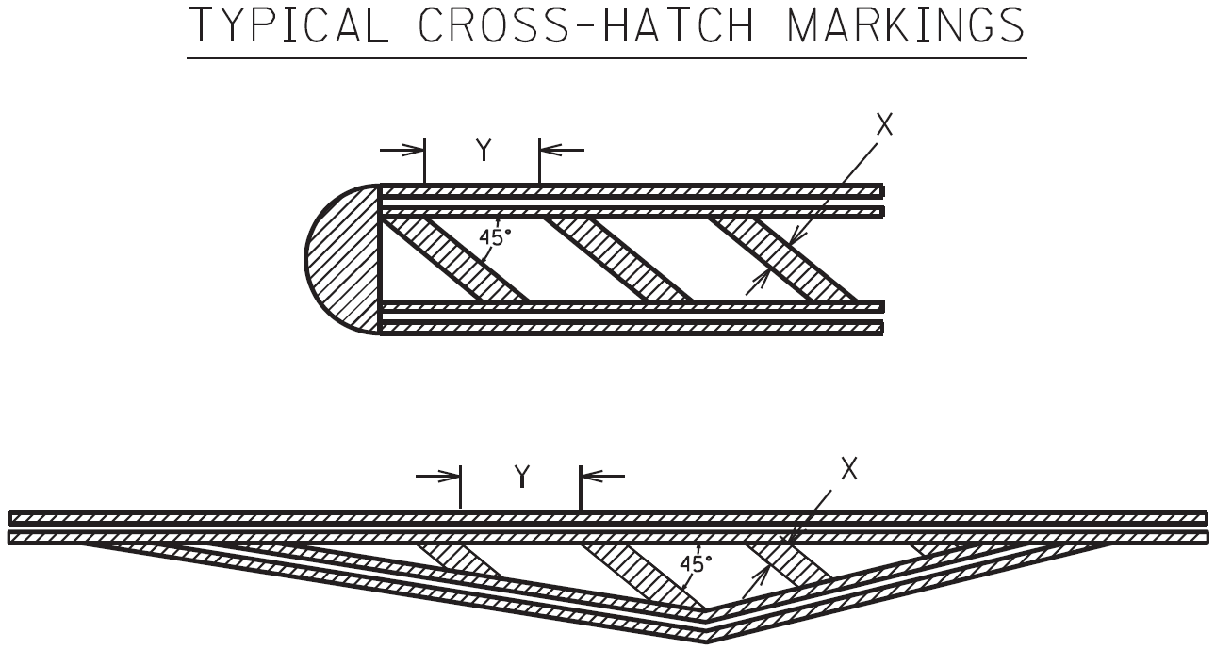

The cross-hatch pavement marking width (X) and spacing (Y) will usually be specified in the plans. The width to spacing values usually have a ratio of 1:10. If the plans do not specify the width (X) and spacing (Y) the Engineer will provide the contractor with the X and Y values for each cross-hatch installation. If necessary, the Engineer may obtain guidance from the District Traffic Engineer and/or the Division of Traffic Operations.

NOTE: Adjust the width and spacing of the cross-hatch pavement markings as necessary so that a minimum of three (3) cross-hatch markings are placed within the area being marked. The 1:10 ratio between width and spacing values should be maintained as much as possible.

Refer to Section 717 of the Standard Specifications for Road and Bridge Construction, current edition, for more information concerning Material and Construction specifications.

The Department will measure the finished in-place area of Cross-Hatch Pavement Markings in Square Feet. The Department will NOT measure overlaps or the void space between cross-hatching. See Section 717.04 for additional measurement information.

When listed in the bid items, the Department will make payment for the completed and accepted quantities of Cross-Hatch Pavement Markings under the following:

Code Pay Item Pay Unit

06569 Pave Marking-Thermo Cross-Hatch Square Foot

23253ES717 Pave Mark TY 1 Tape Cross Hatch Square Foot