**CONTRAST PAVEMENT MARKINGS DETAIL**

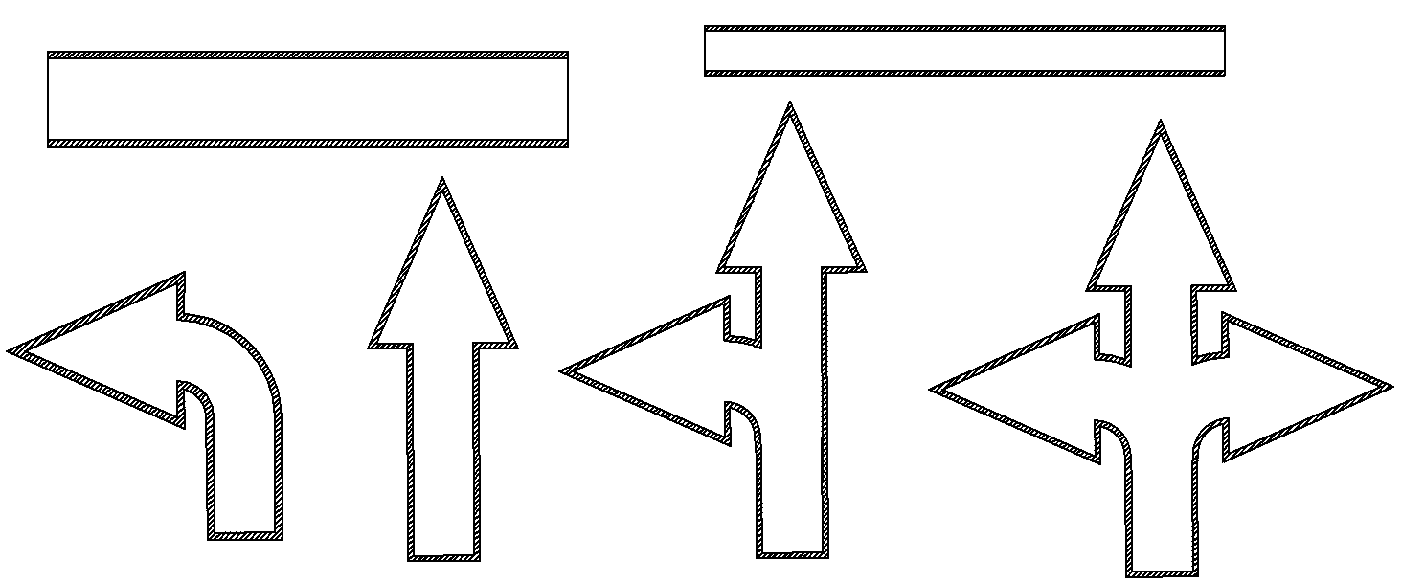

Contrast pavement markings shall consist of standard pavement markings with a defined contrast black border as shown in the chart below:

|  |  |
| --- | --- |
| Pavement Marking | Contrast Border Width |
| Curve Arrow | 4" |
| Through Arrow | 4" |
| Through and Curve Arrow | 4" |
| Triple Arrow | 4" |
| 24" Stop Bar | 3" |
| 6" Cross Walk | 1.5" |
| 12" Cross Walk | 3" |
| Word Markings | 1.5" |
| 4", 6”, 8”, and 12” Stripe | 1.5" |

The defined contrast black border shall consist of the same material as the standard pavement marking. ‘Word Markings’ are defined as any bid item consisting of pavement marking letters and words such as ‘STOP’, ‘AHEAD’, ‘ONLY’, etc...

Place contrast pavement markings as indicated on the plans and/or summary sheets, or as directed by the Engineer.