When HSIP’s consultant partners or district partners submit final project documents for letting, HSIP requires the submittal to include a TRANSPORT Checklist and a Project Information Sheet. While all understand the need for a vicinity map, plan sheets, and summary sheets, details, and so forth, it may not be clear what the function of a TRANSPORT Checklists and Project Information Sheets are for.
The TRANSPORT Checklist
Why do we call it a TRANSPORT Checklist? The specialized software suite that KYTC uses to input and manage all the required information to take a project from letting, to award, to construction is called AASHTOWare Project (read more about this here: AASHTOWare Project). KYTC used to call this software suite the TRANSPORT system. At some point, Construction Procurement went back to calling it AASHTOWare Project, but many at KYTC, like HSIP, resist change and continue to call it the TRANSPORT system possibly because it sounds better to say “TRANSPORT” than “AASHTOWare Project.”
TRANSPORT Checklist - the purpose of, and how to use a TRANSPORT Checklist
Definition of checklist: a list of items required, things to be done, or points to be considered, used as a reminder.
The TRANSPORT Checklist is a critical part of the submittal documents and serves exactly the purpose stated above in the definition of “checklist.” It is a checklist of everything needed to build a proposal that can be submitted to Construction Procurement for letting. It serves as a reminder that certain documents are needed, or topics that need to be discussed or considered with the project team. Think of the TRANSPORT Checklist as a pilot’s checklist before taking flight.
The 1-220 Completion Date and Liquidated Damages (CD&LD) note is a good example of how one of the list items is needed, and needs to be considered by the project team. It is easily overlooked in the rush of gathering all the “important” proposal documents, but the CD&LD is a critical document in that it states the completion date, possibly the milestone completion dates, and the consequence of NOT meeting those dates. The CD&LD note is also the only document that provides the disincentive to leaving the lane or road closures out beyond what is stated in the Traffic control plan. So, while discussing and completing the CD&LD note only takes a few minutes, and is easily overlooked, it is a critical document.
What is the difference between the TRANSPORT Checklist for a Single Project in a Single Proposal vs the TRANSPORT Checklist for Multiple Projects in a Grouped Proposal?
Let’s start with the difference between a “project” and a “proposal.” Most people use these two terms, “project” and “proposal,” interchangeably. This usually is not an issue until the discussion is how to let the projects/proposals.
Each project item number, such as 6-949.00, is a “project.” Sometimes the best way to let the “projects” is to group the projects into one grouped “proposal.” HSIP’s high friction surface treatment (HFST) projects are a good example of why. If there are several HFST projects on one route, or within one county, or one district Project Delivery and Preservation Branch (each district has two PD&P ranches – see ProjectDeliveryPreservation_FEB_2020.pdf), or a district, it is oftentimes mutually beneficial to both KYTC and the contractor to have these various projects grouped into one proposal. The potential contractors would prefer to bid on the multiple HFST projects in one grouped proposal, and KYTC is likely to receive better bids. Think about a small, relatively fast project, and the costs of mobilizing the specialized equipment required to complete the HFST project. Another example of where grouping multiple projects together is when an HSIP project is grouped with a state/FD05 resurfacing project. All would agree that there are benefits to completing the HSIP project work (think superelevation improvements, widening turning radii, replacing drainage culverts or headwalls, etc.) prior to resurfacing. The end product is significantly better. Plus, there are cost-sharing benefits: HSIP does not have to pay for the resurfacing, and the resurfacing project may not have to pay for some of the work, like base failure repairs.
All will recognize that there is a logical, efficient way to organize proposal documents when the proposal is advertised for bids. Continuing the example of the HFST projects grouped into a single proposal above, if the TRANSPORT Checklist for Single Projects in a Single Proposal is used, then all the documents will be included in the proposal in order of the Special Provision Codes (a list of all Special Provision Codes is in Exhibit A). In other words, all the ROW Certifications will be together (this is logical), all the sketch maps will be together, then all the typical sections will be together, then all the summary sheets, etc. in that order as follows:
- 1-9601: Project 1 sketch map, project 2 sketch map, project 3 sketch map, etc.
- 1-9625: Project 1 summary sheets, project 2 summary shts., project 3 summary shts., etc.
- 1-9701: Project 1 typical section, project 2 typ. section, project 3 typ. section, etc.
- 1-9801: Project 1 detail sheets, project 2 detail shts., project 3 detail shts., etc.
This document organization is not going to work out well once the proposal goes to construction. It would be a mess for both KYTC’s Project Engineer and for the Contractor.
The more logical, efficient way to group the multiple projects in one proposal would be to have each of the project documents together. Using the TRANSPORT Checklist for Multiple Projects in a Grouped Proposal, the file organization would then be:
- 1-9801 Project 1 a Sketch Map
- 1-9801 Project 1 b Summary Sheets
- 1-9801 Project 1 c Typical Sections
- 1-9801 Project 1 d Detail Sheets
- 1-9801 Project 2 a Sketch Map
- 1-9801 Project 2 b Summary Sheets
- 1-9801 Project 2 c Typical Sections
- 1-9801 Project 2 d Detail Sheets
- Etc.
This file organization pattern can be seen in the way HSIP sets up their Working Proposal Files folder organization for grouped projects as seen in the example below:
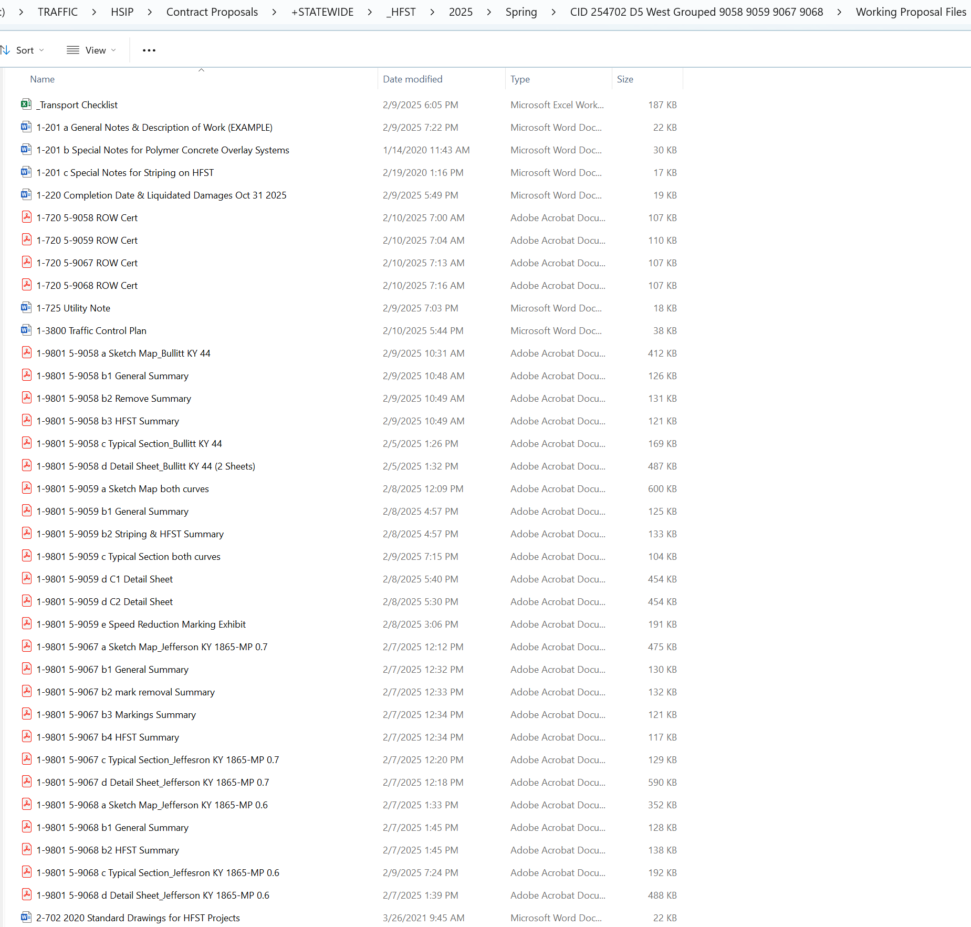
Suggested use of the TRANSPORT Checklist:
For each new project, HSIP recommends getting a new copy of the TRANSPORT Checklist from HSIP’s webpage resources here: HSIP Project Development Resources | KYTC; Path: KYTC Homepage > scroll down to the bottom of the KYTC Webpage and select Traffic Operations link under Department of Highways > select the HSIP Project Development Resources link found under the Resources in the right hand navigation column. HSIP recommends using a new TRANSPORT Checklist, and not an old one from a previous project, because HSIP occasionally updates the TRANSPORT Checklist as new information, notes, requirements, guidance are provided by the Division of Construction Procurement and the Division of Construction. HSIP also occasionally adds new detail sheets and special notes, and will add these to the TRANSPORT Checklist.
Go down the list and carefully consider each item and line. Ask yourself if the item is needed for this particular project. The list may remind you of an item of work that needs to be addressed, like tree trimming or cutting. You may think tree trimming is a minor piece of the overall safety project, but here are bats, endangered bats… Every item on the TRANSPORT Checklist is important.
Anatomy of the TRANSPORT Checklist
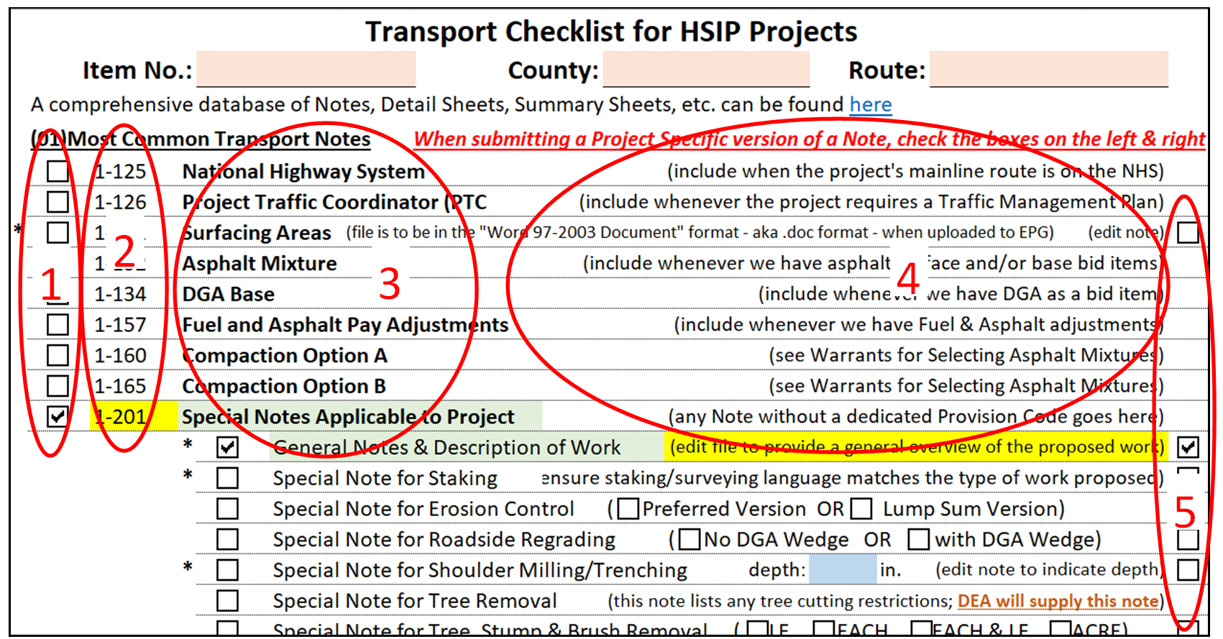
1 and 5: Why the check boxes on the left side vs the check boxes on the right side?
The boxes to check on the left side of the document are to indicate all items to be included in a proposal. There are many of these items that are standard for every project – special notes that do not need to be edited, or details that are always the same.
- Example: 1-125 National Highway System. If the project is on the National Highway System (this can be determined from HIVEi here: HIVEiKYTC - Query), check this box, then HSIP knows to enter this Special Provision code, 1-125, into the TRANSPORT system, which then will automatically add the standard note to the proposal. This 1-125 special provision never changes as a project either is, or is not on the National Highway System, therefore there is no option to change the note, and no box on the right column to note a changed note.
The boxes to the right side of the TRANSPORT Checklist indicate a special provision that requires a unique, edited note or detail, that is unique to the particular project or proposal.
- Example: 1-131 Surfacing Areas. If the project has resurfacing, the areas will have to be indicated in this 1-131 Surfacing Area special note. When the box to the left is checked, the box to the right is automatically checked, and the final submittal must include a unique 1-131 Surfacing Area file with the specific surfacing areas indicated.
2: these numbers, 1-125, 1-126, 1-131, etc. are called Special Provision Codes. These Special Provision Codes are entered into TRANSPORT:
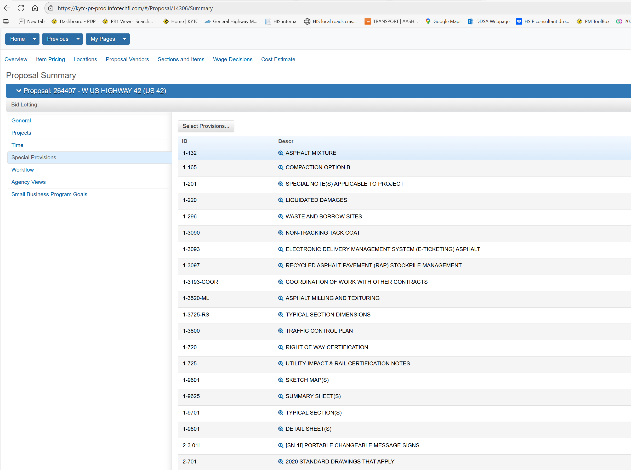
Once the codes (1-125, 1-131, 1-9625, 1-201, 1-9801, etc.) are entered into the system, KYTC uses a program, Electronic Proposal Generator (EPG), that allows users to use a standard file, or switch the standard file with a project-specific file. EPG looks like this:
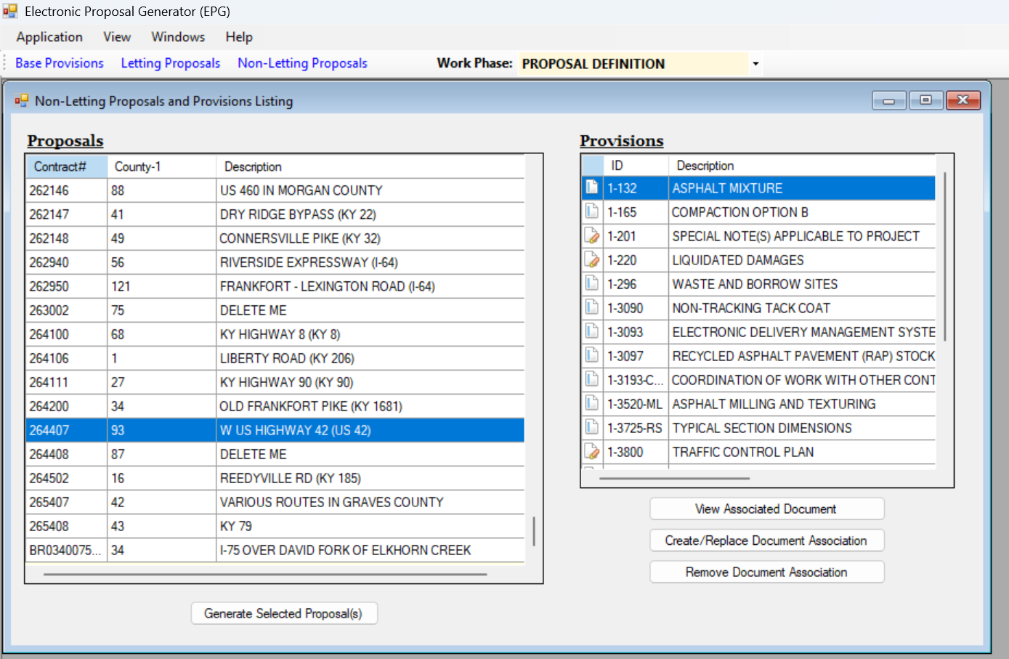
The proposal is designated on the left table, then the Special Provision codes that were selected in TRANSPORT appear on the upper right table. The commands on the bottom right are used to view, replace, or remove files. Once all the files have been attached, a DRAFT proposal can be generated to review for errors (bottom left).
3: these names are the titles of the Special Provision Codes.
4: these are instructions of when to include the Special Provisions or how to edit the Special Provision files.
Items highlighted in yellow: if a Special Provision code box is checked, it will be highlighted in yellow. This draws HSIP’s attention to the check and ensures HSIP doesn’t inadvertently miss adding the Special Provision Code when doing the TRANSPORT work.
Items highlighted in green: always required in every project
Items highlighted in pink/salmon: items that are required that HSIP will provide.

The Project Information Sheet
This document contains all the information needed for the HSIP staff to initiate a project in the TRANSPORT system. The HSIP staff always say it takes about 1,001 intricate, detailed steps to get a project into the system and let, and the Project information Sheet helps quite a bit, for example:
- some fields require the project length to 2 decimal points while another field requires the project length to 3 decimal points.
- The project item number cannot have a dash (-), HSIP staff must use a zero (0) in place of the dash; the district must be represented with 2 digits
- The latitude and longitude must be in degrees, minutes and seconds to 2 decimal points.
In other words, the Project Information Sheet helps the HSIP get the 1,001 intricate details correct.
Instructions on how to fill out the information are generally to the right.
HSIP has recently added a new section to the Project information sheet: Information for Consultants/Designer to verify as complete. These are items that sometimes get overlooked and HSIP would like to have our consultant partners help keep track of these project management items.
Note that there is a tab on the Permanent Traffic Counting Stations where the Co-Route-MPs can be checked to ensure the project will not rip out an existing permanent count station. These cost about $30,000 to replace.
Note that there is also a tab to help identifying projects that require a Traffic Management Plan.
Preferences on final submissions for letting
When submitting final documents, it is helpful to be very organized and methodical.
- Avoid sending documents that are not needed unless previously discussed with the HSIP staff.
- Send the original Word and Excel documents when possible. When Bidder’s questions come in during the letting process, oftentimes it is easier and faster for the HSIP staff to correct something, like a quantity on a summary sheet, than to email the consultant and request a correction.
- PDFs can also be sent.
- Do not send DGN files until after the project is awarded as corrections may be necessary during the letting process.
- Label the files with the appropriate Special Provision Code and name, HSIP staff set up their contract letting folders as follows:
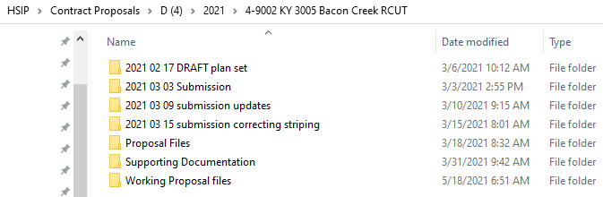
- Year month date description (i.e. Submission consultant name)
- HSIP keeps a clean original copy of all the documents sent in by the consultant
- Year Month Date description (i.e. updated detail sheets)
- Working Proposal Files (step 1)
- HSIP copies the original submission and builds the proposal in the Working Proposal Files folder. The Working Proposal Files folder typically looks like this:
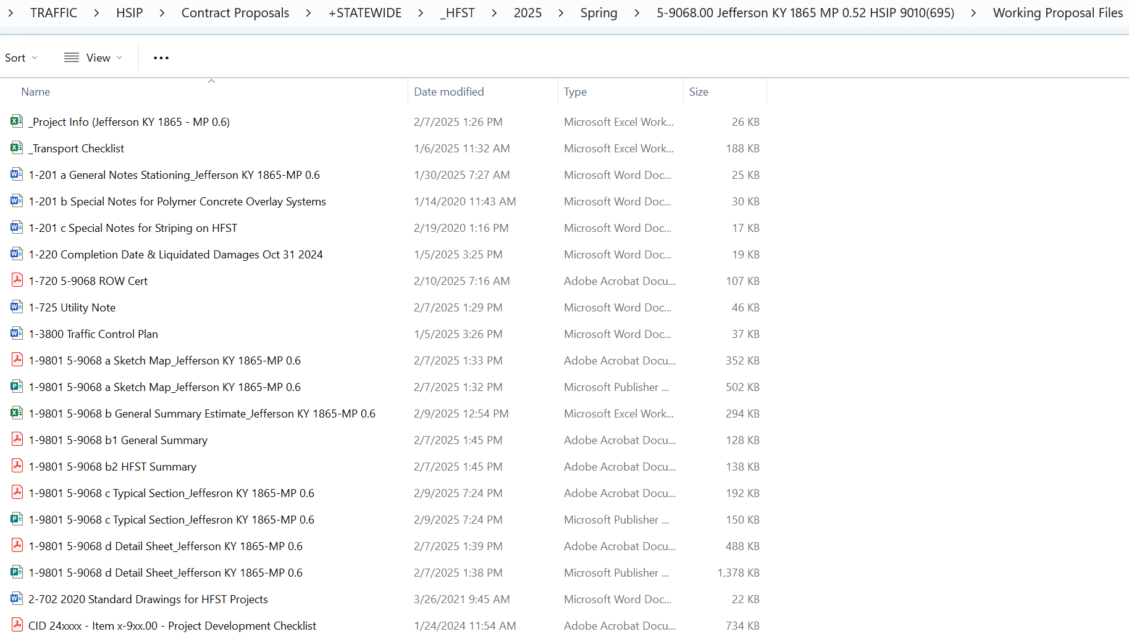
If there are standard special notes and/or detail sheets that were not edited specifically for the project (i.e. only checked on the left column), some HSIP staff prefer those to be checked on the TRANSPORT Checklist, but not submitted with the final documents. This is because HSIP has a folder of all the standard notes and details that are known to be the most up-to-date copies. The HSIP staff will make a copy of those most up—to-date documents and drop copies into the Working Proposal Files folder. That way the HSIP staff member is certain that the most up-to-date file is used. There have been known instances where consultant firms have used an older file from a previous KYTC project that had been modified.
- Proposal Files (step 2)
- HSIP builds a proposal in the Working Proposal Files folder (step 1), then combines the Special Provision codes into one single PDF, or saves a Word document as a PDF into the Proposal Files folder (step 2). The Proposal Files folder typically looks like this:
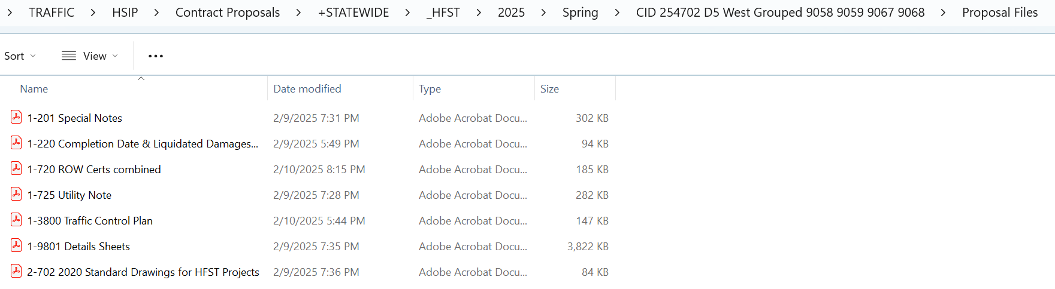
- These PDFs are then copied into the Electronic Proposal Generator (EPG, an ancient program that doesn’t always work and everyone despises), which assembles all the designated Special Provisions Codes and PDFs into a proposal that is published online for bids.
- Supporting Documentation (step 3)
- This is the information required by FHWA for federal projects. HSIP staff assembles a copy of the sketch map, estimate, ROW Cert., Utility Note, and the signed environmental document, combines them into one PDF, then copies the combined file to a ProjectWise folder for FHWA’s review. This folder typically looks like this:
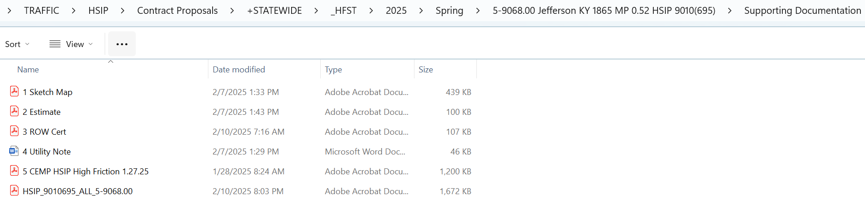

Exhibit A – Special Provision Codes

