TWITTER – County Specific
1st Tweet:
Starting [YOUR TRANSITION DATE HERE], driver licensing services for residents of [YOUR COUNTY] will transfer from the Office of the Circuit Court Clerk to KYTC Driver Licensing Regional Offices. Learn more: [INSERT PRESS RELEASE LINK HERE]
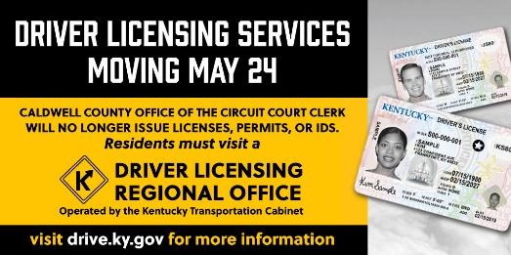
[PICTURE FOR REFERENCE ONLY.]

2nd Tweet in a thread:
Regional offices offer more choices & modern services that take licensing to the next level. @kystatepolice will continue to oversee all permit & license testing. Appointments MUST BE scheduled for written or road testing. Visit kentuckystatepolice.org/driver-testing for scheduling & locations.
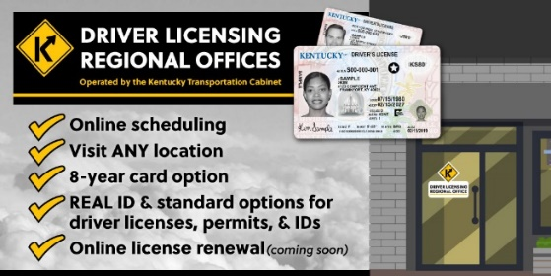
[PICTURE FOR REFERENCE ONLY.]

