Online Renewal Verbiage
As of July 7, 2021

Facebook/Instagram:
Renew your Kentucky driver’s license on your time! Now, standard or REAL ID driver’s licenses and motorcycle licenses can be renewed online, as long as your address and name remain the same! This is just one of many benefits of Drive.KY.gov's new Driver Licensing Regional Offices program! Learn more at https://dlrenewal.ky.gov/
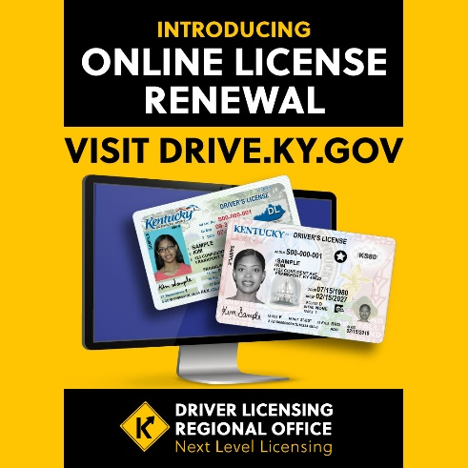
PICTURE IS ONLY FOR REFERENCE. PLEASE USE FULL SIZE GRAPHIC AT https://transportation.ky.gov/PublicAffairs/Documents/Online-License-Renewal-2-FB-IG.jpg

Twitter:
Renew your Kentucky driver’s license on your time! Now, standard or REAL ID driver’s licenses and motorcycle licenses can be renewed online, as long as your address and name remain the same! Learn more at https://dlrenewal.ky.gov/
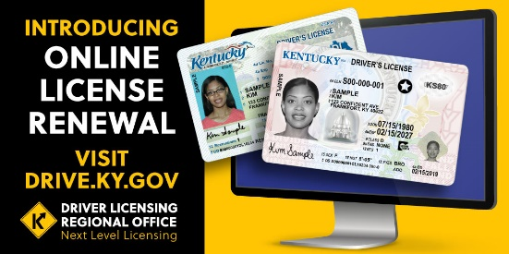
PICTURE IS ONLY FOR REFERENCE. PLEASE USE FULL SIZE GRAPHIC AT
https://transportation.ky.gov/PublicAffairs/Documents/Online-License-Renewal-2-Twitter.jpg

