FACEBOOK/INSTAGRAM – County specific
IMPORTANT ANNOUNCEMENT FOR [YOUR COUNTY] COUNTY RESIDENTS!
It’s a new era for driver licensing in Kentucky! Starting [YOUR TRANSITION DATE HERE], residents of [YOUR COUNTY] will visit any Driver Licensing Regional Office, instead of the Office of the Circuit Court Clerk in their county of residence,, to request or renew driving credentials and IDs. This is part of a phased, county-by-county transfer that provides Kentuckians more choices and modern licensing services. Here’s what you need to know:
HOW TO RENEW OR APPLY:
[YOUR COUNTY] residents may renew or apply for a REAL ID or new standard driver licenses, permits, CDLs and ID cards at any KYTC Driver Licensing Regional Office. Applicants are encouraged to make an appointment online at drive.ky.gov. Walk-ins are welcome but capacity is limited.
RENEW FROM HOME:
For the first time in Kentucky, license holders who want to renew their current license, and whose name and address have not changed, now can do so online or by mail. See www.drive.ky.gov for information.
DRIVER TESTING:
@KentuckyStatePolice will continue to oversee all permit and license testing. Appointments MUST BE scheduled online for written or road testing. Visit kentuckystatepolice.org/driver-testing for scheduling and testing locations.
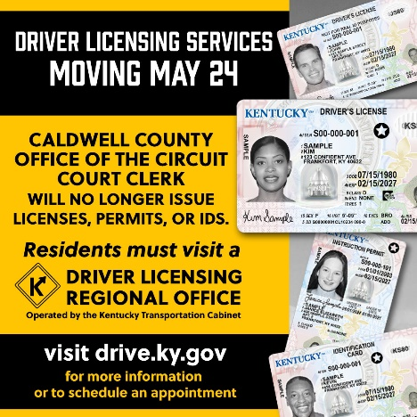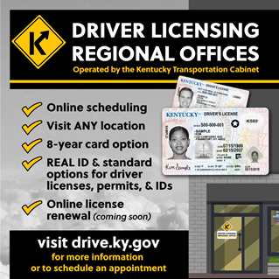
[PICTURES FOR REFERENCE ONLY.]

