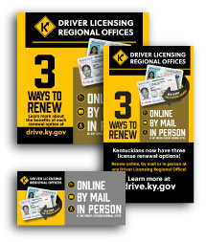
3 Ways to Renew
Social media verbiage

All Platforms:
Kentuckians now have three license renewal options! Renew online, by mail or in-person at any Driver Licensing Regional Office! Learn more at drive.ky.gov

