Construction Bid Proposal Template for Local Public Agency (LPA) Federal-aid Transportation Projects

The following document is an example template that LPAs may use to develop the bid proposal for their Federal-aid construction project. The template has seven sections:

- Scope of Work
- Federal Contract Notes
- Employment, Wage and Record Requirements
- Certifications
- Specifications and Standard Drawings
- Insurance
- Bid Items

The template is provided in Microsoft Office Word format allowing the LPA full editing flexibility.
Information that the LPA or its representative must provide are highlighted in yellow.

The following descriptions are items not covered by the template that the LPA may choose to include as part of the project process:

Additive or Deductive Alternates: Alternate bidding is a technique that may be used by owner-agencies to achieve maximum project scope within available budget. Under this procedure, the owner-agency defines its critical project scope components as the “base” and defines specific additional components as ‘alternates’ which will be added to the base in a pre-defined order to establish the low bid. The contract would be awarded to the bidder providing the maximum scope within the budget. While this alternative bidding method is considered to be non-traditional, when implemented in a fair and transparent manner, it is consistent with the competitive bidding principles in 23 U.S.C. 112, and therefore, does not need SEP-14 approval. The owner-agency must clearly define the priority order in which the alternatives will be considered and added to the base. Additionally, the bid documents may establish whether the bid prices for unselected alternates will apply should the owner-agency receive additional funds for the contract. For a deductive alternate contract, the predefined alternate packets will be deducted from the base in a predefined order in a contract that fits the budget. The LPA should work with KYTC when electing to include alternate bidding language in its bid proposal.

Hold Harmless Clause: A hold harmless clause is a waiver of liability in a contract between parties whereby “one or both parties agree not to hold the other party responsible for any loss, damage, or legal liability that may arise under the agreement.” The LPA should work with KYTC when electing to include such a clause in its bid proposal.

Retainage: Due to conflict with prompt payment provision 49 CFR 26.29, retainage is not permitted on federally funded projects. However, a LPA is permitted to include a bid item for demobilization up to 1.5% of the total project price.

Pre-Bid Meeting: This is a meeting that clarifies any concerns bidders may have with the bid documents, scope of work, and other detailed requirements. Information to bidders about a mandatory or non-mandatory pre-bid meeting would be mentioned in the solicitation documents (postings, advertisements, etc).

Pre-Construction Meeting: A pre-construction meeting provides an opportunity to communicate the requirements of a construction project to the selected contractor. This meeting would allow for review and discussion of implementation procedures, specifications, and material requirements including testing. Requiring this meeting prior to construction work beginning, will help to ensure that all parties involved fully understand the goals and objectives for the project and the expected construction requirements to achieve them.

LPA Name
  - (optional-add city seal)

XXX COUNTY
FED/STATE PROJECT NUMBER: XXX
KYTC ITEM NUMBER: X-XXX
DESCRIPTION/PROJECT NAME: XXX
WORK TYPE: XXX
PRIMARY COMPLETION: XXX

LETTING DATE: XXX
Sealed Bids will be received until 10:00 AM/PM EASTERN/CENTRAL DAYLIGHT TIME MMM DD, 20YY. Bids will be publicly opened and announced at 10:00 AM/PM EASTERN/CENTRAL DAYLIGHT TIME.

PLANS AVAILABLE FOR THIS PROJECT.
DBE CERTIFICATION REQUIRED: XX%

REQUIRED BID PROPOSAL GUARANTY: Not less than 5% of the total bid.

TABLE OF CONTENTS
PART I SCOPE OF WORK
- Project(s) & Completion Date(s)
- Contract Notes
- Standard Specification Provisions
- Vendor Document Disclosure
PART II FEDERAL CONTRACT NOTES
- Civil Right Act of 1964
- Notice to All Bidders (Report Bid Rigging)
- Second Tier Subcontracts
- DBE Program
  - Contract Goal
  - Obligation of Contractors
  - Certifications of Contract Goal
  - DBE Participation Plan
  - Upon Award and Before a Work Order Will be Issued
  - Consideration of Good Faith Efforts Requests
  - Failure to Meet Good Faith Requirement
  - Sanction for Failure to Meet DBE Requirements
  - Prompt Payment to DBEs
  - Contractor Reporting
  - Default or Decertification of the DBE
- Federal-Aid Construction Contracts – FHWA 1273 (Revised 5/1/12)
PART III EMPLOYMENT, WAGE AND RECORD REQUIREMENTS
- Employment Requirements (KRS 344)
- Notice of Requirement for Affirmative Action to Ensure EEO
- Labor Final Rule on Federal Executive Order 11246
- Standard Title VI/Non-Discrimination Assurances
- Project Wage Rates

PART IV CERTIFICATIONS
- Executive Branch Code of Ethics
- Certification Regarding KRS 45A.485
- Non-Collusion Certification
- Certification of Organization(s)
- Certification of Performance
- Certification for Federal-Aid Contract
- Certification of Bid Proposal/DBE
- DBE Subcontractor Bidder List
- DBE Plan/Subcontract Request (TC 14 – 35)
- DBE Subcontractor List
- Required Affidavit for Bidders
PART V SPECIFICATIONS AND STANDARD DRAWINGS
- Asphalt Mixture
- DGA Base
- DBA Base for Shoulders
- Incidental Surfacing
- Compaction Option B
- Special Note(s) Applicable to Project
  - Tree Removal
  - Bridge Demolition/Renovation
  - Asbestos Abatement Report
- Right of Way Certification
- Utility Clearance Impact & Railroad Impact Note
- KPDES Storm Water Permit, BMP and NOI
- KYTC LPA Change Order Form
- 23 CFR 635.109 Standardized Changed Conditions Clauses
- 23 CFR 635.410 Buy America Requirements
- 23 CFR 635.411 Material or Product Selection
- Specifications Reference
- Supplemental Specification
PART VI INSURANCE
PART VII BID ITEMS
- Example of Proposed Bid Items List

PART I

SCOPE OF WORK

Project(s) & Completion Date(s)

KYTC HIGHWAY DISTRICT XX

FED/STATE PROJECT NUMBER: XX
ADMINISTERING OFFICE: OLP/DISTRICT XX
COUNTY - XXXX
ITEM NO: X-XXX

PROJECT DESCRIPTION:
INSERT DESCRIPTION

GEOGRAPHIC COORDINATES LATITUDE XX:XX:XX.00 LONGITUDE XX:XX:XX.00
COMPLETION DATE(S): XXX WORKING DAYS, XXX CALENDAR DAYS, OR MMM DD, 20YY
APPLIES TO ENTIRE CONTRACT

CONTRACT NOTES

PROPOSAL ADDENDA
All addenda to this proposal must be applied when calculating bid and certified in the bid packet submitted to the LPA’s name. Failure to use the correct and most recent addenda may result in the bid being rejected.

STANDARD SPECIFICATION PROVISIONS
The project will follow the Kentucky Standard Specifications for Road and Bridge Construction 2012. For their bids to be accepted, bidders and Disadvantaged Business Enterprises (“DBE”) subcontractors must be prequalified with the Kentucky Transportation Cabinet and possess a Certificate of Eligibility at the time of the bid opening. All other subcontractors must be prequalified when accepting subcontracts. All bids exceeding $40,000 must be accompanied with a Bid Bond of not less than 5% of the total construction bid. Project will be awarded to the lowest responsive and responsible bidder and determined by the LPA and the Kentucky Transportation Cabinet. The awarded bidder will be responsible for providing a Performance Bond of 100% and a Payment Bond of 100% of the awarded bid amount payable to the LPA.

JOINT VENTURE BIDDING
Joint venture bidding is permissible. All companies in the joint venture must be prequalified in one of the work types in the Qualifications for Bidders for the project. A joint bid bond of 5% may be submitted for both companies or each company may submit a separate bond of 5%.

UNDERGROUND FACILITY DAMAGE PROTECTION
The contractor is advised that the Underground Facility Damage Protection Act of 1994, became law January 1, 1995. It is the contractor’s responsibility to determine the impact of the act regarding this project, and take all steps necessary to be in compliance with the provision of the act.

SPECIAL NOTE FOR COMPOSITE OFFSET BLOCKS
Contrary to the Standard Drawings (2012 edition) the Cabinet will allow 6” composite offset blocks in lieu of wooden offset blocks, except as specified on proprietary end treatments and crash cushions. The composite blocks shall be selected from the Cabinet’s List of Approved Materials.

REGISTRATION WITH THE SECRETARY OF STATE BY A FOREIGN ENTITY
Pursuant to KRS 176.085(1)(b), an agency, department, office, or political subdivision of the Commonwealth of Kentucky shall not award a state contract to a person that is a foreign entity required by KRS 14A.9-010 to obtain a certificate of authority to transact business in the Commonwealth (“certificate”) from the Secretary of State under KRS 14A.9-030 unless the person produces the certificate within fourteen (14) days of the bid or proposal opening. If the foreign entity is not required to obtain a certificate as provided in KRS 14A.9-010, the foreign entity should identify the applicable exception. Foreign entity is defined within KRS 14A.1-070.
For all foreign entities required to obtain a certificate of authority to transact business in the Commonwealth, if a copy of the certificate is not received by the contracting agency within the time frame identified above, the foreign entity’s solicitation response shall be deemed non-responsive or the awarded contract shall be cancelled.
Businesses can register with the Secretary of State at
https://secure.kentucky.gov/sos/ftbr/welcome.aspx .

SPECIAL NOTE FOR PROJECT QUESTIONS DURING ADVERTISEMENT
Questions about projects during the advertisement should be submitted in writing to the LPA. The LPA will attempt to answer all submitted questions. The LPA reserves the right not to answer if the question is not pertinent or does not aid in clarifying the project intent.
The deadline for posting answers will be 3:00 pm Eastern Daylight Time, the day preceding the Letting. Questions may be submitted until this deadline with the understanding that the later a question is submitted, the less likely an answer will be able to be provided.
The answers provided shall be considered part of this Special Note and, in case of a discrepancy, will govern over all other bidding documents.

HARDWOOD REMOVAL RESTRICTIONS
The US Department of Agriculture has imposed a quarantine in Kentucky and several surrounding states, to prevent the spread of an invasive insect, the emerald ash borer. Hardwood cut in conjunction with the project may not be removed from the state. Chipping or burning on site is the preferred method of disposal.

INSTRUCTIONS FOR EXCESS MATERIAL SITES AND BORROW SITES
Identification of excess material sites and borrow sites shall be the responsibility of the Contractor. The Contractor shall be responsible for compliance with all applicable state and federal laws and may wish to consult with the US Fish and Wildlife Service to seek protection under Section 10 of the Endangered Species Act for these activities.

ACCESS TO RECORDS
The contractor, as defined in KRS 45A.030 (9) agrees that the contracting agency, the Finance and Administration Cabinet, the Auditor of Public Accounts, and the Legislative Research Commission, or their duly authorized representatives, shall have access to any books, documents, papers, records, or other evidence, which are directly pertinent to this contract for the purpose of financial audit or program review. Records and other prequalification information confidentially disclosed as part of the bid process shall not be deemed as directly pertinent to the contract and shall be exempt from disclosure as provided in KRS 61.878(1)(c). The contractor also recognizes that any books, documents, papers, records, or other evidence, received during a financial audit or program review shall be subject to the Kentucky Open Records Act, KRS 61.870 to 61.884.
In the event of a dispute between the contractor and the contracting agency, Attorney General, or the Auditor of Public Accounts over documents that are eligible for production and review, the Finance and Administration Cabinet shall review the dispute and issue a determination, in accordance with Secretary's Order 11-004. (See attachment)

Bidder Check
The LPA will check if the lowest responsive and responsible bidder is not on the federal excluded party list.

Traffic Control Coordinator
If determined to be applicable by the LPA or KYTC, the Contractor is to designate a traffic control coordinator to be responsible for the Traffic Control Plan for the project.

FHWA Requirement
Prime contractors must submit their entire proposal (all pages).
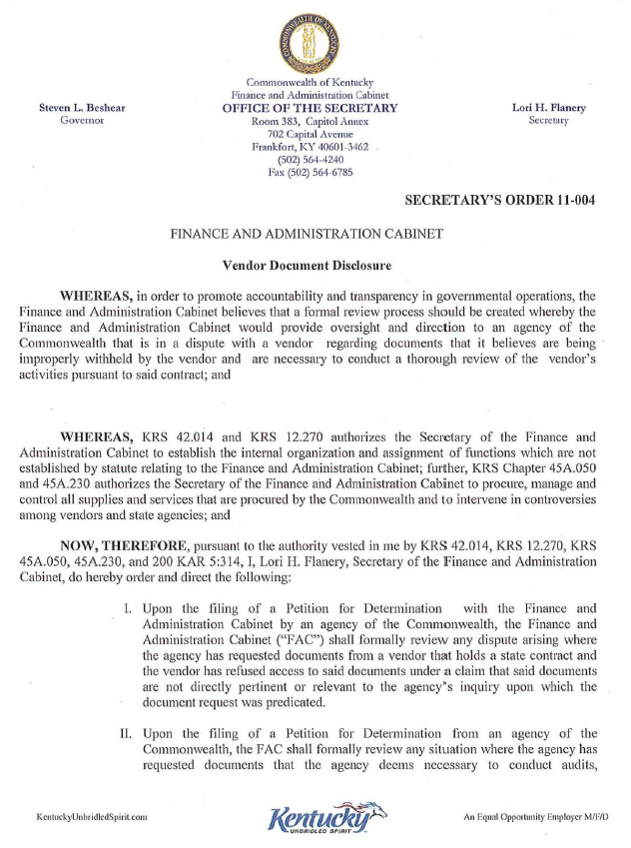

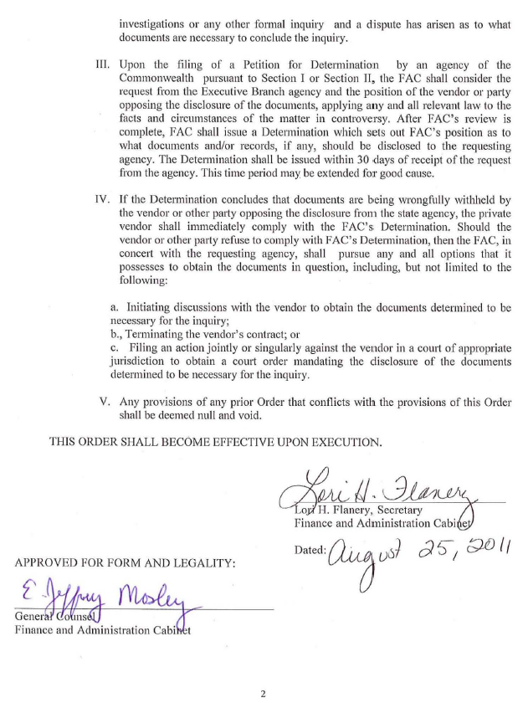

PART II

FEDERAL CONTRACT NOTES

FEDERAL CONTRACT NOTES
The LPA, in accordance with the Regulations of the United States Department of Transportation 23 CFR 635.112 (h), hereby notifies all bidders that failure by a bidder to comply with all applicable sections of the current Kentucky Standard Specifications, including, but not limited to the following, may result in a bid not being considered responsive and thus not eligible to be considered for award:
102.08 Irregular Bid Proposals
102.09 Bid Proposal Guaranty
102.10 Delivery of Bid Proposals
102.14 Disqualification of Bidders

CIVIL RIGHTS ACT OF 1964
The LPA, in accordance with the provisions of Title VI of the Civil Rights Act of 1964 (78 Stat. 252) and the Regulations of the Federal Department of Transportation (49 C.F.R., Part 21), issued pursuant to such Act, hereby notifies all bidders that it will affirmatively insure that the contract entered into pursuant to this advertisement will be awarded to the lowest responsible bidder without discrimination on the ground of race, color, or national origin.

NOTICE TO ALL BIDDERS
To report bid rigging activities call: 1-800-424-9071.
The U.S. Department of Transportation (DOT) operates the above toll-free “hotline” Monday through Friday, 8:00 a.m. to 5:00 p.m. eastern time. Anyone with knowledge of possible bid rigging, bidder collusion, or other fraudulent activities should use the “hotline” to report such activities.
The “hotline” is part of the DOT’s continuing effort to identify and investigate highway construction contract fraud and abuse and is operated under the direction of the DOT Inspector General. All information will be treated confidentially and caller anonymity will be respected.

SECOND TIER SUBCONTRACTS
Second Tier subcontracts on federally assisted projects shall be permitted. However, in the case of DBE’s, second tier subcontracts will only be permitted where the other subcontractor is also a DBE. All second tier subcontracts shall have the consent of both the Contractor and the Engineer.

DISADVANTAGED BUSINESS ENTERPRISE PROGRAM
It is the policy of the Kentucky Transportation Cabinet (“the Cabinet”) that Disadvantaged Business Enterprises (“DBE”) shall have the opportunity to participate in the performance of construction projects financed in whole or in part by Federal Funds in order to create a level playing field for all businesses who wish to contract with the Cabinet. For this proposal, the LPA will adopt that same policy and comply with the regulations found in 49 CFR Part 26, and the definitions and requirements contained therein shall be adopted as if set out verbatim herein.
The LPA, contractors, subcontractors, and sub-recipients shall not discriminate on the basis of race, color, national origin, or sex in the performance of work performed pursuant to LPA’s contracts. The contractor shall carry out applicable requirements of 49 CFR 26 in the award and administration of federally assisted construction projects. The contractor will include this provision in all its subcontracts and supply agreements pertaining to contracts with the LPA.
Failure by the contractor to carry out these requirements is a material breach of its contract with the LPA, which may result in the termination of the contract or such other remedy as the LPA deems necessary.

DBE GOAL
The Disadvantaged Business Enterprise (DBE) goal established for this contract, as listed on the front page of the proposal, is the percentage of the total value of the contract. The contractor shall exercise all necessary and reasonable steps to ensure that Disadvantaged Business Enterprises participate in a least the percent of the contract as set forth above as goals for this contract.

OBLIGATION OF CONTRACTORS
Each contractor prequalified to perform work on Cabinet projects shall designate and make known to the LPA a liaison officer who is assigned the responsibility of effectively administering and promoting an active program for utilization of DBEs. If a formal goal has not been designated for the contract, all contractors are encouraged to consider DBEs for subcontract work as well as for the supply of material and services needed to perform this work. Contractors are encouraged to use the services of banks owned and controlled by minorities and women.

CERTIFICATION OF CONTRACT GOAL
Contractors shall include the following certification in bids for projects for which a DBE goal has been established. BIDS SUBMITTED WHICH DO NOT INCLUDE CERTIFICATION OF DBE PARTICIPATION WILL NOT BE ACCEPTED. These bids will not be considered for award by the LPA and they will be returned to the bidder.
“The bidder certifies that it has secured participation by Disadvantaged Business Enterprises (“DBE”) in the amount of ____ percent of the total value of this contract and that the DBE participation is in compliance with the requirements of 49 CFR 26 and the policies of the Kentucky Transportation Cabinet pertaining to the DBE Program.”
All contractors must certify their DBE participation on the DBE certification statement in this document. DBEs utilized in achieving the DBE goal must be certified and prequalified for the work items at the time the bid is submitted.

DBE PARTICIPATION PLAN
Lowest responsive and responsible bidders must submit the DBE Plan/ Subcontractor Request, KYTC form TC 14-35 DBE, within 7 days of the letting.
http://transportation.ky.gov/Organizational-Resources/Forms/TC 14-35.xlsx
http://transportation.ky.gov/Organizational-Resources/Forms/TC%2014-35.pdf
This is necessary before the Awards Committee will review and make a recommendation. The project will not be considered for award prior to submission and approval of the apparent low bidder’s DBE Plan/Subcontractor Request.
The DBE Participation Plan shall include the following:
- Name and address of DBE Subcontractor(s) and/or supplier(s) intended to be used in the proposed project;
- Description of the work each is to perform including the work item, unit, quantity, unit price and total amount of the work to be performed by the individual DBE;
- The dollar value of each proposed DBE subcontract and the percentage of total project contract value this represents. DBE participation may be counted as follows;
  - If DBE suppliers and manufactures assume actual and contractual responsibility, the dollar value of materials to be furnished will be counted toward the goal as follows:
    - The entire expenditure paid to a DBE manufacturer;
    - 60 percent of expenditures to DBE suppliers that are not manufacturers provided the supplier is a regular dealer in the product involved. A regular dealer must be engaged in, as its principal business and in its own name, the sale of products to the public, maintain an inventory and own and operate distribution equipment; and
    - The amount of fees or commissions charged by the DBE firms for a bona fide service, such as professional, technical, consultant, or managerial services and assistance in the procurement of essential personnel, facilities, equipment, materials, supplies, delivery of materials and supplies or for furnishing bonds, or insurance, providing such fees or commissions are determined to be reasonable and customary.
  - The dollar value of services provided by DBEs such as quality control testing, equipment repair and maintenance, engineering, staking, etc.;
  - The dollar value of joint ventures. DBE credit for joint ventures will be limited to the dollar amount of the work actually performed by the DBE in the joint venture;
- Written and signed documentation of the bidder’s commitment to use a DBE contractor whose participation is being utilized to meet the DBE goal; and
- Written and signed confirmation from the DBE that it is participating in the contract as provided in the prime contractor’s commitment.

UPON AWARD AND BEFORE A WORK ORDER WILL BE ISSUED
Contractors must submit the signed subcontract between the contractor and the DBE contractor, the DBE’s certificate of insurance, and an affidavit for bidders, offerors, and contractors from the DBE to the LPA. An affidavit can be found on the KYTC Construction Procurement website. If the DBE is a supplier of materials for the project, a signed purchase order and an affidavit for bidders, offerors, and contractors must be submitted to the LPA.
Changes to DBE Participation Plans must be approved by the LPA. The LPA may consider extenuating circumstances including, but not limited to, changes in the nature or scope of the project, the inability or unwillingness of a DBE to perform the work in accordance with the bid, and/or other circumstances beyond the control of the prime contractor.

CONSIDERATION OF GOOD FAITH EFFORTS REQUESTS
If the DBE participation submitted in the bid by the apparent lowest responsive and responsible bidder does not meet or exceed the DBE contract goal, the apparent lowest responsive and responsible bidder must submit a Good Faith Effort Package to satisfy the LPA that sufficient good faith efforts were made to meet the contract goals prior to submission of the bid. Efforts to increase the goal after bid submission will not be considered in justifying the good faith effort, unless the contractor can show that the proposed DBE was solicited prior to the letting date. DBEs utilized in achieving the DBE goal must be certified and prequalified for the work items at the time the bid is submitted. One complete set and XXX (X) copies of this information must be received by the LPA no later than XX:XX AM/PM of the tenth calendar day after receipt of notification that they are the apparent low bidder.
Where the information submitted includes repetitious solicitation letters it will be acceptable to submit a sample representative letter along with a distribution list of the firms solicited. Documentation of DBE quotations shall be a part of the good faith effort submittal as necessary to demonstrate compliance with the factors listed below which the LPA considers in judging good faith efforts. This documentation may include written subcontractors’ quotations, telephone log notations of verbal quotations, or other types of quotation documentation. The Good Faith Effort Package shall include, but may not be limited to information showing evidence of the following:
- Whether the bidder attended any pre-bid meetings that were scheduled by the LPA to inform DBEs of subcontracting opportunities;
- Whether the bidder provided solicitations through all reasonable and available means;
- Whether the bidder provided written notice to all DBEs listed in the DBE directory at the time of the letting who are prequalified in the areas of work that the bidder will be subcontracting;
- Whether the bidder followed up initial solicitations of interest by contacting DBEs to determine with certainty whether they were interested. If a reasonable amount of DBEs within the targeted districts do not provide an intent to quote or no DBEs are prequalified in the subcontracted areas, the bidder must notify the DBE Liaison in the Office of Minority Affairs to give notification of the bidder’s inability to get DBE quotes;
- Whether the bidder selected portions of the work to be performed by DBEs in order to increase the likelihood of meeting the contract goals. This includes, where appropriate, breaking out contract work items into economically feasible units to facilitate DBE participation, even when the prime contractor might otherwise perform these work items with its own forces;
- Whether the bidder provided interested DBEs with adequate and timely information about the plans, specifications, and requirements of the contract;
- Whether the bidder negotiated in good faith with interested DBEs not rejecting them as unqualified without sound reasons based on a thorough investigation of their capabilities. Any rejection should be so noted in writing with a description as to why an agreement could not be reached;
- Whether quotations were received from interested DBE firms but were rejected as unacceptable without sound reasons why the quotations were considered unacceptable. The fact that the DBE firm’s quotation for the work is not the lowest quotation received will not in itself be considered as a sound reason for rejecting the quotation as unacceptable. The fact that the bidder has the ability and/or desire to perform the contract work with its own forces will not be considered a sound reason for rejecting a DBE quote. Nothing in this provision shall be construed to require the bidder to accept unreasonable quotes in order to satisfy DBE goals;
- Whether the bidder specifically negotiated with subcontractors to assume part of the responsibility to meet the contract DBE goal when the work to be subcontracted includes potential DBE participation;
- Whether the bidder made any efforts and/or offered assistance to interested DBEs in obtaining the necessary equipment, supplies, materials, insurance and/or bonding to satisfy the work requirements of the bid proposal; and
- Any other evidence that the bidder submits which may show that the bidder has made reasonable good faith efforts to include DBE participation.

FAILURE TO MEET GOOD FAITH REQUIREMENT
Where the apparent lowest responsive and responsible bidder fails to submit sufficient participation by DBE firms to meet the contract goal and upon a determination by the LPA based upon the information submitted that the apparent lowest responsive and responsible bidder failed to make sufficient reasonable efforts to meet the contract goal, the bidder will be offered the opportunity to meet in person for administrative reconsideration. The bidder will be notified of the Committee’s decision within 24 hours of its decision. The bidder will have 24 hours to request reconsideration of the Committee’s decision. The reconsideration meeting will be held within two days of the receipt of a request by the bidder for reconsideration.
The request for reconsideration will be heard by the LPA. The bidder will have the opportunity to present written documentation or argument concerning the issue of whether it met the goal or made an adequate good faith effort. The bidder will receive a written decision on the reconsideration explaining the basis for the finding that the bidder did or did not meet the goal or made adequate Good Faith efforts to do so.
The result of the reconsideration process is not administratively appealable to the Cabinet or to the United States Department of Transportation.
The LPA reserves the right to award the contract to the next lowest responsive and responsible bidder or to rebid the contract in the event that the contract is not awarded to the low bidder as the result of a failure to meet the good faith requirement.

SANCTIONS FOR FAILURE TO MEET DBE REQUIREMENTS OF THE PROJECT
Failure by the prime contractor to fulfill the DBE requirements of a project under contract or to demonstrate good faith efforts to meet the goal constitutes a breach of contract. When this occurs, the LPA will hold the prime contractor accountable, as would be the case with all other contract provisions. Therefore, the contractor’s failure to carry out the DBE contract requirements shall constitute a breach of contract and as such the LPA reserves the right to exercise all administrative remedies at its disposal including, but not limited to the following:
    - Disallow credit toward the DBE goal;
    - Withholding progress payments;
    - Withholding payment to the prime in an amount equal to the unmet portion of the contract goal; and/or
    - Termination of the contract.

PROMPT PAYMENT
The prime contractor will be required to pay the DBE within seven (7) working days after he or she has received payment from the LPA for work performed or materials furnished.

CONTRACTOR REPORTING
All contractors must keep detailed records and provide reports to the LPA on their progress in meeting the DBE requirement on any LPA contract. These records may include, but shall not be limited to payroll, lease agreements, cancelled payroll checks, executed subcontracting agreements, etc. Prime contractors will be required to submit certified reports on monies paid to each DBE subcontractor or supplier utilized to meet a DBE goal.
http://transportation.ky.gov/Organizational-Resources/Forms/TC 18-7.docx
These reports must be submitted within 14 days of payment made to the DBE contractor.
Payment information that needs to be reported includes date the payment is sent to the DBE, check number, Contract ID, amount of payment and the check date. Before Final Payment is made on this contract, the Prime Contractor will certify that all payments were made to the DBE subcontractor and/or DBE suppliers.
The Prime Contractor should supply the payment information at the time the DBE is compensated for their work. The form to use is located at:

http://transportation.ky.gov/Construction/Pages/Subcontracts.aspx
The prime contractor should notify the KYTC Administering Office seven (7) days prior to DBE contractors commencing work on the project.
Photocopied payments and completed form to be submitted to: Office of Civil Rights and Small Business Development 6th Floor West 200 Mero Street Frankfort, KY 40622

DEFAULT OR DECERTIFICATION OF THE DBE
If the DBE subcontractor or supplier is decertified or defaults in the performance of its work, and the overall goal cannot be credited for the uncompleted work, the prime contractor may utilize a substitute DBE or elect to fulfill the DBE goal with another DBE on a different work item. If after exerting good faith effort in accordance with the LPA’s Good Faith Effort policies and procedures, the prime contractor is unable to replace the DBE, then the unmet portion of the goal may be waived at the discretion of the LPA.

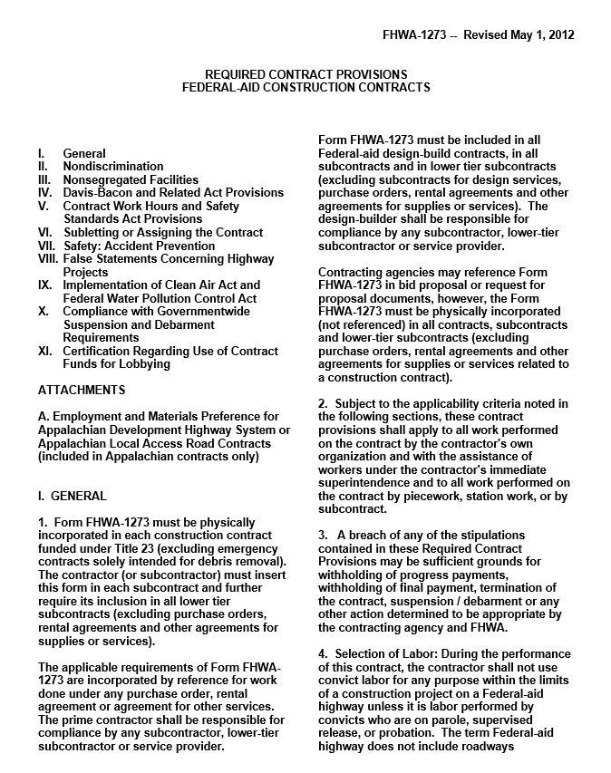
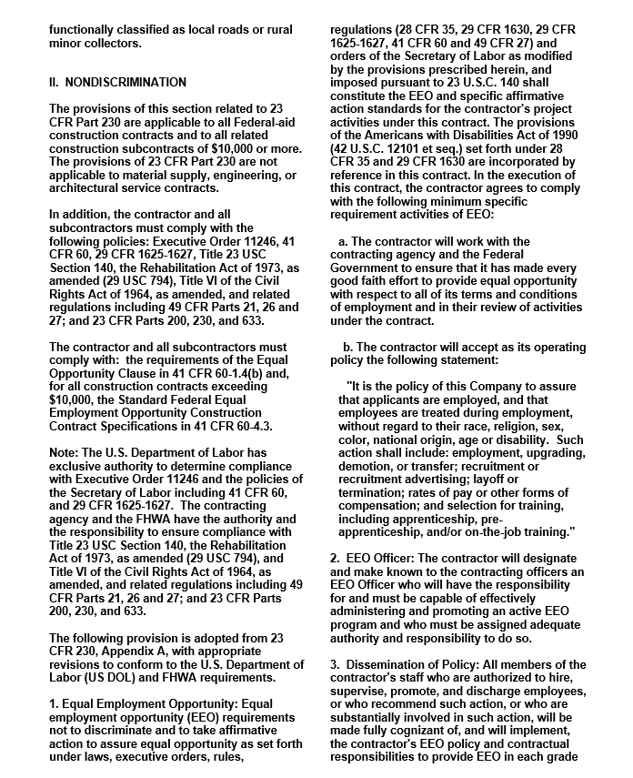

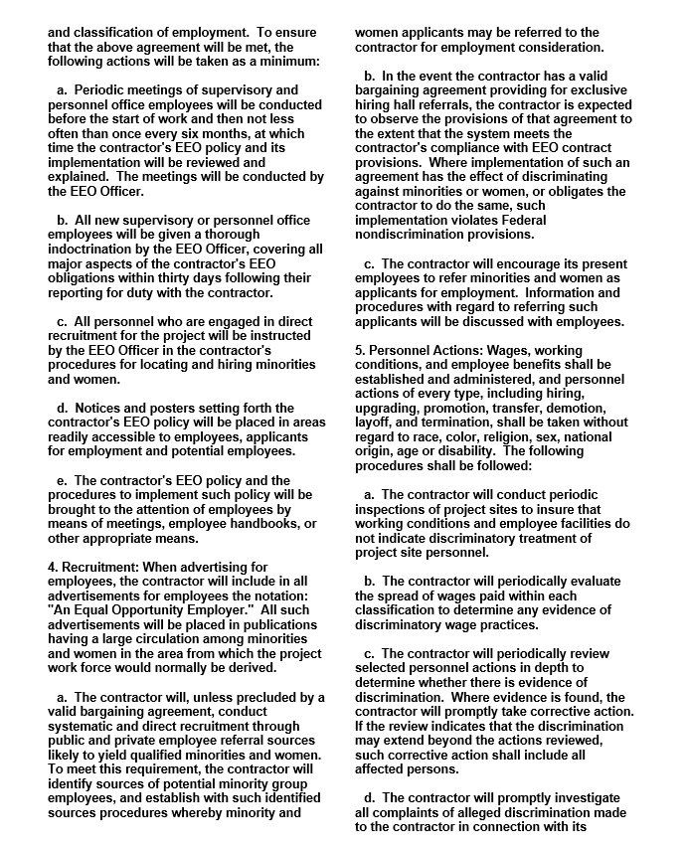

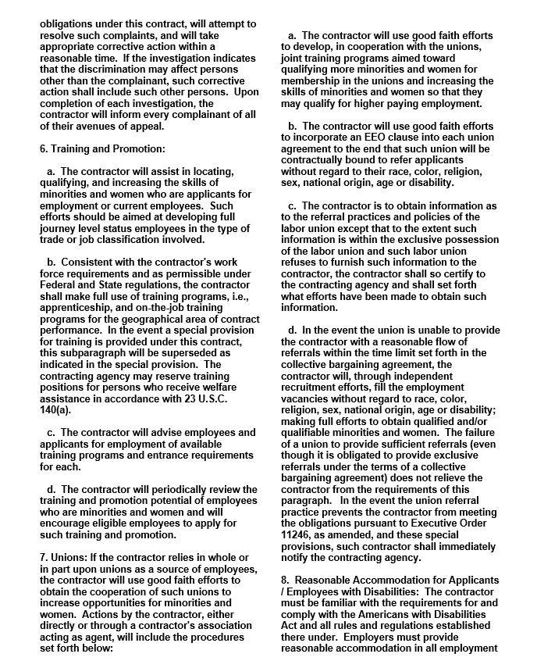

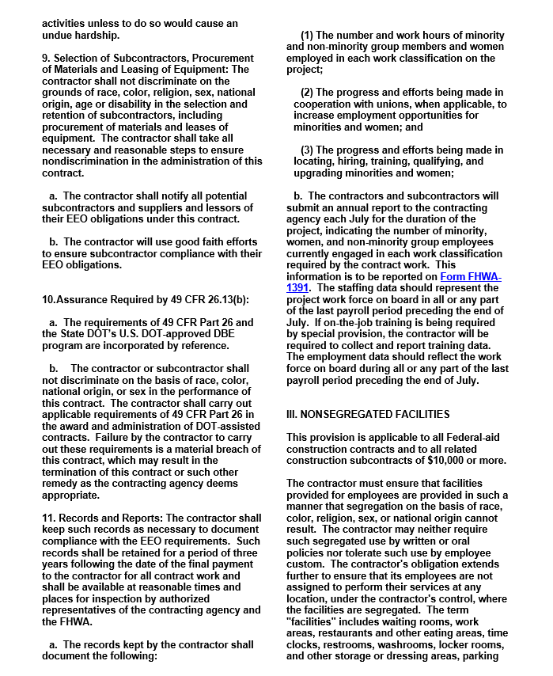

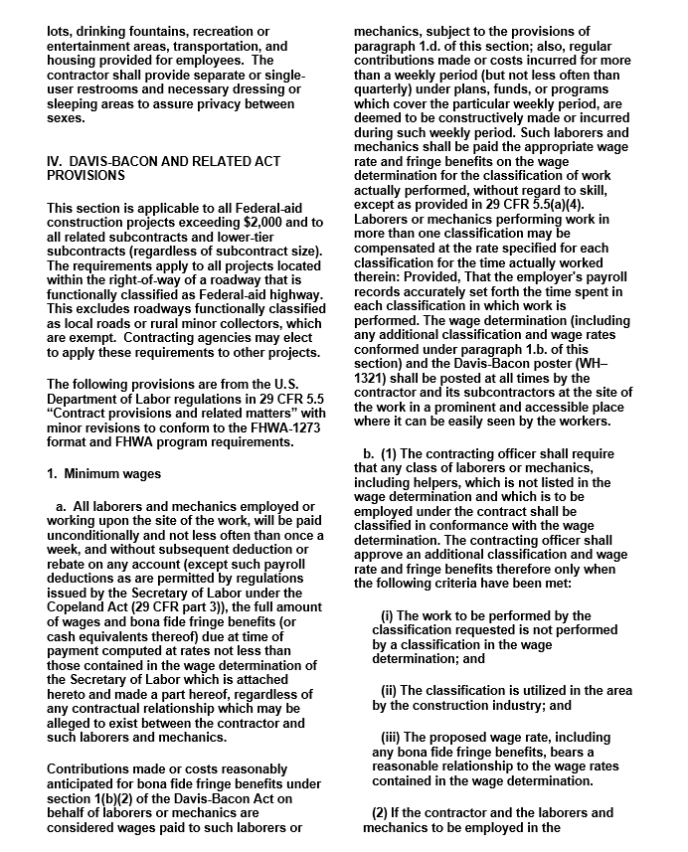

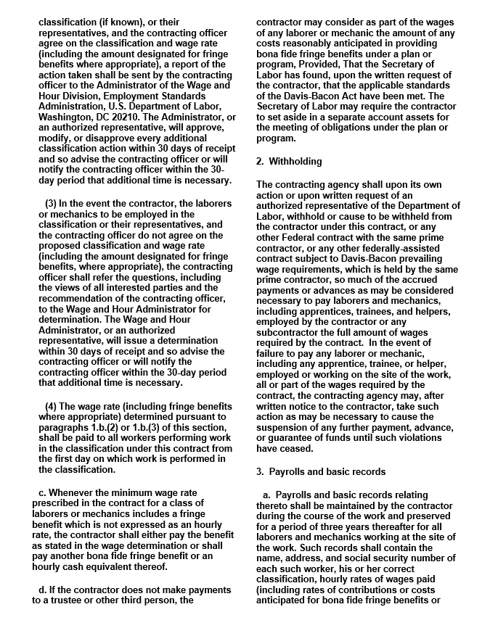

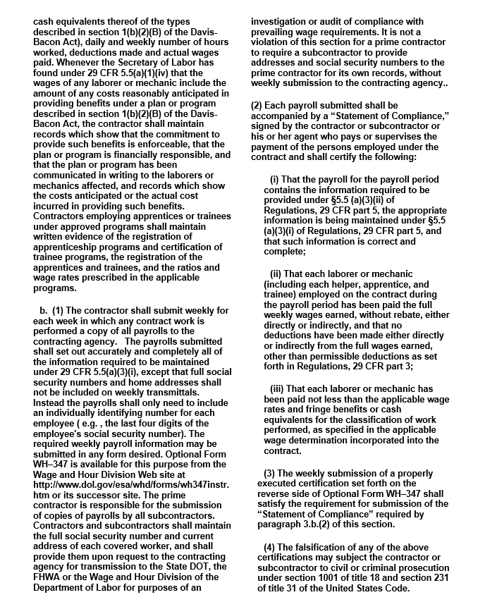

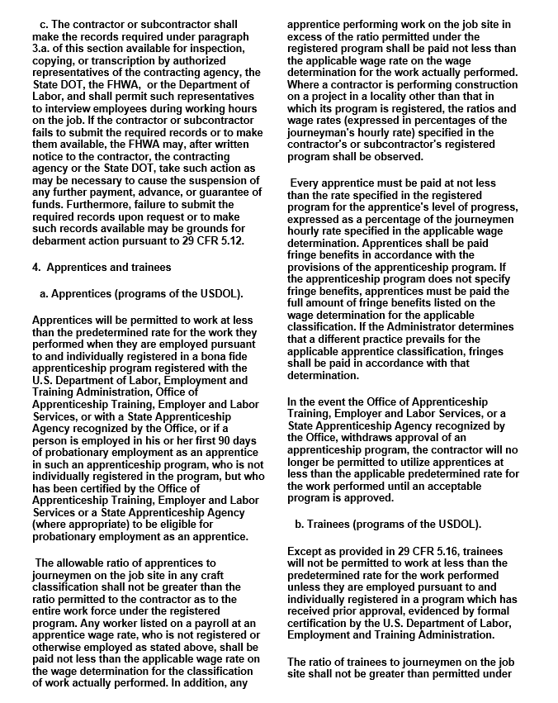

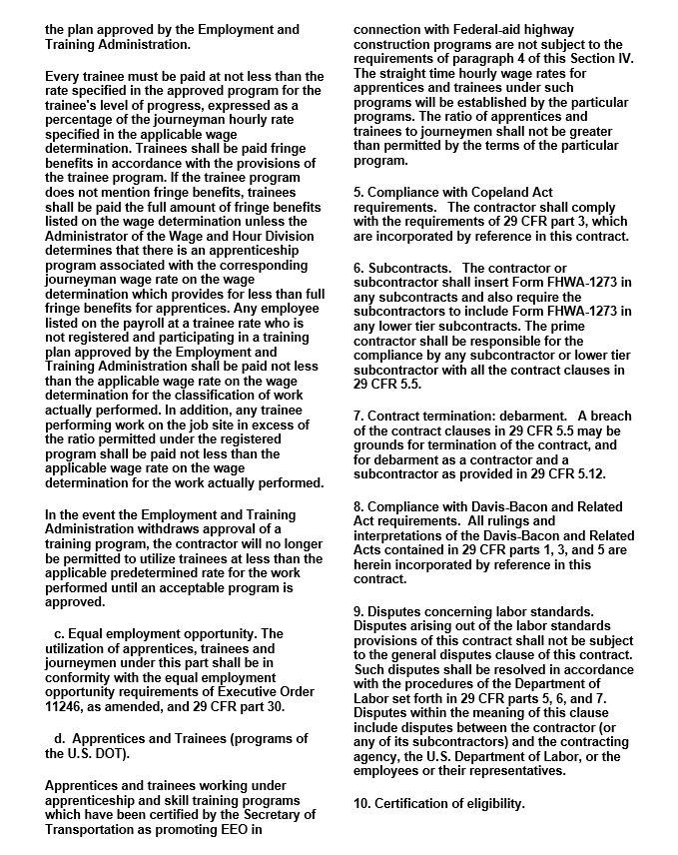

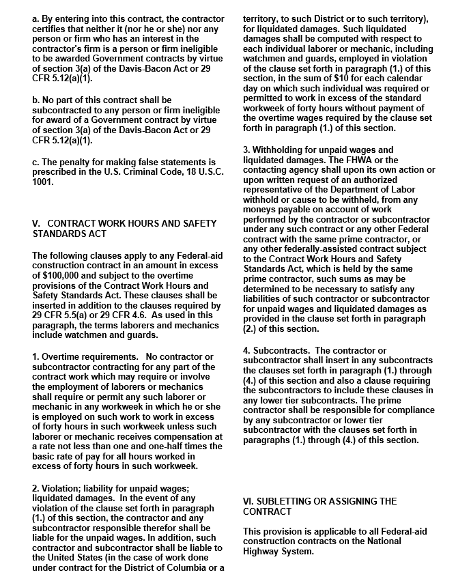

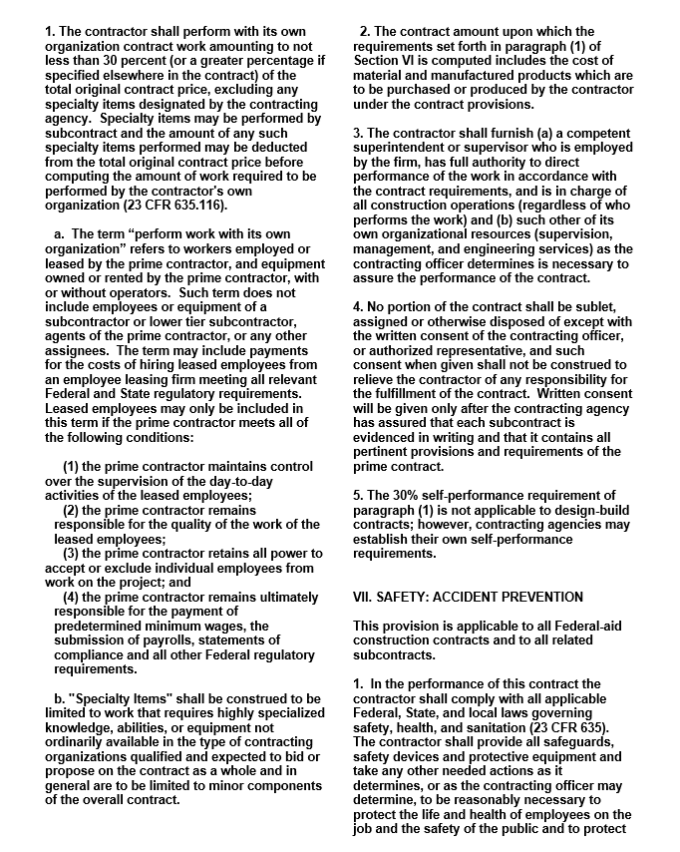

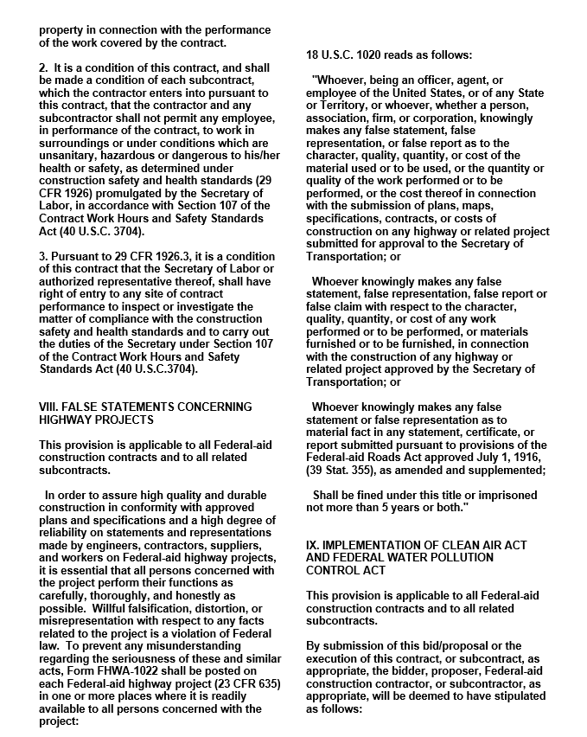

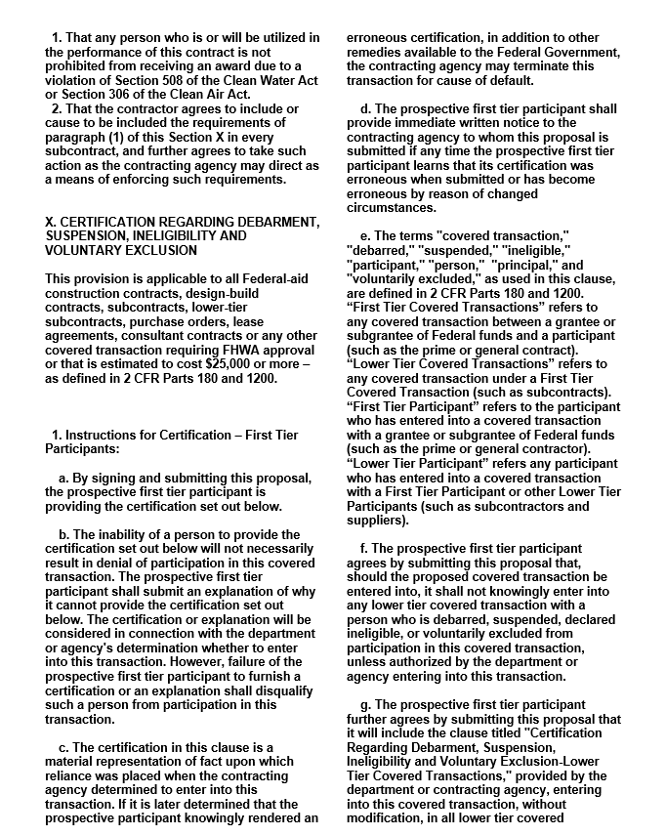

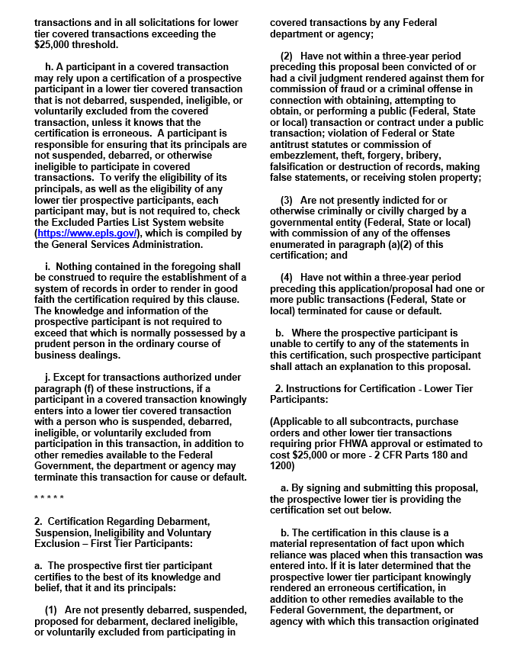

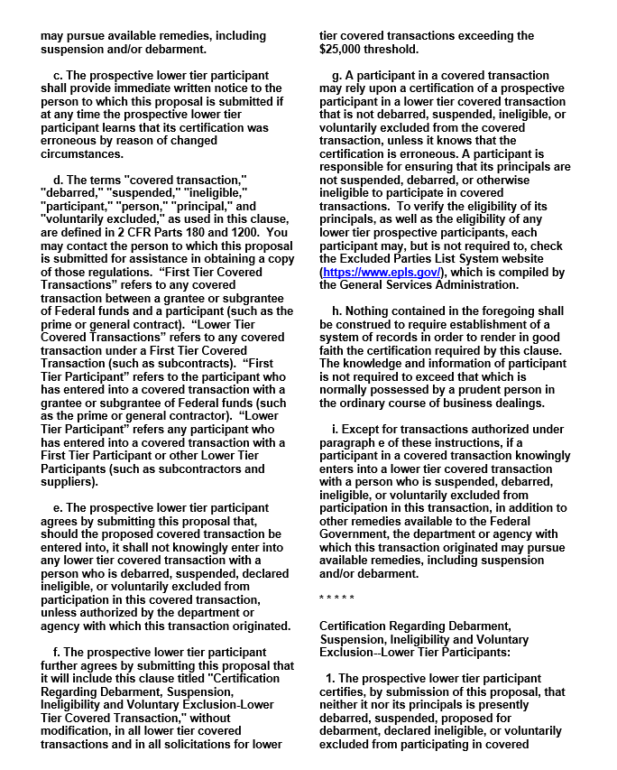

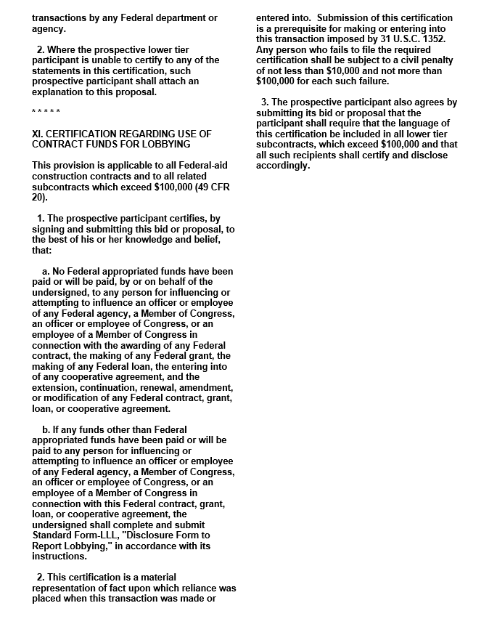

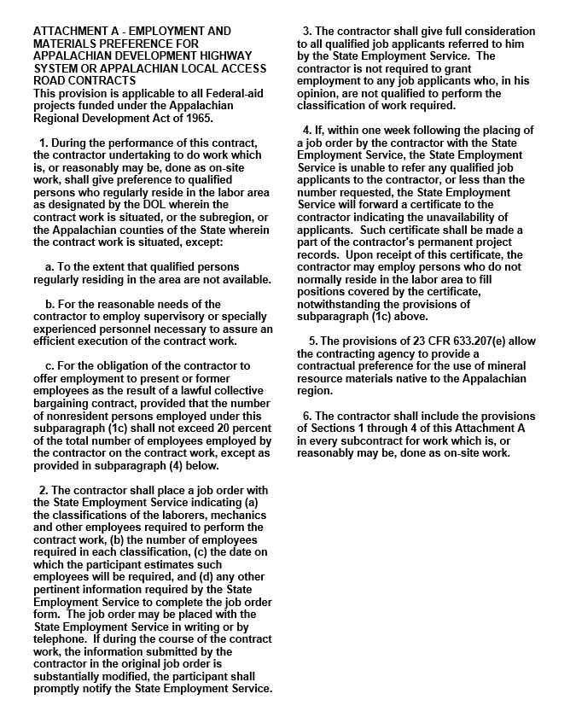

PART III

EMPLOYMENT, WAGE AND RECORD REQUIREMENTS

KENTUCKY TRANSPORTATION CABINET
DEPARTMENT OF HIGHWAYS

EMPLOYMENT REQUIREMENTS
RELATING TO
NONDISCRIMINATION OF EMPLOYEES
(APPLICABLE TO FEDERAL-AID SYSTEM CONTRACTS)

AN ACT OF THE KENTUCKY GENERAL ASSEMBLY
TO PREVENT DISCRIMINATION IN EMPLOYMENT

KRS CHAPTER 344
EFFECTIVE JUNE 16, 1972

The contract on this project, in accordance with KRS Chapter 344, provides that during the performance of this contract, the contractor agrees as follows:
1. The contractor shall not fail or refuse to hire, or shall not discharge any individual, or otherwise discriminate against an individual with respect to his compensation, terms, conditions, or privileges of employment, because of such individual's race, color, religion, national origin, sex, disability or age (between forty and seventy); or limit, segregate, or classify his employees in any way which would deprive or tend to deprive an individual of employment opportunities or otherwise adversely affect his status as an employee, because of such individual's race, color, religion, national origin, sex, disability or age (between forty and seventy). The contractor agrees to post in conspicuous places, available to employees and applicants for employment, notices to be provided setting forth the provisions of this nondiscrimination clause.
2. The contractor shall not print or publish or cause to be printed or published a notice or advertisement relating to employment by such an employer or membership in or any classification or referral for employment by the employment agency, indicating any preference, limitation, specification, or discrimination, based on race, color, religion, national origin, sex, disability or age (between forty and seventy), except that such notice or advertisement may indicate a preference, limitation, or specification based on religion, or national origin when religion, or national origin is a bona fide occupational qualification for employment.
3. If the contractor is in control of apprenticeship or other training or retraining, including on-the-job training programs, he shall not discriminate against an individual because of his race, color, religion, national origin, sex, disability or age (between forty and seventy), in admission to, or employment in any program established to provide apprenticeship or other training.
4. The contractor will send to each labor union or representative of workers with which he has a collective bargaining agreement or other contract or understanding, a notice to be provided advising the said labor union or workers' representative of the contractor's commitments under this section, and shall post copies of the notice in conspicuous places available to employees and applicants for employment. The contractor will take such action with respect to any subcontract or purchase order as the administrating agency may direct as a means of enforcing such provisions, including sanctions for non-compliance.

REVISED: 12-3-92

NOTICE OF REQUIREMENT FOR AFFIRMATIVE ACTION
TO ENSURE EMPLOYMENT OPPORTUNITY
(Executive Order 11246)

            - The Offeror’s or Bidder’s attention is called to the “Equal Opportunity Clause” and the “Standard Federal Equal Employment Specifications” set forth herein.

            - The goals and timetables for minority and female participation, expressed in percentage terms for the Contractor’s aggregate work force in each trade on all construction work in the covered area, are as follows:

GOALS FOR MINORITY GOALS FOR FEMALE
PARTICIPATION PARTICIPATION
IN EACH TRADE EACH TRADE
_______________________________________________________________________________________

6.9%
_______________________________________________________________________________________

These goals are applicable to all Contractor’s construction work (whether or not it is Federal or federally-assisted) performed in the covered area. If the contractor performs construction work in a geographical area located outside of the covered area, it shall apply the goals established for such geographical area where the work is actually performed. With regard to this second area, the contractor also is subject to the goals for both its federally involved and non- federally involved construction.

The Contractor’s compliance with the Executive Order and the regulations in CFR Part 60-4 shall be based on its implementation of the Equal Opportunity Clause, specific affirmation action obligations required by the specifications set forth in 41 CFR 60-4, 3(a), and its efforts to meet the goals. The hours of minority and female employment and training must be substantially uniform throughout the length of the contract, and in each trade, and the contractor shall make a good faith effort to employ minorities and women evenly on each of its projects. The transfer of minority or female employees or trainees from Contractor to Contractor or from project to project for the sole purpose of meeting the Contractor’s goals shall be a violation of the contract, the Executive Order and the regulations in 41 CFR Part 60-4. Compliance with the goals will be measured against the total work hours performed.

            - The Contractor shall provide written notification to the Director of the Office of Federal Contract Compliance Programs within ten (10) working days of award of any construction subcontract in excess of $10,000.00 at any tier for construction work under the contract resulting from the solicitation. The notification shall list the name, address and telephone number of the subcontractor; employer identification number of the subcontractor; estimated dollar amount of the subcontract; estimated starting and completion dates of the subcontract; and the geographical area in which the subcontract is to be performed. The notification shall be mailed to:

Evelyn Teague, Regional Director
Office of Federal Contract Compliance Programs
61 Forsyth Street, SW, Suite 7B75
Atlanta, Georgia 30303-8609

            - As used in this Notice, and in the contract resulting from this solicitation, the “covered area” is XXX County.

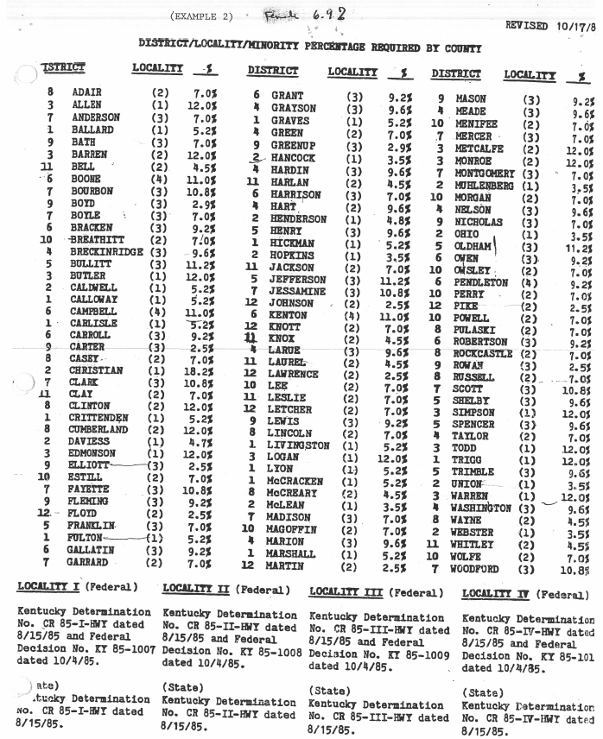
US Department of Labor Final Rule on Federal Executive Order 11246

Discrimination:

Discrimination (because of race, religion, color, national origin, sex, sexual orientation, gender identity, age, or disability) is prohibited. This section applies only to contracts utilizing federal funds, in whole or in part. During the performance of this contract, the contractor agrees as follows:

- The contractor will not discriminate against any employee or applicant for employment because of race, religion, color, national origin, sex, sexual orientation, gender identity, or age. The contractor further agrees to comply with the provisions of the Americans with Disabilities Act (ADA), Public Law 101-336, and applicable federal regulations relating thereto prohibiting discrimination against otherwise qualified disabled individuals under any program or activity. The contractor agrees to provide, upon request, needed reasonable accommodations. The contractor will take affirmative action to ensure that applicants are employed and that employees are treated during employment without regard to their race, religion, color, national origin, sex, sexual orientation, gender identity, age or disability. Such action shall include, but not be limited to the following; employment, upgrading, demotion or transfer; recruitment or recruitment advertising; layoff or termination; rates of pay or other forms of compensations; and selection for training, including apprenticeship. The contractor agrees to post in conspicuous places, available to employees and applicants for employment, notices setting forth the provisions of this non-discrimination clause.

- The contractor will, in all solicitations or advertisements for employees placed by or on behalf of the contractor; state that all qualified applicants will receive consideration for employment without regard to race, religion, color, national origin, sex, sexual orientation, gender identity, age or disability.

- The contractor will send to each labor union or representative of workers with which he has a collective bargaining agreement or other contract or understanding, a notice advising the said labor union or workers' representative of the contractor's commitments under this section, and shall post copies of the notice in conspicuous places available to employees and applicants for employment. The contractor will take such action with respect to any subcontract or purchase order as the administering agency may direct as a means of enforcing such provisions, including sanctions for noncompliance.

- The contractor will comply with all provisions of Executive Order No. 11246 of September 24, 1965 as amended, and of the rules, regulations and relevant orders of the Secretary of Labor.

- The contractor will furnish all information and reports required by Executive Order No. 11246 of September 24, 1965, as amended, and by the rules, regulations and orders of the Secretary of Labor, or pursuant thereto, and will permit access to his books, records and accounts by the administering agency and the Secretary of Labor for purposes of investigation to ascertain compliance with such rules, regulations and orders.

- In the event of the contractor's noncompliance with the nondiscrimination clauses of this contract or with any of the said rules, regulations or orders, this contract may be cancelled, terminated or suspended in whole or in part and the contractor may be declared ineligible for further government contracts or federally-assisted construction contracts in accordance with procedures authorized in Executive Order No. 11246 of September 24, 1965, as amended, and such other sanctions may be imposed and remedies invoked as provided in or as otherwise provided by law.

- The contractor will include the provisions of paragraphs (1) through (7) of section 202 of Executive Order 11246 in every subcontract or purchase order unless exempted by rules, regulations or orders of the Secretary of Labor, issued pursuant to section 204 of Executive Order No.11246 of September 24, 1965, as amended, so that such provisions will be binding upon each subcontractor or vendor. The contractor will take such action with respect to any subcontract or purchase order as the administering agency may direct as a means of enforcing such provisions including sanctions for noncompliance; provided, however, that in the event a contractor becomes involved in, or is threatened with, litigation with a subcontractor or vendor as a result of such direction by the agency, the contractor may request the United States to enter into such litigation to protect the interests of the United States.

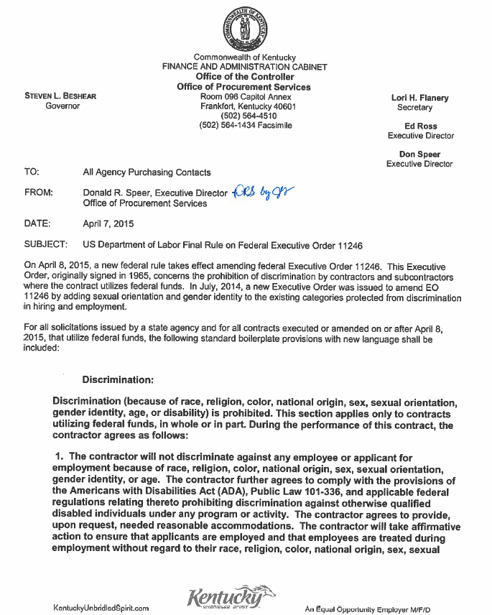

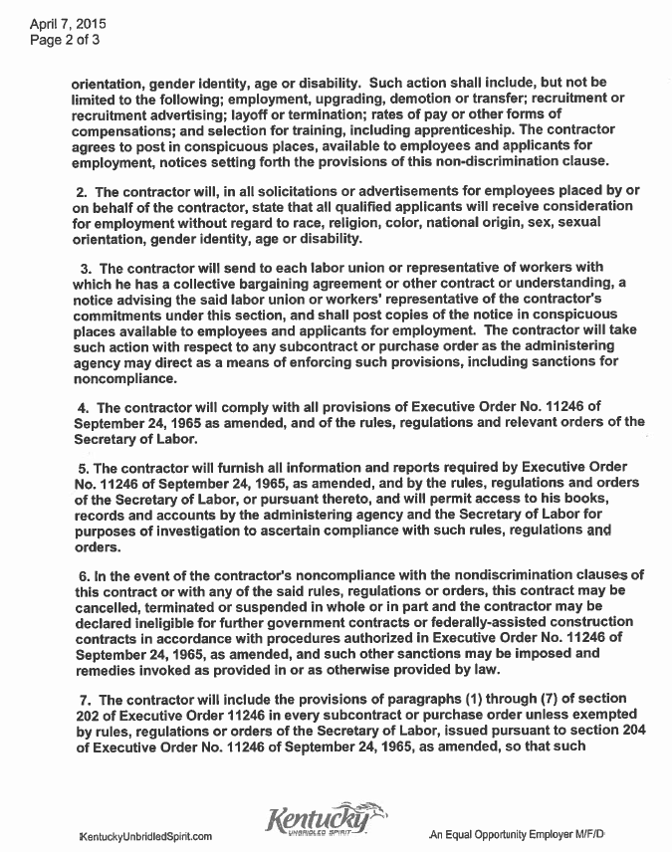

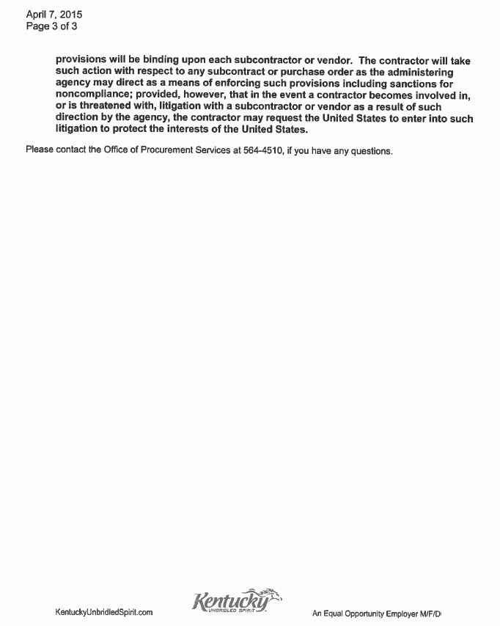

Standard Title VI/Non-Discrimination Assurances
During the performance of this contract, the contractor, for itself, its assignees, and successors in interest (hereinafter referred to as the “contractor”) agrees as follows:
            - Compliance with Regulations: The contractor (hereinafter includes consultants) will comply with the Acts and the Regulations relative to Non-discrimination in Federally-assisted programs of the U.S. Department of Transportation, Federal Highway Administration, as they may be amended from time to time, which are herein incorporated by reference and made a part of this contract.
            - Non-discrimination: The contractor, with regard to the work performed by it during the contract, will not discriminate on the grounds of race, color, or national origin in the selection and retention of subcontractors, including procurements of materials and leases of equipment. The contractor will not participate directly or indirectly in the discrimination prohibited by the Acts and the Regulations, including employment practices when the contract covers any activity, project, or program set forth in Appendix B of 49 CFR Part 21.
            - Solicitations for Subcontracts, Including Procurements of Materials and Equipment: In all solicitations, either by competitive bidding, or negotiation made by the contractor for work to be performed under a subcontract, including procurements of materials, or leases of equipment, each potential subcontractor or supplier will be notified by the contractor of the contractor’s obligations under this contract and the Acts and the Regulations relative to Non-discrimination on the grounds of race, color, or national origin.
            - Information and Reports: The contractor will provide all information and reports required by the Acts, the Regulations, and directives issued pursuant thereto and will permit access to its books, records, accounts, other sources of information, and its facilities as may be determined by the Recipient or the Federal Highway Administration to be pertinent to ascertain compliance with such Acts, Regulations, and instructions. Where any information required of a contractor is in the exclusive possession of another who fails or refuses to furnish the information, the contractor will so certify to the Recipient or the Federal Highway Administration, as appropriate, and will set forth what efforts it has made to obtain the information.
            - Sanctions for Noncompliance: In the event of a contractor’s noncompliance with the Non-discrimination provisions of this contract, the Recipient will impose such contract sanctions as it or the Federal Highway Administration may determine to be appropriate, including, but not limited to:
a. withholding payments to the contractor under the contract until the contractor complies; and/or
b. cancelling, terminating, or suspending a contract, in whole or in part.
            - Incorporation of Provisions: The contractor will include the provisions of paragraphs one through six in every subcontract, including procurements of materials and leases of equipment, unless exempt by the Acts, the Regulations and directives issued pursuant thereto. The contractor will take action with respect to any subcontract or procurement as the Recipient or the Federal Highway Administration may direct as a means of enforcing such provisions including sanctions for noncompliance. Provided, that if the contractor becomes involved in, or is threatened with litigation by a subcontractor, or supplier because of such direction, the contractor may request the Recipient to enter into any litigation to protect the interests of the Recipient. In addition, the contractor may request the United States to enter into the litigation to protect the interests of the United States.

Standard Title VI/Non-Discrimination Statutes and Authorities

During the performance of this contract, the contractor, for itself, its assignees, and successors in interest (hereinafter referred to as the “contractor”) agrees to comply with the following nondiscrimination statutes and authorities; including but not limited to:
- Title VI of the Civil Rights Act of 1964 (42 U.S.C. § 2000d et seq., 78 stat. 252), (prohibits discrimination on the basis of race, color, national origin); and 49 CFR Part 21;
- The Uniform Relocation Assistance and Real Property Acquisition Policies Act of 1970,
(42 U.S.C. § 4601), (prohibits unfair treatment of persons displaced or whose property has been acquired because of Federal or Federal-aid programs and projects);
- Federal-Aid Highway Act of 1973, (23 U.S.C. § 324 et seq.), (prohibits discrimination on the basis of sex);
- Section 504 of the Rehabilitation Act of 1973, (29 U.S.C. § 794 et seq.), as amended, (prohibits discrimination on the basis of disability); and 49 CFR Part 27;
- The Age Discrimination Act of 1975, as amended, (42 U.S.C. § 6101 et seq.), (prohibits discrimination on the basis of age);
- Airport and Airway Improvement Act of 1982, (49 USC § 471, Section 47123), as amended, (prohibits discrimination based on race, creed, color, national origin, or sex);
- The Civil Rights Restoration Act of 1987, (PL 100-209), (Broadened the scope, coverage and applicability of Title VI of the Civil Rights Act of 1964, The Age Discrimination Act of 1975 and Section 504 of the Rehabilitation Act of 1973, by expanding the definition of the terms “programs or activities” to include all of the programs or activities of the Federal-aid recipients, sub-recipients and contractors, whether such programs or activities are Federally funded or not);
- Titles II and III of the Americans with Disabilities Act, which prohibit discrimination on the basis of disability in the operation of public entities, public and private transportation systems, places of public accommodation, and certain testing entities (42 U.S.C. §§ 12131 -- 12189) as implemented by Department of Transportation regulations at 49 C.F.R. parts 37 and 38;
- The Federal Aviation Administration’s Non-discrimination statute (49 U.S.C. § 47123) (prohibits discrimination on the basis of race, color, national origin, and sex);
- Executive Order 12898, Federal Actions to Address Environmental Justice in Minority Populations and Low-Income Populations, which ensures non-discrimination against minority populations by discouraging programs, policies, and activities with disproportionately high and adverse human health or environmental effects on minority and low-income populations;
- Executive Order 13166, Improving Access to Services for Persons with Limited English Proficiency, and resulting agency guidance, national origin discrimination includes discrimination because of limited English proficiency (LEP). To ensure compliance with Title VI, you must take reasonable steps to ensure that LEP persons have meaningful access to your programs (70 Fed. Reg. at 74087 to 74100);
- Title IX of the Education Amendments of 1972, as amended, which prohibits you from discriminating because of sex in education programs or activities (20 U.S.C. 1681 et seq).

Insert Federal Wage Rates

http://www.wdol.gov/

http://www.wdol.gov/dba.aspx

Fringe benefit amounts are applicable for all hours worked except when otherwise noted.
No laborer, workman or mechanic shall be paid at a rate less than that of a Journeyman except those classified as bona fide apprentices.
Apprentices or trainees shall be permitted to work as such subject to Administrative Regulations adopted by the Commissioner of Workplace Standards. Copies of these regulations will be furnished upon request from any interested person.
Before using apprentices on the job the contractor shall present to the Contracting Officer written evidence of registration of such employees in a program of a State apprenticeship and training agency approved and recognized by the U. S. Bureau of Apprenticeship and Training. In the absence of such a State agency, the contractor shall submit evidence of approval and registration by the U. S. Bureau of Apprenticeship and Training.
The contractor shall submit to the Contracting Officer, written evidence of the established apprenticeship-journeyman ratios and wage rates in the project area, which will be the basis for establishing such ratios and rates for the project under the applicable contract provisions.
TO: EMPLOYERS/EMPLOYEES
PREVAILING WAGE SCHEDULE:
The wages indicated on this wage schedule are the least permitted to be paid for the occupations indicated. When an employee works in more than one classification, the employer must record the number of hours worked in each classification at the prescribed hourly base rate.
OVERTIME:
Overtime is to be paid after an employee works eight (8) hours a day or forty (40) hours a week, whichever gives the employee the greater wages. At least time and one-half the base rate is required for all overtime. A laborer, workman or mechanic and an employer may enter into a written agreement or a collective bargaining agreement to work more than eight (8) hours a calendar day but not more than ten (10) hours a calendar day for the straight time hourly rate. Wage violations or questions should be directed to the designated Engineer or the undersigned.

PART IV

CERTIFICATIONS

EXECUTIVE BRANCH CODE OF ETHICS
In the 1992 regular legislative session, the General Assembly passed and Governor Brereton Jones signed Senate Bill 63 (codified as KRS 11A), the Executive Branch Code of Ethics, which states, in part:
KRS 11A.040 (6) provides:
No present or former public servant shall, within six (6) months of following termination of his office or employment, accept employment, compensation or other economic benefit from any person or business that contracts or does business with, or is regulated by, the state in matters in which he was directly involved during the last thirty-six (36) months of his tenure. This provision shall not prohibit an individual from returning to the same business, firm, occupation, or profession in which he was involved prior to taking office or beginning his term of employment, provided that, for a period of six (6) months, he personally refrains from working on any matter in which he was directly involved during the last thirty-six (36) months of his tenure in state government. This subsection shall not prohibit the performance of ministerial functions, including, but not limited to, filing tax returns, filing applications for permits or licenses, or filing incorporation papers, nor shall it prohibit the former officer or public servant from receiving public funds disbursed through entitlement programs.
KRS 11A.040 (8) states:
A former public servant shall not represent a person in a matter before a state agency in which the former public servant was directly involved, for a period of one (1) year after the latter of:
a) The date of leaving office or termination of employment; or
b) The date the term of office expires to which the public servant was elected.
This law is intended to promote public confidence in the integrity of state government and to declare as public policy the idea that state employees should view their work as a public trust and not as a way to obtain private benefits.
If you have worked for the executive branch of state government within the past six months, you may be subject to the law's prohibitions. The law's applicability may be different if you hold elected office or are contemplating representation of another before a state agency.
Also, if you are affiliated with a firm which does business with the state and which employs former state executive-branch employees, you should be aware that the law may apply to them.
In case of doubt, the law permits you to request an advisory opinion from the Executive Branch Ethics Commission, Room 136, Capitol Building, 700 Capitol Avenue, Frankfort, Kentucky 40601; telephone (502) 564-7954.

CERTIFICATION REGARDING
KRS 45A.485
Pursuant to 1994’s Senate Bill 258, the bidder/offeror shall reveal to the Commonwealth, prior to the award of a contract, any final determination of a violation by the contractor within the
previous five (5) year period of the provisions of KRS Chapter 136, 139, 141, 337, 338, 341 and
342.
For the purpose of complying with the provisions of Senate Bill 258, please list any final determination(s) of violations(s) of KRS Chapters 136, 139, 141, 337, 338, 341, and 342, which have been rendered against the bidder or offeror within the five (5) years preceding the award of this contact. Please include, the date of the determination the state agency issuing the determination. (Please use extra sheets if necessary.)

KRS VIOLATION DATE STATE AGENCY

______________________________________________________________________________

______________________________________________________________________________

The contractor is further notified that 1994’s Senate Bill 258 requires that for the duration of this contract, the contractor shall be in continuous compliance with the provisions of KRS Chapters 136, 139, 141, 337, 338, 341 and 342, which apply to the contractor’s operations. Senate Bill 258, further provides that the contractor’s failure to reveal a final determination of a violation of KRS Chapters 136, 139, 141, 337, 338, 341 and 342, or failure to comply with the above-cited statues for the duration of the contact, shall be grounds for the Commonwealth’s cancellation of the contract, and the contractor’s disqualification from eligibility to bid or submit proposals to the Commonwealth for a period of two (2) years.

NON-COLLUSION CERTIFICATION

COMMONWEALTH OF KENTUCKY

COUNTY: _______________

PROJECT NO. _________________

I, ___________________________________________ _______________________under penalty of
(Printed Name of officer signing certification) (Title)
perjury under the laws of the United States, do hereby certify that

__________________________________________________________________________________________
(Name of Individual, Co-Partnership, or Corporation submitting bid)
its agent, officers or employees have not directly or indirectly entered into any agreement, participated in any collusion, or otherwise taken action in restraint of free competitive bidding in connection with this proposal.

__________________________________________________________________________________________
(Signature) (Title) (Date)

---------------------------------------------------------------------------------------------------------------------------------------------------

NON-COLLUSION CERTIFICATION

COMMONWEALTH OF KENTUCKY

COUNTY: _______________

PROJECT NO. _________________

I, ______________________________________ _______________________under penalty of
(Printed Name of officer signing certification) (Title)
perjury under the laws of the United States, do hereby certify that

_________________________________________________________________________________________
(Name of Individual, Co-Partnership, or Corporation submitting bid)
its agent, officers or employees have not directly or indirectly entered into any agreement, participated in any collusion, or otherwise taken action in restraint of free competitive bidding in connection with this proposal.

_________________________________________________________________________________________
(Signature) (Title) (Date)

CERTIFICATION OF ORGANIZATION(S)

COMMONWEALTH OF KENTUCKY

COUNTY: ___________________

PROJECT NO.__________________

I, _____________________________________ _______________________under penalty of
(Printed Name of officer signing certification) (Title)
perjury under the laws of the United States, do hereby certify that, except as noted below,

____________________________________________________________________________________________
(Name of Individual, Co-Partnership, or Corporation submitting bid)

any person associated therewith in the capacity of (owner, partner, director, officer, principal investigator, project director, manager, auditor, or any position involving the Administration of Federal Funds): is not currently under suspension, debarment, voluntary exclusion, or determination of ineligibility by any federal agency; has not been suspended, debarred, voluntarily excluded or determined ineligible by any federal agency within the past 3 years; does not have a proposed debarment pending; and has not been indicted, convicted or had a civil judgment rendered against (it) by a court of competent jurisdiction in any matter involving fraud or official misconduct within the past 3 years.

Please list below any exceptions to the foregoing, to whom it applies, initiating agency and dates of action.

Exceptions:

__________________________________________ _____________________________
(Signature) (Title)

CERTIFICATION OF PERFORMANCE

Certification with regard to the Performance of Previous Contracts or Subcontracts subject to the Equal Opportunity Clause and the filing of Required Reports.

The _______________________________________________, hereby certifies that it __________________ ,
(Name of Individual, Co-Partnership, or Corporation submitting bid)

participated in previous contract or subcontract subject to the equal opportunity clause, as required by
Executive Orders 10925, 11114, or 11246, and that he, filed with the Joint Reporting Committee, the Director
of the Office of Federal Contract Compliance, a Federal Government contracting or administering agency,
or the Former President's Committee on Equal Employment Opportunity, all reports due under the
applicable filing requirements.

__________________________________________________________________
(Name of Individual, Co-Partnership, or Corporation submitting bid)

_________________________________________ _______________________
(Printed Name of officer signing certification) (Title)

_________________________________________ ______________________
(Signature) (Date)

NOTE: The above certification is required by the Equal Employment Opportunity Regulations of the Secretary of Labor (41 CFR 60-1.7(b)(1)), and must be submitted by bidders and proposed subcontractors only in connection with the contracts and subcontracts which are subject to the equal opportunity clause. Contracts and subcontracts which are exempt from the equal opportunity clause are set forth in 41 CFR 60- 1.5. (Generally only contracts or subcontracts of $10,000 or under are exempt.) Currently, Standard Form 100 (EE0-1) is the only report required by the Executive Orders of their implementing regulation. Proposed prime contractors and subcontractors who have participated in a previous contract or subcontract subject to the Executive Orders and have not filed reports should note that 41 CFR 60-1.7(b) (1) prevents the award of contracts and subcontracts unless such contractor submits a report covering the delinquent period or such other period specified by the Federal Highway Administration or by the Director or by the Director, Office of Federal Contract Compliance, U.S. Department of Labor.

CERTIFICATION FOR FEDERAL-AID CONTRACT

The prospective participant certifies, by signing and submitting this bid or proposal, to the best of his or her knowledge and belief, that:
- No Federal appropriated funds have been paid or will be paid, by or on behalf of the undersigned, to any person for influencing or attempting to influence an officer or employee of any Federal agency, a Member of Congress, an officer or employee of Congress, or an employee of a Member of Congress in connection with the awarding of any Federal contract, the making of any Federal grant, the making of any Federal loan, the entering into of any cooperative agreement, and the extension, continuation, renewal, amendment, or modification of any Federal contract, grant, loan, or cooperative agent.

- If any funds other than the Federal appropriated funds have been paid or will be paid to any person for influencing or attempting to influence an officer or employee of any Federal agency, a Member of Congress, an officer or employee of Congress, or an employee of a Member of Congress in connection with this Federal contract, grant, loan, or cooperative agreement, the undersigned shall complete and submit Standard Form-LLL, "Disclosure Form to Report Lobbying," in accordance with its instructions.

This certification is a material representation of fact which reliance was placed when this transaction was made or entered into. Submission of this certification is a prerequisite for making or entering into this transaction imposed by Section 1352, Title 31, U.S. Code. Any person who fails to file the required certification shall be subject to a civil penalty of not less than $10,000 and not more than $100,000 for each such failure.

The prospective participation also agrees by submitting his or her bid proposal that he or she shall require the language of this certification be included in all lower tier subcontracts, which exceed $100,000 and that all such subrecipients shall certify and disclose accordingly.

__________________________________________________________________
(Name of Individual, Co-Partnership, or Corporation submitting bid)

_________________________________________ _______________________
(Printed Name of officer signing certification) (Title)

_________________________________________ ______________________
(Signature) (Date)

CERTIFICATION OF BID PROPOSAL/ DBE

We (I) proposed to furnish all labor, equipment and materials necessary to construct and/or improve the subject project in accordance with the plans, the Transportation Cabinet's Standard Specifications for Road and Bridge Construction 2012 special provisions, notes applicable to the project as indicated herein and all addenda issued on this project subsequent to purchase of proposal.

We (I) attach a bid guaranty as provided in the special provisions in an amount not less than 5% of the total bid. We agree to execute a contract in accordance with this proposal within 15 calendar days after the receipt of the notice of award for the project.

We (I) have examined the site of proposed work, project plans, specifications, special provisions, and notes applicable to the project referred to herein. We understand that the quantities shown herein are estimated quantities subject to increase or decrease as provided in the specifications.

We (I) acknowledge receipt of all addendum(s) (if applicable) and have made necessary revisions to the bid proposal. We have considered all addendum(s) in calculation of the submitted bid and applied the updated bid items, which are included.

"The bidder certifies that it has secured participation by Disadvantaged Business Enterprises (DBE) in the amount of _______ percent of the total value of this contract and that the DBE participation is in compliance with the requirements of 49 CFR 26 and the policies of the Kentucky Transportation Cabinet pertaining to the DBE Program."

____________________________________________________________________
(Name of Individual, Co-Partnership, or Corporation submitting bid)

____________________________________________________________________
(Printed Name of Officer or Authorized Agent and Title)

____________________________________________________________________
(Signature of Officer or Authorized Agent) (Date)

When two or more organizations bid as a joint venture, enter names of each organization and an authorized agent for each organization must sign above.

Contract ID: ___________________

DBE SUB-CONTRACTOR BIDDER LIST

The Department of Transportation Federal Regulations require that the Kentucky Transportation Cabinet provide a bidder list to be maintained in the Office of Personnel Management, Small Business Development Branch (49 CFR 26:11) for each federally funded project awarded.
Project No.__________________
List all quotes/bids received on this project.
DBE (Disadvantaged Business Enterprise) Contractors, Consultants, and Suppliers submitting quotes/bids for this projects:
1.
2.
3.
4.
5.
6.
7.
8.

DBE (Disadvantaged Business Enterprise) Contractors, Consultants, and Suppliers contacted who did NOT submit quotes/bids for this project:
1.
2.
3.
4.
5.
6.
7.
8.

Non-DBE (Disadvantaged Business Enterprise) Contractors, Consultants, and Suppliers submitting quotes/bids for this projects:
1.
2.
3.
4.
5.
6.
7.
8.

If you need additional space, please attach a separate page. If you need assistance regarding this form, please contact Melvin Bynes at (502) 564-3601.

Insert DBE Forms

http://transportation.ky.gov/Organizational-Resources/Forms/TC%2014-35.xlsx

http://transportation.ky.gov/Organizational-Resources/Forms/TC%2014-35.pdf

ANNUAL AFFIDAVIT FOR BIDDERS, OFFERORS, AND CONTRACTORS

Affidavit Effective Date:
Affidavit Expiration Date:
Maximum Length One-Year
REQUIRED AFFIDAVIT FOR BIDDERS, OFFERORS, AND CONTRACTORS PAGE 1 OF 2

FOR BIDS AND CONTRACTS IN GENERAL:

- Each bidder or offeror swears and affirms under penalty of perjury, that to the best of their knowledge:

  - In accordance with KRS 45A.110 and KRS 45A.115, neither the bidder or offeror as defined in KRS 45A.070(6), nor the entity which he/she represents, has knowingly violated any provisions of the campaign finance laws of the Commonwealth of Kentucky; and the award of a contract to the bidder or offeror or the entity which he/she represents will not violate any provisions of the campaign finance laws of the Commonwealth.

  - The bidder or offeror swears and affirms under penalty of perjury that, to the extent required by Kentucky law, the entity bidding, and all subcontractors therein, are aware of the requirements and penalties outlined in KRS 45A.485; have properly disclosed all information required by this statute; and will continue to comply with such requirements for the duration of any contract awarded.

  - The bidder or offeror swears and affirms under penalty of perjury that, to the extent required by Kentucky law, the entity bidding, and its affiliates, are duly registered with the Kentucky Department of Revenue to collect and remit the sales and use tax imposed by KRS Chapter 139, and will remain registered for the duration of any contract awarded.

  - The bidder or offeror swears and affirms under penalty of perjury that the entity bidding is not delinquent on any state taxes or fees owed to the Commonwealth of Kentucky and will remain in good standing for the duration of any contract awarded.

  - The bidder or offeror swears and affirms under penalty of perjury that the entity bidding, is not currently engaged in, and will not for the duration of the contract engage in, the boycott of a person or an entity based in or doing business with a jurisdiction with which Kentucky can enjoy open trade, as defined in Executive Order No. 2018-905.

  - The bidder or offeror swears and affirms that the entity bidding, and all subcontractors therein, have not violated any of the prohibitions set forth in KRS 11A.236 during the previous ten (10) years, and further pledge to abide by the restrictions set forth in such statute for the duration of the contract awarded.

FOR “NON-BID” CONTRACTS (I.E. SOLE-SOURCE; NOT-PRACTICAL OR FEASIBLE TO BID; OR EMERGENCY CONTRACTS, ETC):

- Each contractor further swears and affirms under penalty of perjury, that to the best of their knowledge:

  - In accordance with KRS 121.056, and if this is a non-bid contract, neither the contractor, nor any member of his/her immediate family having an interest of 10% or more in any business entity involved in the performance of any contract awarded, have contributed more than the amount specified in KRS 121.150 to the campaign of the gubernatorial slate elected in the election last preceding the date of contract award.

ANNUAL AFFIDAVIT FOR BIDDERS, OFFERORS, AND CONTRACTORS

REQUIRED AFFIDAVIT FOR BIDDERS, OFFERORS AND CONTRACTORS PAGE 2 OF 2

  - In accordance with KRS 121.330(1) and (2), and if this is a non-bid contract, neither the contractor, nor officers or employees of the contractor or any entity affiliated with the contractor, nor the spouses of officers or employees of the contractor or any entity affiliated with the contractor, have knowingly contributed more than $5,000 in aggregate to the campaign of a candidate elected in the election last preceding the date of contract award that has jurisdiction over this contract award.

  - In accordance with KRS 121.330(3) and (4), and if this is a non-bid contract, to the best of his/her knowledge, neither the contractor, nor any member of his/her immediate family, his/her employer, or his/her employees, or any entity affiliated with any of these entities or individuals, have directly solicited contributions in excess of $30,000 in the aggregate for the campaign of a candidate elected in the election last preceding the date of contract award that has jurisdiction over this contract.

As a duly authorized representative for the bidder, offeror, or contractor, I have fully informed myself regarding the accuracy of all statements made in this affidavit, and acknowledge that the Commonwealth is reasonably relying upon these statements, in making a decision for contract award and any failure to accurately disclose such information may result in contract termination, repayment of funds and other available remedies under law. If the bidder, offeror, or contractor becomes non-compliant with any statements during the affidavit effective period, I will notify the Finance and Administration Cabinet, Office of Procurement Services immediately. I understand that the Commonwealth retains the right to request an updated affidavit at any time.

Signature |  | Printed Name
Title |  | Date

Company Name
Address

Commonwealth of Kentucky Vendor Code (if known)
Subscribed and sworn to before me by
(Affiant) | (Title)

of | this day of ,20 .
(Company Name)
Notary Public
[seal of notary] | My commission expires:

PART V

SPECIFICATIONS AND STANDARD DRAWINGS

ASPHALT MIXTURE
Unless otherwise noted, the LPA estimates the rate of application for all asphalt mixtures to be 110 lbs/sy per inch of depth.
DGA BASE
Unless otherwise noted, the LPA estimates the rate of application for DGA Base to be 115 lbs/sy per inch of depth.
DGA BASE FOR SHOULDERS
Unless otherwise noted, the LPA estimates the rate of application for DGA Base for Shoulders to be 115 lbs/sy per inch of depth. The Department will not measure necessary grading and/or shaping of existing shoulders prior to placing of DGA Base, but shall be incidental to the Contract unit price per ton for DGA Base.
Accept payment at the Contract unit price per ton as full compensation for all labor, materials, equipment, and incidentals for grading and/or shaping of existing shoulders and furnishing, placing, and compacting the DGA Base.
INCIDENTAL SURFACING
The LPA has included in the quantities of asphalt mixtures established in the proposal estimated quantities required for resurfacing or surfacing mailbox turnouts, farm field entrances, residential and commercial entrances, curve widening, ramp gores and tapers, and road and street approaches, as applicable. Pave these areas to the limits as shown on Standard Drawing RPM-110-06 or as directed by the Engineer. In the event signal detectors are present in the intersecting streets or roads, pave the crossroads to the right of way limit or back of the signal detector, whichever is the farthest back of the mainline. Surface or resurface these areas as directed by the Engineer. The LPA will not measure placing and compacting for separate payment but shall be incidental to the Contract unit price for the asphalt mixtures.
OPTION B
Be advised that the Department will control and accept compaction of asphalt mixtures furnished on this project under OPTION B in accordance with Sections 402 and 403.

SPECIAL NOTE

For Tree Removal

XXX County
LPA Project
Item No. X-XXX

NO CLEARING OF TREES 3 INCHES OR GREATER (DIAMETER BREAST
HEIGHT) FROM JUNE 1- JULY 31

If there are any questions regarding this note, please contact David Waldner,
Director, Division of Environmental Analysis, 200 Mero Street, Frankfort, KY
40601, Phone: (502) 564-7250, for District administered projects; or Mike Jones, (502) 564-2060, for Office of Local Programming administered projects.

Special Note for Bridge Demolition, Renovation and Asbestos Abatement

If the project includes any bridge demolition or renovation, the successful bidder is required to notify Kentucky Division for Air Quality (KDAQ) via filing of form (DEP 7036) a minimum of 10 days prior to commencement of any bridge demolition or renovation work.

Any available information regarding possible asbestos containing materials (ACM) on or within bridges to be affected by the project has been included in the bid documents. These are to be included with the Contractor’s notification filed with the KDAQ. If not included in the bid documents, the Department will provide that information to the successful bidder for inclusion in the KDAQ notice as soon as possible. If there are no documents stating otherwise, the bidders should assume there are no asbestos containing materials that will in any way affect the work.

Insert Right-Of-Way Form

http://transportation.ky.gov/Local-Programs/Documents/Right%20of%20Way%20Certification.docx

Insert Utility and Railroad Document

http://transportation.ky.gov/Right-of-Way-and-Utilities/Guidance%20Documents/UR%209047%20Utilities%20and%20Rail%20Certification%20Note.docx

http://transportation.ky.gov/Right-of-Way-and-Utilities/Guidance%20Documents/HSIP%20and%20Maintenance%20Project%20Utilities%20and%20Rail%20Certification%20Note%20(Revised%206-24-16).docm

Insert BMP Materials (if applicable)

Change Order Form

http://transportation.ky.gov/Program-Management/Documents/LPA9%20-%20Attach%205%20-%20District%20Change%20Order%20Form.xlsx

http://transportation.ky.gov/Organizational-Resources/Forms/TC%2020-32.xls

Code of Federal Regulations

Title 23 - Highways
Volume: 1
Date: 2013-04-01
Original Date: 2013-04-01Title: Section 635.109 - Standardized changed condition clauses.
Context: Title 23 - Highways. CHAPTER I - FEDERAL HIGHWAY ADMINISTRATION, DEPARTMENT OF TRANSPORTATION. SUBCHAPTER G - ENGINEERING AND TRAFFIC OPERATIONS. PART 635 - CONSTRUCTION AND MAINTENANCE. Subpart A - Contract Procedures.

§ 635.109 Standardized changed condition clauses.

(a) Except as provided in paragraph (b) of this section, the following changed conditions contract clauses shall be made part of, and incorporated in, each highway construction project approved under 23 U.S.C. 106:

(1) Differing site conditions.

(i) During the progress of the work, if subsurface or latent physical conditions are encountered at the site differing materially from those indicated in the contract or if unknown physical conditions of an unusual nature, differing materially from those ordinarily encountered and generally recognized as inherent in the work provided for in the contract, are encountered at the site, the party discovering such conditions shall promptly notify the other party in writing of the specific differing conditions before the site is disturbed and before the affected work is performed.

(ii) Upon written notification, the engineer will investigate the conditions, and if it is determined that the conditions materially differ and cause an increase or decrease in the cost or time required for the performance of any work under the contract, an adjustment, excluding anticipated profits, will be made and the contract modified in writing accordingly. The engineer will notify the contractor of the determination whether or not an adjustment of the contract is warranted.

(iii) No contract adjustment which results in a benefit to the contractor will be allowed unless the contractor has provided the required written notice.

(iv) No contract adjustment will be allowed under this clause for any effects caused on unchanged work. (This provision may be omitted by the STD's at their option.)

(2) Suspensions of work ordered by the engineer.

(i) If the performance of all or any portion of the work is suspended or delayed by the engineer in writing for an unreasonable period of time (not originally anticipated, customary, or inherent to the construction industry) and the contractor believes that additional compensation and/or contract time is due as a result of such suspension or delay, the contractor shall submit to the engineer in writing a request for adjustment within 7 calendar days of receipt of the notice to resume work. The request shall set forth the reasons and support for such adjustment.

(ii) Upon receipt, the engineer will evaluate the contractor's request. If the engineer agrees that the cost and/or time required for the performance of the contract has increased as a result of such suspension and the suspension was caused by conditions beyond the control of and not the fault of the contractor, its suppliers, or subcontractors at any approved tier, and not caused by weather, the engineer will make an adjustment (excluding profit) and modify the contract in writing accordingly. The contractor will be notified of the engineer's determination whether or not an adjustment of the contract is warranted.
(iii) No contract adjustment will be allowed unless the contractor has submitted the request for adjustment within the time prescribed.

(iv) No contract adjustment will be allowed under this clause to the extent that performance would have been suspended or delayed by any other cause, or for which an adjustment is provided or excluded under any other term or condition of this contract.

(3) Significant changes in the character of work.

(i) The engineer reserves the right to make, in writing, at any time during the work, such changes in quantities and such alterations in the work as are necessary to satisfactorily complete the project. Such changes in quantities and alterations shall not invalidate the contract nor release the surety, and the contractor agrees to perform the work as altered.

(ii) If the alterations or changes in quantities significantly change the character of the work under the contract, whether such alterations or changes are in themselves significant changes to the character of the work or by affecting other work cause such other work to become significantly different in character, an adjustment, excluding anticipated profit, will be made to the contract. The basis for the adjustment shall be agreed upon prior to the performance of the work. If a basis cannot be agreed upon, then an adjustment will be made either for or against the contractor in such amount as the engineer may determine to be fair and equitable.

(iii) If the alterations or changes in quantities do not significantly change the character of the work to be performed under the contract, the altered work will be paid for as provided elsewhere in the contract.

(iv) The term “significant change” shall be construed to apply only to the following circumstances:

- When the character of the work as altered differs materially in kind or nature from that involved or included in the original proposed construction; or
- When a major item of work, as defined elsewhere in the contract, is increased in excess of 125 percent or decreased below 75 percent of the original contract quantity. Any allowance for an increase in quantity shall apply only to that portion in excess of 125 percent of original contract item quantity, or in case of a decrease below 75 percent, to the actual amount of work performed.

(b) The provisions of this section shall be governed by the following:

(1) Where State statute does not permit one or more of the contract clauses included in paragraph (a) of this section, the State statute shall prevail and such clause or clauses need not be made applicable to Federal-aid highway contracts.

(2) Where the State transportation department has developed and implemented one or more of the contract clauses included in paragraph (a) of this section, such clause or clauses, as developed by the State transportation department may be included in Federal-aid highway contracts in lieu of the corresponding clause or clauses in paragraph (a) of this section. The State's action must be pursuant to a specific State statute requiring differing contract conditions clauses. Such State developed clause or clauses, however, must be in conformance with 23 U.S.C., 23 CFR and other applicable Federal statutes and regulations as appropriate and shall be subject to the Division Administrator's approval as part of the PS&E.

(c) In the case of a design-build project, STDs are strongly encouraged to use “suspensions of work ordered by the engineer” clauses, and may consider “differing site condition” clauses and “significant changes in the character of work” clauses which are appropriate for the risk and responsibilities that are shared with the design-builder.

[56 FR 37004, Aug. 2, 1991; 57 FR 10062, Mar. 23, 1992, as amended at 67 FR 75925, Dec. 10, 2002]

Code of Federal Regulations

Title 23 - Highways
Volume: 1
Date: 2013-04-01
Original Date: 2013-04-01Title: Section 635.410 - Buy America requirements.
Context: Title 23 - Highways. CHAPTER I - FEDERAL HIGHWAY ADMINISTRATION, DEPARTMENT OF TRANSPORTATION. SUBCHAPTER G - ENGINEERING AND TRAFFIC OPERATIONS. PART 635 - CONSTRUCTION AND MAINTENANCE. Subpart D - General Material Requirements.

§ 635.410 Buy America requirements.

(a) The provisions of this section shall prevail and be given precedence over any requirements of this subpart which are contrary to this section. However, nothing in this section shall be construed to be contrary to the requirements of § 635.409(a) of this subpart.

(b) No Federal-aid highway construction project is to be authorized for advertisement or otherwise authorized to proceed unless at least one of the following requirements is met:

(1) The project either:

(i) Includes no permanently incorporated steel or iron materials, or
(ii) if steel or iron materials are to be used, all manufacturing processes, including application of a coating, for these materials must occur in the United States. Coating includes all processes which protect or enhance the value of the material to which the coating is applied.

(2) The State has standard contract provisions that require the use of domestic materials and products, including steel and iron materials, to the same or greater extent as the provisions set forth in this section.

(3) The State elects to include alternate bid provisions for foreign and domestic steel and iron materials which comply with the following requirements. Any procedure for obtaining alternate bids based on furnishing foreign steel and iron materials which is acceptable to the Division Administrator may be used. The contract provisions must (i) require all bidders to submit a bid based on furnishing domestic steel and iron materials, and (ii) clearly state that the contract will be awarded to the bidder who submits the lowest total bid based on furnishing domestic steel and iron materials unless such total bid exceeds the lowest total bid based on furnishing foreign steel and iron materials by more than 25 percent.

(4) When steel and iron materials are used in a project, the requirements of this section do not prevent a minimal use of foreign steel and iron materials, if the cost of such materials used does not exceed one-tenth of one percent (0.1 percent) of the total contract cost or $2,500, whichever is greater. For purposes of this paragraph, the cost is that shown to be the value of the steel and iron products as they are delivered to the project.

(c)(1) A State may request a waiver of the provisions of this section if;

(i) The application of those provisions would be inconsistent with the public interest; or
(ii) Steel and iron materials/products are not produced in the United States in sufficient and reasonably available quantities which are of a satisfactory quality.

(2) A request for waiver, accompanied by supporting information, must be submitted in writing to the Regional Federal Highway Administrator (RFHWA) through the FHWA Division Administrator. A request must be submitted sufficiently in advance of the need for the waiver in order to allow time for proper review and action on the request. The RFHWA will have approval authority on the request.

(3) Requests for waivers may be made for specific projects, or for certain materials or products in specific geographic areas, or for combinations of both, depending on the circumstances.

(4) The denial of the request by the RFHWA may be appealed by the State to the Federal Highway Administrator (Administrator), whose action on the request shall be considered administratively final.

(5) A request for a waiver which involves nationwide public interest or availability issues or more than one FHWA region may be submitted by the RFHWA to the Administrator for action.

(6) A request for waiver and an appeal from a denial of a request must include facts and justification to support the granting of the waiver. The FHWA response to a request or appeal will be in writing and made available to the public upon request. Any request for a nationwide waiver and FHWA's action on such a request may be published in the Federal Register for public comment.

(7) In determining whether the waivers described in paragraph (c)(1) of this section will be granted, the FHWA will consider all appropriate factors including, but not limited to, cost, administrative burden, and delay that would be imposed if the provision were not waived.

(d) Standard State and Federal-aid contract procedures may be used to assure compliance with the requirements of this section.

[48 FR 53104, Nov. 25, 1983, as amended at 49 FR 18821, May 3, 1984; 58 FR 38975, July 21, 1993]

Code of Federal Regulations

Title 23 - Highways
Volume: 1
Date: 2011-04-01
Original Date: 2011-04-01Title: Section 635.411 - Material or product selection.
Context: Title 23 - Highways. CHAPTER I - FEDERAL HIGHWAY ADMINISTRATION, DEPARTMENT OF TRANSPORTATION. SUBCHAPTER G - ENGINEERING AND TRAFFIC OPERATIONS. PART 635 - CONSTRUCTION AND MAINTENANCE. Subpart D - General Material Requirements.

§ 635.411 Material or product selection.

(a) Federal funds shall not participate, directly or indirectly, in payment for any premium or royalty on any patented or proprietary material, specification, or process specifically set forth in the plans and specifications for a project, unless:

(1) Such patented or proprietary item is purchased or obtained through competitive bidding with equally suitable unpatented items; or

(2) The State transportation department certifies either that such patented or proprietary item is essential for synchronization with existing highway facilities, or that no equally suitable alternate exists; or

(3) Such patented or proprietary item is used for research or for a distinctive type of construction on relatively short sections of road for experimental purposes.

(b) When there is available for purchase more than one nonpatented, nonproprietary material, semifinished or finished article or product that will fulfill the requirements for an item of work of a project and these available materials or products are judged to be of satisfactory quality and equally acceptable on the basis of engineering analysis and the anticipated prices for the related item(s) of work are estimated to be approximately the same, the PS&E for the project shall either contain or include by reference the specifications for each such material or product that is considered acceptable for incorporation in the work. If the State transportation department wishes to substitute some other acceptable material or product for the material or product designated by the successful bidder or bid as the lowest alternate, and such substitution results in an increase in costs, there will not be Federal-aid participation in any increase in costs.

(c) A State transportation department may require a specific material or product when there are other acceptable materials and products, when such specific choice is approved by the Division Administrator as being in the public interest. When the Division Administrator's approval is not obtained, the item will be nonparticipating unless bidding procedures are used that establish the unit price of each acceptable alternative. In this case Federal-aid participation will be based on the lowest price so established.

(d) Reference in specifications and on plans to single trade name materials will not be approved on Federal-aid contracts.

(e) In the case of a design-build project, the following requirements apply: Federal funds shall not participate, directly or indirectly, in payment for any premium or royalty on any patented or proprietary material, specification, or process specifically set forth in the Request for Proposals document unless the conditions of paragraph (a) of this section are applicable.

[41 FR 36204, Aug. 27, 1976, as amended at 67 FR 75926, Dec. 10, 2002; 71 FR 66454, Nov. 15, 2006]

SPECIFICATIONS REFERENCE

Any reference in the plans or proposal to previous editions of the Standard Specifications for Road and Bridge Construction and Standard Drawings are superseded by Standard Specifications for Road and Bridge Construction, Edition of 2012 and Standard Drawings, Edition of 2012 with the 2012 Revision.

Insert Supplemental Specifications to the Standard Specifications for Road and Bridge Construction, 2012 Edition

The current KYTC Supplemental Specifications can be found through the following link:
http://transportation.ky.gov/Construction/Pages/Kentucky-Standard-Specifications.aspx

PART VI

INSURANCE

INSURANCE

The Contractor shall procure and maintain the following insurance in addition to the insurance required by law:

- Commercial General Liability-Occurrence Form – not less than $2,000,000 General aggregate, $2,000,000 Products & Completed Aggregate, $1,000,000 Personal & Advertising, $1,000,000 each occurrence.

- Automobile Liability – $1,000,000 per accident

- Employers Liability:
a) $100,000 each accident bodily injury
b) $500,000 policy limit bodily injury by disease
c) $100,000 each employee bodily injury by disease

- The insurance required above must be evidenced by a Certificate of Insurance and this Certificate of Insurance must contain one of the following statements:
a) "policy contains no deductible clauses.”
b) "policy contains _________________ (amount) deductible property damage clause
but company will pay claim and collect the deductible from the insured

- KENTUCKY WORKMEN’S COMPENSATION INSURANCE. The contractor shall furnish evidence of coverage of all his employees or give evidence of self-insurance by submitting a copy of a certificate issued by the Workmen’s Compensation Board. The cost of insurance is incidental to all contract items. All subcontractors must meet the same minimum insurance requirements.

PART VII

BID ITEMS

EXAMPLE OF PROPOSED BID ITEMS LIST

Section: 0001 PAVING
LINE | BID CODE | ALT | DESCRIPTION | QUANTITY | UNIT | UNIT PRICE | FP | AMOUNT
0010 | 00001 |  | DGA BASE |  | TON |  | $
0020 | 00100 |  | ASPHALT SEAL AGGREGATE |  | TON |  | $
0030 | 00103 |  | ASPHALT SEAL COAT |  | TON |  | $
0040 | 00221 |  | CL2 ASPH BASE 0.75D PG64-22 |  | TON |  | $
0050 | 00301 |  | CL2 ASPH SURF 0.38D PG64-22 |  | TON |  | $
0060 | 02101 |  | CEM CONC ENT PAVEMENT – 8 IN |  | SQYD |  | $

Section: 0002 ROADWAY
LINE | BID CODE | ALT | DESCRIPTION | QUANTITY | UNIT | UNIT PRICE | FP | AMOUNT
0070 | 01000 |  | PERFORATED PIPE 4 - IN |  | LF |  | $
0080 | 01020 |  | PERF PIPE HEADWALL TY 1-4 IN |  | EACH |  | $
0090 | 01987 |  | DELINEATOR FOR GUARDRAIL BI DIRECTIONAL WHITE |  | EACH |  | $
0100 | 02091 |  | REMOVE PAVEMENT |  | SQYD |  | $
0110 | 02159 |  | TEMP DITCH |  | LF |  | $
0120 | 02160 |  | CLEAN TEMP DITCH |  | LF |  | $
0130 | 02230 |  | EMBANKMENT IN PLACE |  | CUYD |  | $
0140 | 02242 |  | WATER (DUST CONTROL) |  | MGAL |  | $
0150 | 02351 |  | GUARDRAIL-STEEL W BEAM-S FACE |  | LF |  | $
0160 | 02360 |  | GUARDRAIL TERMINAL SECTION NO 1 |  | EACH |  | $
0170 | 02381 |  | REMOVAL GUARDRAIL |  | LF |  | $
0180 | 02432 |  | WITNESS POST |  | EACH |  | $
0190 | 02483 |  | CHANNEL LINING CLASS II |  | TON |  | $
0200 | 02545 |  | CLEARING AND GRUBBING (APPR XX ACRES) |  | LS |  | $
0210 | 02562 |  | TEMPORARY SIGNS |  | SQFT |  | $
0220 | 02565 |  | OBJECT MARKERS TYPE 2 |  | EACH |  | $
0230 | 02585 |  | EDGE KEY |  | LF |  | $
0240 | 02596 |  | FABRIC-GEOTEXTILE TYPE I |  | SQYD |  | $
0250 | 02600 |  | FABRIC GEOTEXTILE TY IV FOR PIPE |  | SQYD |  | $
0260 | 02650 |  | MAINTAIN & CONTROL TRAFFIC |  | LS |  | $
0270 | 02690 |  | SAFELOADING |  | CUYD |  | $
0280 | 02701 |  | TEMP SILT FENCE |  | LF |  | $
0290 | 02704 |  | SILT TRAP TYPE B |  | EACH |  | $
0300 | 02705 |  | SILT TRAP TYPE C |  | EACH |  | $
0310 | 02707 |  | CLEAN SILT TRAP TYPE B |  | EACH |  | $
0320 | 02708 |  | CLEAN SILT TRAP TYPE C |  | EACH |  | $
0330 | 02726 |  | STAKING |  | LS |  | $
0340 | 02731 |  | REMOVE STRUCTURE @ STA XXX+XX |  | LS |  | $
0350 | 05950 |  | EROSION CONTROL BLANKET |  | SQYD |  | $
0360 | 05952 |  | TEMP MULCH |  | SQYD |  | $
0370 | 05953 |  | TEMP SEEDING AND PROTECTION |  | SQYD |  | $
0380 | 05963 |  | INITIAL FERTILIZER |  | TON |  | $
0390 | 05964 |  | 20-10-10 FERTILIZER |  | TON |  | $
0400 | 05985 |  | SEEDING AND PROTECTION |  | SQYD |  | $
0410 | 05992 |  | AGRICULTURAL LIMESTONE |  | TON |  | $
0420 | 06568 |  | PAVE MARKING-THERMO STOP BAR-24 IN |  | LF |  | $
0430 | 20071EC |  | JOINT ADHESIVE (LONGITUDINAL) |  | LF |  | $
0440 | 24540 |  | R/W MONUMENT TYPE 3 |  | EACH |  | $
0450 | 24541 |  | R/W MONUMENT TYPE 3A |  | EACH |  | $
0460 | 24663ED |  | WITNESS R/W MONUMENT TYPE 4 |  | EACH |  | $

Section: 0003 DRAINAGE
LINE | BID CODE | ALT | DESCRIPTION | QUANTITY | UNIT | UNIT PRICE | FP | AMOUNT
00470 | 00440 |  | ENTRANCE PIPE-15 IN |  | LF |  | $
0480 | 00461 |  | CULVERT PIPE-15 IN |  | LF |  | $
0490 | 00462 |  | CULVERT PIPE-18 IN |  | LF |  | $
0500 | 01202 |  | PIPE CULVERT HEADWALL-15 IN |  | EACH |  | $
0510 | 01204 |  | PIPE CULVERT HEADWALL-18 IN |  | EACH |  | $
0520 | 01577 |  | DROP BOX INLET TYPE 14 |  | EACH |  | $
0530 | 01583 |  | DROP BOX INLET-SPECIAL |  | EACH |  | $

Above Sections Total = __________

Section: 0004 DEMOBILIZATION AND/OR MOBILIZATION
LINE | BID CODE | ALT | DESCRIPTION | QUANTITY | UNIT | UNIT PRICE | FP | AMOUNT
0900 | 02550 |  | MOBILIZATION (not more than 5.0% of total bid) |  | LS |  | $
0910 | 02569 |  | DEMOBILIZATION (not less than 1.5% of total bid) |  | LS |  | $

Proposed Bid = _________

