**METHODOLOGY FOR DEVELOPING SOCIOECONOMIC STUDIES FOR KYTC PLANNING**

**Cover Page**

**Title**: Insert specific study type/area

**Subtitle**: Socioeconomic Study

**Date**:

**Author**:

**Analysis**

Agencies should demonstrate meaningful public involvement with all people regardless of race, color, national origin, or income, with respect to development, implementation and enforcement of environmental laws, regulations and policies.

Additionally KYTC works to identify potential populations of the Elderly, Disabled, Limited English Proficiency and Limited Transportation Options that may be impacted in or near the Affected Community (AC) should highway improvements take place in the future.

Examples of these studies include, but are not limited to:

* Corridor Studies
* Traffic Studies
* Small Urban Area Studies
* Feasibility Studies
* Interchange Justification Studies
* Interchange Modification Reports

Affected Communities with potential impacts are determined by locating populations of minority, low-income, elderly, disabled, and limited English proficiency and calculating their percentage in the area relative to a reference community of comparison (COC).

Communities of comparison:

* The county percentage
* Kentucky percentage
* Block groups within reasonable proximity of the study area
* United States
* ADD Region

The demographics of the study area should be defined using block group data accessed via the American Community Survey 5 year data:

* Minority
* Low-income
* Elderly
* Disabled populations
* Limited English Proficiency

**Sample Analysis**

The percentage of persons living below the poverty level in Kentucky (18.60%) is significantly higher than that of the United States (14.90%). Poverty levels in Metcalfe County are slightly lower than that of the state with 16.10% of Metcalfe County residents living below the poverty level. CT 9601 has greater levels of poverty than does the county, state and U.S. with 17.90% of persons living below the poverty level. CT 9603 however has a lower level of poverty than Metcalfe County as a whole and the state, with 13.40% of residents living below the poverty.

**\*\*\*\*The following disclaimer should be included in the document in the Socioeconomic Study methodologies Section:\*\*\*\***

*The methodologies used in this planning document are appropriate for identifying possible areas of concern in small urban areas and potential project corridors.  However, during future phases of project development a more detailed and robust analysis may identify the potential for impacts to low-income and minority populations.*

A map or shapefile of the alternatives will be provided by the consultant or KYTC to the applicable Area Development District (ADD). KYTC, in conjunction with the consultant, will review the ADD data for quality and completeness. The consultant will summarize the information provided by the ADD in the final report. The full Socioeconomic analysis should be placed in an Appendix for reference as necessary.

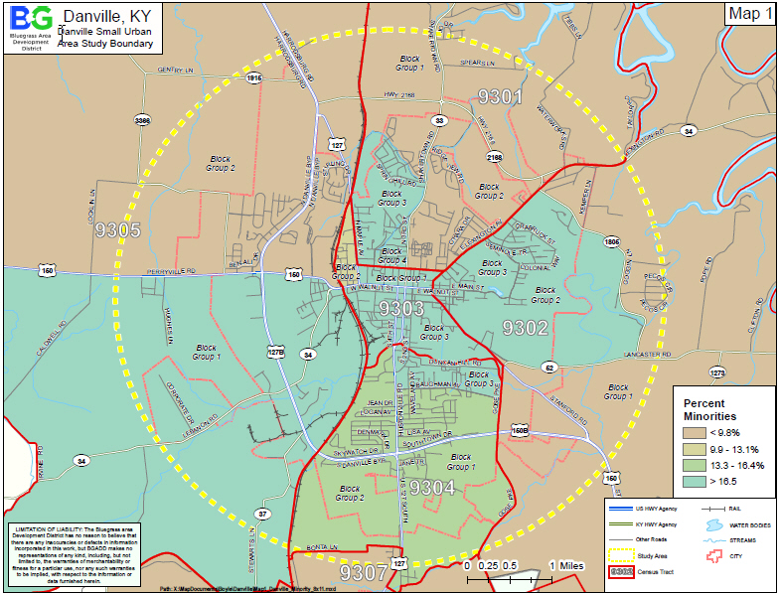Maps should be included with the analysis that depict the project area in relation to the Census tracts and block groups included in the analysis. Maps similar to **Figure 1** should be symbolized utilizing and appropriate range dependent on the relevant data being studied.

**Figure 1**

**Additional Information**

The below information may be beneficial to note for future reference

* Changes due to new residential developments in the area
* Increases in Asian and/or Hispanic populations.
* Concentrations or communities that share a common religious, cultural, ethnic, or other background, e.g., Amish communities.
* Communities or neighborhoods that exhibit a high degree of community cohesion or interaction and the ability to mobilize community actions at the start of community involvement.
* Concentrations of common employment, religious centers, and/or educational

Institutions.

**Tips**

* Only include data that is being analyzed. For instance there is no need to define Block Groups if they are not used. Similarly, Census Tracts should only be referenced as they relate to location of Block Groups discussed.
* Choropleth maps (shaded, color gradation) should be developed based on population percentage.
* One page summary facing the adjacent related map is a functional, readily relatable format.
* At this stage there is no proposed alignment, therefore we can make no assumptions regarding adverse impacts or mitigation efforts to any populations. We can only identify potential locations of Affected Communities.

**Applicable Laws, Acts and Executive Orders**

**Civil Rights Act of 1964, Title VI (42 USC 2000d et seq.)** – This title declares it to be the policy of the United States that discrimination on the grounds of race, color, or national origin shall not occur in connection with programs and activities receiving federal financial assistance, and authorizes and directs the appropriate federal departments and agencies to take action to carry out this policy. The Presidential Memorandum accompanying Executive Order 12898 states that in accordance with this title, each federal agency should ensure that all programs or activities receiving federal financial assistance that affect human health or the environment do not directly, or through contractual or other arrangements, use criteria, methods, or practices that discriminate on the basis of race, color, or national origin.

**Age Discrimination Act of 1975 - 42 U.S.C. 6101**, provides: No person in the United States shall, on the basis of age, be excluded from participation in, be denied the benefits of, or be subjected to discrimination under any program or activity receiving Federal financial assistance.

**Rehabilitation Act of 1973, Section 504 - 42 U.S.C. 794, et seq**., provides: No qualified handicapped person shall, solely by reason of his handicap, be excluded from participation in, be denied the benefits of, be subjected to discrimination under any program or activity that receives or benefits from Federal financial assistance.

**Americans With Disabilities Act of 1990 - 42 U.S.C. 12131, et seq**., provides: No qualified individual with a disability shall, by reason of such disability, be excluded from the participation in, be denied the benefits of, or be subjected to discrimination by a department, agency, special purpose district, or other instrumentality of a State or local government.

**Executive Order #13166** - (Limited-English-Proficiency) directs federal agencies to evaluate services provided and implement a system that ensures that Limited English Proficiency persons are able to meaningfully access the services provided consistent with and without unduly burdening the fundamental mission of each federal agency.

**Socioeconomic Report Checklist**

|  |  |  |  |
| --- | --- | --- | --- |
| COMPLETE | TASK | GUIDANCE | RESOURCES |
|  | Create Cover Page | Study Name; Date; Prepared For; Prepared By | See Example Socioeconomic Reports - Provided by KYTC |
|  | Create Table of Contents | Introduction;; Definitions; Methodology; Census Data Analysis; Study Findings; Census Tract Maps; Census Track Tables; Block Group Maps; Block Group Tables; Conclusion |  |
|  | Introduction | INCLUDE THE FOLLOWING TEXT: *Data for this report comes from the 2014-2018* American Community Survey five-year estimate, using tables, charts and maps. The purpose of the report is to analyze the data and identify potential populations that may be displaced or adversely affected by the recommended improvements proposed in the study. Statistics are provided for minority, elderly, low-income, disabled and limited-English populations for the nation, state, county and Census Tract Block Groups in the project area.* *Use most recent ACS information. ALSO INCLUDE: *The intent of this review is to assist the Kentucky Transportation Cabinet in making informed and prudent transportation decisions in the study area* | <https://www.census.gov/programs-surveys/acs/> |
|  |  |  |  |
|  |  |  |  |
|  | Methodology | The data was collected using the method outlined by the KYTC document “Methodology for Developing Socioeconomic Studies for KYTC Planning” (INCLUDE THIS AS AN APPENDIX). The demographics of the affected area should be defined using U.S. Census Bureau data and the percentages for minority, low-income, elderly, disabled and limited-English populations should be compared to the Census Tracts and Block Groups, the county as a whole, the entire state and the United States. The primary source of data for this report is the 2014-2018* U.S. Census Bureau American Community Survey five-year estimate. Data was drawn from these tables: *• S0101 – Age and Sex • S1811 – Selected Economic Characteristics for the Civilian Noninstitutionalized Population by Disability Status* • B03002 – Hispanic or Latino Origin by Race • B17021 – Poverty Status in the Past 12 Months by Living Arrangement • B16004 – Language spoken at home for population ages 5 or older | KYTC Document:  *"* *METHODOLOGY FOR ASSESSING*  *UNDERSERVED POPULATIONS FOR KYTC PLANNING STUDIES " (Updated March 2025)* |
|  | Census Data Analysis |  | See Example Socioeconomic Reports - Provided by KYTC |
|  | Study Findings |  | See Example Socioeconomic Reports - Provided by KYTC |
|  | Maps; Tables |  | See Example Socioeconomic Reports - Provided by KYTC |
|  | Conclusion |  | See Example Socioeconomic Reports - Provided by KYTC |
|  |  |  |  |