SECTION 1: GENERAL INFORMATION
Bicycle warning signs (W-11-1) and Share the Road supplemental plaques (W16-1) should be installed by the Kentucky Transportation Cabinet where there is a need to warn motorists to watch for bicyclists traveling along the highway. Excessive use of the sign combination should be avoided as proliferation of signs tends to diminish their effectiveness. Requests for such signs should normally come from a municipality or other responsible party (such as a recognized bicycle advisory board or committee). For more information, refer to Traffic Operations Guidance Manual, policy 403-11. |  | 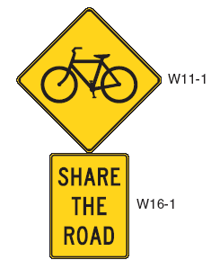
SECTION 2: REQUESTOR INFORMATION
REQUESTING AGENCY/PARTY | DATE
CONTACT NAME | CONTACT PHONE NUMBER
ROUTE(S) NUMBER OR NAME | COUNTY
SECTION 3: SUBMITTAL INSTRUCTIONS
Please include the following attachments:
- Documentation of a significant bicycling demand for the route and a link to organized ride or event information for the route
- Identification of sections of roadway where signs are desired, including specific mile point or marker
Submit completed form and attachments to:
Kentucky Transportation Cabinet
Bicycle & Pedestrian Coordinator
Division of Planning
200 Mero Street
Frankfort, KY 40622
502-782-5060
SECTION 4: FOR DEPARTMENT USE ONLY
Is the roadway on a federal, state-designated, or local bike route?
Are there areas where there are significant changes in the roadway?
Average Daily Traffic for: | MOTOR VEHICLES |  | HEAVY VEHICLES |  |  | BICYCLES
Crash history involving bicycles for the following date range: |  |  |  | FROM |  |  | TO
# OF COLLISIONS: |  | # OF FATALITIES: |  |  | # OF INJURIES:

