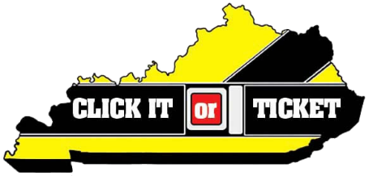
2023 CIOT Talking Points

Law enforcement agencies across the nation are joining together for the annual Click It or Ticket seat belt enforcement mobilization May 22 – June 4.

The campaign, funded by the National Highway Traffic Safety Administration’s (NHTSA), combines increased enforcement with effective communication to road users on the importance of buckling up.

According to NHTSA, motorists are 75 percent less likely to be killed in a rollover crash if buckled up.

A seat belt provides the best chance of preventing injury and death if involved in a crash. Anyone can be involved in a crash at any time, so make buckling up the first thing you do when entering a vehicle.

Proper fit

According to NHTSA, when worn correctly, seat belts are proven to reduce the risk of fatal injury to front-seat occupants by 45 percent and by 60 percent in pickup trucks, SUVs and minivans.

Seat belts fit properly when the lap belt lays across the upper thighs (not the stomach) and the shoulder belt lays across the chest (not the neck).

Properly positioned seat belts spread the crash forces over a wide area of the body, putting less stress on any one part.

Kentucky information

Kentucky has a primary seat belt law. Drivers are responsible for making sure everyone in the vehicle is buckled up and will be fined for each person that is not wearing a seat belt.

Kentucky’s seat belt usage rate increased with the passage of the primary law from 67.2 percent in 2006 to 86.7 percent in 2022.

Even though more people are buckling up, Kentucky experiences far too many deaths which could be avoided with the simple use of a seatbelt.

Of the 744 roadway deaths last year in Kentucky, 512 were occupants of motor vehicles.

Of the 512 killed in motor vehicle crashes, 268 were either not wearing a seat belt or were not properly restrained in a car seat or booster seat.
Children

Seven of the 512 motor vehicle occupants killed in Kentucky in 2022 were children age 9 and under. One of those seven was improperly restrained.

According to NHTSA, motor vehicle crashes are a leading cause of death for children age 1 to 13.

According to NHTSA, child seats are 71 percent effective in reducing infant deaths, 54 percent effective in reducing toddler deaths and 67 percent effective in reducing the need for hospitalization.

According to NHTSA, the use of belt-positioning booster seats lowers the risk of injury to children age 4 to 7 in crashes by 59 percent compared with the use of vehicle seat belts.

Pickup Trucks

Kentucky has a particularly low seat belt usage rate for pickup trucks. Pickup truck drivers and passengers have an 78.3 percent usage rate, compared to passenger car occupants with a 87.6 percent usage rate.

Some pickup truck occupants think they don’t need to wear seat belts because they believe the large vehicle will protect them in a crash; however, no matter the type of vehicle, a seat belt is the most effective way to help prevent injury or death.
Data sources: Kentucky Office of Highway Safety, Kentucky Injury Prevention Research Center and Kentucky Transportation Center.

Nighttime

Because nighttime passenger vehicle occupants are among those least likely to buckle up and most likely to die in crashes when unrestrained, nighttime enforcement has become a priority of the Click It or Ticket mobilization.

Despite the low traffic volume, fatal crashes are three times higher nationwide at nighttime versus daytime.

In Kentucky last year, of the 512 occupants killed in motor vehicle crashes, 220 occurred at night. Of those, 126 were unrestrained.

Law enforcement

Law enforcement personnel frequently see motorists who are injured or killed due to lack of seat belt, child seat or booster seat use.

Click It or Ticket isn’t about the citations; it’s about increased awareness and saving lives. Law enforcement would rather write a ticket than make a death notification.

We’re asking all drivers to make good decisions when behind the wheel. Buckling up is the simplest act you can do to reduce your chance of injury or death.

Local Heroes Click It or Ticket FAQs
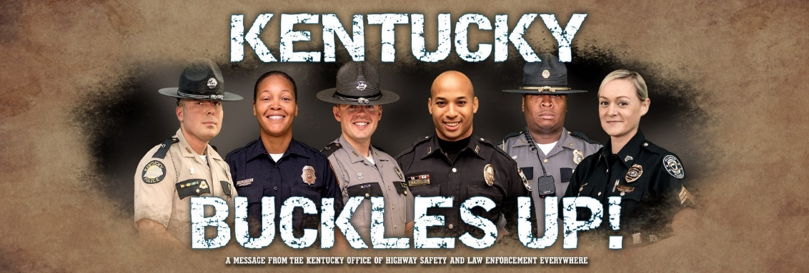
View Click It or Ticket Local Hero videos on the KOHS YouTube page.
What is Local Heroes?
Local Heroes is a multimedia campaign featuring local law enforcement in community-centered TV, radio and social media ads.
Local Heroes is personalized for each county. The goal is to move away from a strict enforcement message and portray local law enforcement as those who care about their community.
Local Heroes complements the existing Click It or Ticket nationwide campaign.
Who is a Local Hero?
Local Heroes enlists law enforcement officers (LEOs) who are well known in their community to produce video, digital and print public service announcements. The goal is to show that the LEOs care about their community and would rather write a seat belt citation than make a death notification.
What counties are targeted for Local Heroes Initiative?
Considerations are given to counties (1) with a low seat belt usage rate, (2) with a high number of collisions involving unrestrained occupants, and/or (3) identified as a seat belt survey county. Statewide English and Spanish versions are also available.

2017 Local Heroes counties (pilot project):
Bourbon
*Clay (updated in 2021)
Greenup
Harrison
Hart
*Henderson (updated in 2022)
*Lincoln (updated in 2023)
*Perry (updated in 2021)
*Pike (updated in 2021)
*Warren (updated in 2022)
2018 Local Heroes counties:
Boyd
*Calloway (updated in 2022)
Floyd
Laurel
Marshall
*McCracken (updated in 2022)
Oldham
*Pulaski (updated in 2023)
*Rowan (updated in 2021)
Shelby

2019 Local Heroes counties: 2020 Local Heroes counties:
Bullitt Clark
Hardin Fayette
*Jefferson (updated in 2023) Franklin
Nelson Jessamine
Spencer Madison
Woodford

2021 Local Heroes counties: 2022 Local Heroes counties:
Bell Barren
Clay Calloway
Knox Daviess
Perry Graves
Pike Grayson
Whitley Henderson
Hopkins
McCracken
Warren

2023 Local Heroes counties:
Anderson
Boyle
Casey
Jefferson
Lincoln
Marion
Pulaski
Washington

