2023 Sample OP-ED
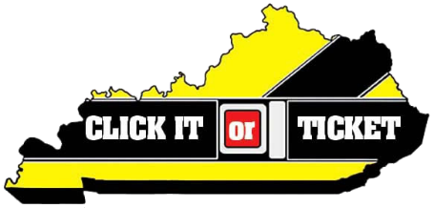

Make it a habit to buckle up!
By: [Local Leader]

Brush teeth, eat breakfast, tie shoes—these are automatic actions taken by millions of Americans every day, often out of habit. Buckling your seat belt should be such an automatic action. In fact, taking two seconds to snap that seat belt should be the automatic next step after sitting down in a vehicle.

Unfortunately, each year in Kentucky, more than 50 percent of those killed on our roadways are unrestrained. Even more horrifying are the children and infants included in this number. They are the youngest victims, and are almost always reliant upon adults to correctly buckle them in to their car seats or boosters.

As law enforcement officers, it is our greatest wish to spread the message about the importance of seat belts, and remind people that the two-seconds it takes to buckle up is the easiest way to reduce your chance of injury or death. That is why [Law enforcement agency] is joining the Kentucky Office of Highway Safety (KOHS), the National Highway Traffic Safety Administration (NHTSA) and law enforcement nationwide for the 2023 Click It or Ticket enforcement mobilization May 22 – June 4.

[Insert city/county stats].

To help spread the message in [county name] we participated in the KOHS Click It or Ticket “Local Heroes” initiative, utilizing actual officers, deputies and Troopers in localized public service announcements. You may view our video here [link to LE agency social media post with video].

We want seat belt use to be an automatic habit for both drivers and passengers. No matter the type of vehicle you’re in or time of day you’re driving, the best way to stay safe is to wear your seat belt – every trip, every time.

According to the KOHS, of the 744 roadway deaths last year in Kentucky, 512 were occupants of motor vehicles. Of those killed in motor vehicle crashes, 268 were either not wearing a seat belt or were not properly restrained in a car seat or booster seat. Seven of the 512 were children age 9 and under. One of the seven was improperly restrained.

This is not a campaign to write tickets or train law enforcement. This is a campaign to help keep people safe and alive. We see the causalities of not buckling up, and we do not wish that devastation on anyone. Believe me—we would rather write a seat belt citation than make a death notification.

Please, buckle up [county/city].

