Click It or Ticket Social Media Messages

Download the static infographics from the Click it or Ticket Traffic Safety Marketing campaign page to include in these posts and tweets.

Instructions and descriptions are in red and should not be posted.

Facebook
1. Don’t leave a loved one behind. Save your life by wearing a seat belt. #BuckleUp #ClickItOrTicket http://ow.ly/HdI73003atl

2. Wearing a seat belt can make all the difference. Don’t wait until ‘next time’, start buckling up now! #ClickItOrTicket http://ow.ly/DdZ43003aVr

3. That pickup truck works a lot better with a seat belt. Don’t wait for a cop to tell you: always #buckleup. #ClickItOrTicket http://ow.ly/qkGl3003b9H

4. You don’t get a second chance in life: that’s why officers make sure you’re buckled up the first time. #ClickItOrTicket http://ow.ly/IR7L3003bfy

5. Did you know? More than half of people killed in crashes at night weren’t wearing a seat belt. Don’t make the night dangerous: #buckleup. #ClickItOrTicket (Insert CIOT Infographics_V2-2c STATIC-01.jpg)

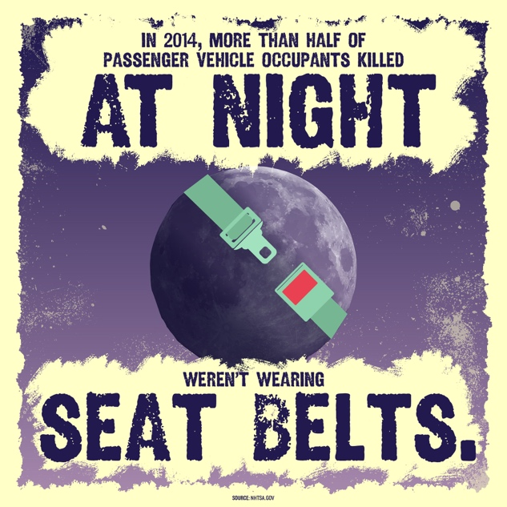

6. Young adults: #BuckleUp! In 2014, 57% of 18 to 34 year olds killed in crashes weren’t buckled up. #ClickItOrTicket (Insert CIOT Infographics_V2-2a STATIC-01.jpg)

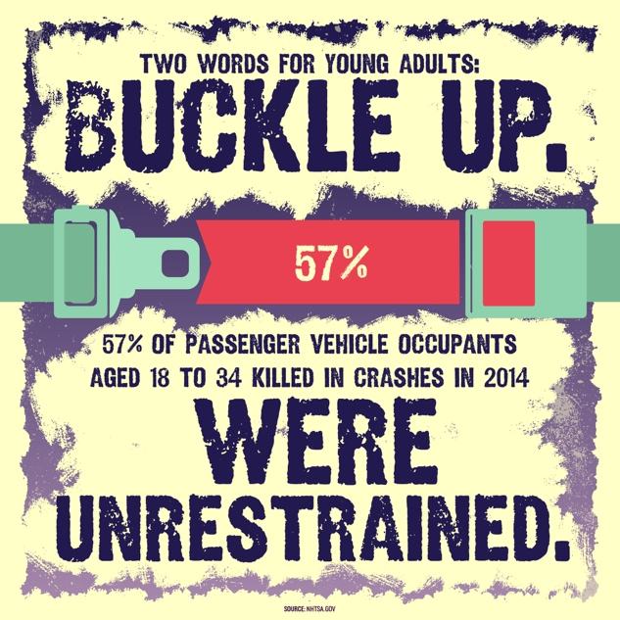

7. A pickup truck isn’t enough to keep you safe: 61% of pickup truck occupants killed in crashes weren’t wearing a seat belt. #ClickItOrTicket (Insert CIOT Infographics_V1d STATIC-01.jpg)

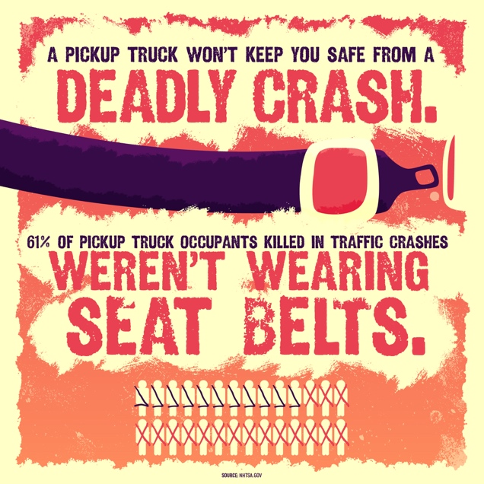

8. Getting killed by an asteroid isn’t likely. Getting killed in a car crash because you’re not wearing a seat belt, however, is very likely. Don’t play the odds: #buckleup. #ClickItOrTicket
http://ow.ly/SPEu300dfYu
9. You have a 98% chance of surviving a shark attack. You only have a 50% chance of surviving a car crash if you’re not wearing a seat belt. #ClickItOrTicket http://ow.ly/pEaU300dg0d

10. What’s more likely: surviving a lighting strike, or surviving a car crash without a seat belt? You might be surprised. Always #buckleup every single time. #ClickItOrTicket http://ow.ly/VZkC300dg3A

11. Would you gamble with your life if the odds of dying were 50/50? That’s what you’re doing when you don’t #buckleup. #ClickItOrTicket http://ow.ly/j4kp300dg4O

Twitter
1. Any drive could be your last. Don’t forget to #buckleup. #ClickItOrTicket http://ow.ly/Dr8U3003aYy

2. Life doesn’t give do-overs. #Buckleup the first time. #ClickItOrTicket http://ow.ly/s2LJ3003b24

3. Seat belts save lives, and cops know it. Don’t forget to #buckleup. #ClickItOrTicket http://ow.ly/8Fde3003bij

4. A pickup truck on its own isn’t as safe as a truck and a seat belt. #ClickItOrTicket http://ow.ly/9zL13003bkp

5. The night can be deadly when it comes to driving. Keep yourself safe and #buckleup. #ClickItOrTicket (Insert CIOT Infographics_V2-2c STATIC-01.jpg)

6. Hey young drivers: be smart and #buckleup. #ClickItOrTicket (Insert CIOT Infographics_V2-2a STATIC-01.jpg)

7. Pickup trucks keep you safest when you’re wearing your seat belt. #ClickItOrTicket (Insert CIOT Infographics_V1d STATIC-01.jpg)

8. Odds of surviving a poisonous snake: 99%. Odds of surviving a car crash without a seat belt: 50%. #ClickItOrTicket http://ow.ly/kE1G300dg6z

9. Don’t play the odds: #buckleup every single ride, every single time. #ClickItOrTicket http://ow.ly/ofkV300dg7V

10. You have a better chance of surviving a lightning strike than you do a crash without a seat belt. #ClickItOrTicket http://ow.ly/TvVF300dga8

11. Skydiving may seem scary and dangerous, but riding around without a seat belt is even more dangerous. #ClickItOrTicket http://ow.ly/hqmi300dgdD
12447a-051716-v1a

