2022 Sample POST Campaign release

FOR IMMEDIATE RELEASE: [Date]
CONTACT: [Name, Phone Number, E-mail address]

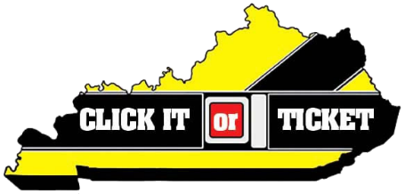

[LE Agency] provides Click It or Ticket results

Campaign to increase seat belt, child seat awareness ran May 23-June 5

[City, State] – [Law enforcement agency] participated in the annual Click It or Ticket high-visibility enforcement effort May 23 – June 5. The campaign, funded by the National Highway Traffic Safety Administration’s (NHTSA), combines increased enforcement with effective communication to road users on the importance of buckling up.

“Utilizing seat belts, child seats and boosters greatly reduces the risk of injury and death if involved in a motor vehicle crash,” said [law enforcement official]. “We believe through our enforcement efforts, lives were saved in [city/county].”

[Insert citation numbers and other citations or arrests made due to increased enforcement]

“Issuing tickets was not our goal; however, we’d rather write a ticket than make a death notification.” said [law enforcement official].

Of the 806 roadway deaths last year in Kentucky, 609 were occupants of motor vehicles. Of those killed in motor vehicle crashes, 333 were either not wearing a seat belt or were not properly restrained in a car seat or booster seat. Twelve of the 609 were children age 9 and under. Four of those twelve were improperly restrained.

[Insert local crash, injury and/or fatality numbers]

According to NHTSA, when worn correctly, seat belts reduce the risk of death by 45 percent for front-seat vehicle occupants and by 60 percent for pickup truck, SUV and minivan occupants.

Also according to NHTSA, child seats are 71 percent effective in reducing infant deaths, 54 percent effective in reducing toddler deaths and 67 percent effective in reducing the need for hospitalization. Additionally, the use of belt-positioning booster seats lowers the risk of injury to children in crashes by 59 percent compared with the use of vehicle seat belts.

For additional information on seat belts, visit https://www.nhtsa.gov/risky-driving/seat-belts. For additional information on child seats and boosters, visit https://www.nhtsa.gov/equipment/car-seats-and-booster-seats.

###

