2021 Sample OP-ED
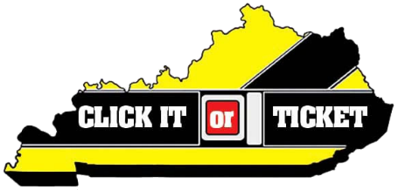

Click It or Ticket: Make seat belt use a daily habit
By: [Local Leader]

Brush teeth, eat breakfast, tie shoes—these are automatic actions taken by millions of Americans every day, often out of habit. Buckling your seat belt should be such an automatic action. In fact, seat belt use should be the automatic next step after sitting down in a vehicle.

Unfortunately, each year in Kentucky, more than 50 percent of those killed on our roadways are unrestrained. Even more horrifying are the children and infants included in this number. They are the youngest victims, and are almost always reliant upon adults to correctly buckle them in to their car seats or boosters.

As law enforcement officers, it is our greatest wish to spread the message about the importance of seat belts, and remind people that the two-seconds it takes to buckle up is the easiest way to reduce your chance of injury or death. That is why [Law enforcement agency] is joining the National Highway Traffic Safety Administration (NHTSA) and law enforcement nationwide for the 2021 Click It or Ticket enforcement mobilization May 24 – June 6.

[Insert city/county stats].

In Kentucky, our overall seat belt usage rate is 89.7 percent. We have a particularly low seat belt usage rate for pickup truck drivers and passengers (83.7 percent). Pickup truck occupants may think that they don’t need to wear seat belts because their large vehicles will protect them in a crash. However, numbers from NHTSA tell the truth: 58 percent of pickup truck occupants who were killed in crashes were not buckled up. That’s compared to 43 percent of passenger car occupants who were unbuckled when they were killed in crashes.

This is not a campaign to write tickets or train law enforcement. This is a campaign to help keep people safe and alive. We see the causalities of not wearing a seat belt, and we do not wish that devastation on anyone. Believe me—we would rather write a seat belt citation than make a death notification.

So please, make it a habit to buckle up the first chance you get, because in real life, we don’t always get a second chance.

Buckle up [county/city].

