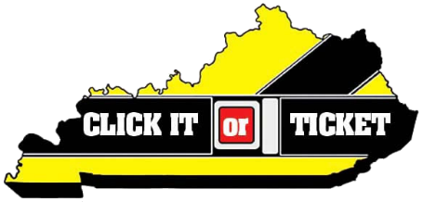
2019 CIOT Talking Points – Memorial Day

Law enforcement agencies across the nation are joining together for the annual Click It or Ticket seat belt enforcement mobilization (May 20 – June 2) through Memorial Day weekend.

The campaign helps bolster seat belt enforcement with traffic safety checkpoints and saturation patrols.

According to the National Highway Traffic Safety Administration (NHTSA), when worn correctly, seat belts are proven to reduce the risk of fatal injury to front-seat occupants by 45 percent and by 60 percent in pickup trucks, SUVs and minivans.

According to NHTSA, motorists are 75 percent less likely to be killed in a rollover crash if buckled up.

Because nighttime passenger vehicle occupants are among those least likely to buckle up and most likely to die in crashes when unrestrained, nighttime enforcement has become a priority of the Click It or Ticket mobilization.

Kentucky seat belt information

Kentucky’s seat belt usage rate increased with the passage of the primary law from 67.2 percent in 2006 to 89.9 percent in 2018.

While the seat belt usage rate increased last year, it is no coincidence that our roadway fatalities decreased from 782 in 2017 to 725 in 2018.

Even though more people are buckling up, Kentucky experiences far too many deaths which could be avoided with the simple use of a seatbelt.

Of the 725 highway fatalities last year in Kentucky, 52.8 percent were not wearing a seat belt.

Drivers are responsible for making sure everyone in the vehicle is buckled up and will be fined for each person that is not wearing a seat belt.

Law enforcement

Click It or Ticket isn’t about the citations; it’s about increased awareness and saving lives.

Police officers see motorists every day who aren’t restrained and who are severely injured or killed because of it. Officers would rather write them a ticket than make a death notification to their family.

We’re asking all drivers to make good decisions when behind the wheel. Buckling up is the simplest thing you can do to reduce your chance of injury or death.

According to NHTSA, car crashes are a leading cause of death for children, so make sure they are properly restrained in a child seat or booster seat.

Anyone can be involved in a crash at any time. Please… always buckle up and make sure your friends and family do the same.

Pickup Trucks

Kentucky has a particularly low seat belt usage rate for pickup trucks. Pickup truck drivers and passengers have an 80.6 percent usage rate, compared to passenger car occupants with a 92.1 percent usage rate.

Some pickup truck occupants think they don’t need to wear seat belts because they believe the large vehicle will protect them in a crash.

No matter the type of vehicle, a seat belt is the most effective way to help prevent injury or death.

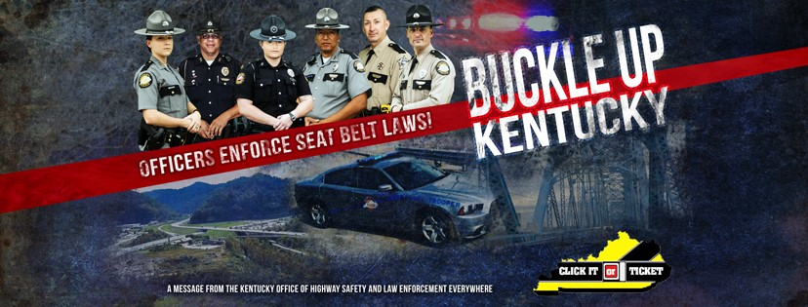
Local Heroes Click It or Ticket FAQs
What is Local Heroes?
Local Heroes is a multimedia campaign featuring local law enforcement in community-centered TV, radio and social media ads.
Local Heroes is personalized for each county. The goal is to move away from a strict enforcement message and portray local law enforcement as those who care about their community.
Local Heroes complements the existing Click It or Ticket nationwide campaign.
Who is a Local Hero?
Local Heroes enlists law enforcement officers (LEOs) who are well known in their community to produce video, digital and print public service announcements. The goal is to show that the LEOs care about their community and would rather write a seat belt citation than make a death notification.
What counties are targeted for Local Heroes Initiative?
The 2017 pilot campaign identified 10 counties with the lowest seat belt usage rate.
The 2018 campaign expanded to include 10 counties with a high number of unrestrained driver at-fault collisions by county of residence, as indicated in the HEAT Map provided by Kentucky Injury Prevention Research Center (KIPRIC).
The 2019 campaign includes three top-tier HEAT map counties and two seat belt usage counties (which are also second-tier HEAT map counties).
A statewide version features Troopers and CVE Officers.

2017 Local Heroes counties:
Bourbon County
Clay County
Greenup County
Harrison County
Hart County
Henderson County
Lincoln County
Perry County
Pike County
Warren County

2018 Local Heroes counties:
Boyd
Calloway
Floyd
Laurel
Marshall
McCracken
Oldham
Pulaski
Rowan
Shelby

2019 Local Heroes counties:
Bullitt County
Hardin County
Jefferson County
Nelson County
Spencer County

