2019 Sample PRE Campaign release

FOR IMMEDIATE RELEASE: [Date]
CONTACT: [Name, Phone Number, E-mail address]

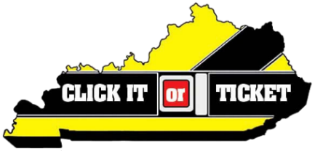
[LE Agency] to participate in ‘Click It or Ticket’ enforcement campaign
Motorists reminded to buckle up, enforcement heightened through Memorial Day

[City, KY] – As the Memorial Day holiday approaches, [local law enforcement agency] is reminding motorists to Click It or Ticket.

The annual campaign is part of the National Highway Traffic Safety Administration’s (NHTSA) high-visibility enforcement effort that runs from May 20 to June 2, 2019. Aimed at increasing seat belt use, the campaign runs concurrent with one of the busiest travel seasons of the year.

“Our law enforcement personnel see firsthand severe injuries or loss of life when people do not buckle up,” said [law enforcement agency spokesperson]. “It’s such a simple act, and hope it becomes the automatic next step for all motorists after sitting down in a vehicle.”

[Insert local numbers]

“If the enforcement crackdown wakes people up to the dangers of unrestrained driving and gets them to buckle up, we’ll consider it a success.”

Of the 725 highway fatalities last year in Kentucky, 52.8 percent were not wearing a seat belt.

“Please, help us spread this life-saving message before one more friend or family member is killed as a result of this senseless inaction,” said [local law enforcement official]. “Seat belts save lives, and everyone—front seat and back, child and adult—needs to remember to buckle up…every trip, every time.”

According to NHTSA, when worn correctly, seat belts reduce the risk of fatalities by 45 percent for front-seat vehicle occupants and by 60 percent for pickup truck, SUV and minivan occupants.

For more on the national Click It or Ticket mobilization, please visit www.nhtsa.gov/ciot.
###

