2019 Sample OP-ED
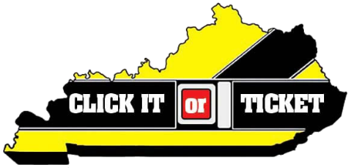

Click It or Ticket: Make seat belt use a daily habit
By: [Local Leader]

Brush teeth, eat breakfast, tie shoes—these are automatic actions taken by millions of Americans every day, often out of habit. Buckling your seat belt should be such an automatic action. In fact, seat belt use should be the automatic next step after sitting down in a vehicle.

From May 20 to June 2 [local law enforcement agency] is joining the National Highway Traffic Safety Administration (NHTSA) and law enforcement agencies nationwide for the 2019 Click It or Ticket enforcement mobilization. No matter where you drive in [county/city] we pay attention to unbuckled drivers and passengers.

Why the month of May? Memorial Day weekend kicks off the busy summer season, with many more families on the roads. We have found this to be the most effective time to remind drivers why seat belt laws matter—they help save lives.

Of the 725 highway fatalities last year in Kentucky, 52.8 percent were not wearing a seat belt.

[Insert city/county stats].

In Kentucky, our overall seat belt usage rate is 89.9 percent. We have a particularly low seat belt usage rate for pickup truck drivers and passengers (80.6 percent). Pickup truck occupants think that they don’t need to wear seat belts because their large vehicles will protect them in a crash. However, numbers from NHTSA tell the truth: 59 percent of pickup truck occupants who were killed in crashes were not buckled up. That’s compared to 42 percent of passenger car occupants who were unbuckled when they were killed in crashes.

This is not a campaign to write tickets or train law enforcement. This is a campaign to help keep people safe and alive. We see the causalities of not wearing a seat belt, and we do not wish that devastation on anyone. Believe me—we would rather write a seat belt citation than make a death notification.

So please, make it a habit to buckle up the first chance you get, because in real life, we don’t always get a second chance.

Buckle up [county/city]. Click It or Ticket!

