Rinex Conversion from Trimble format for OPUS submittal
1.Download and install Trimble's latest version of Convert to RINEX:
http://www.trimble.com/trimblerinex_ts.asp

2. Then before running it, download and install their Configuration Utility:
"The Trimble Configuration Utility from January 25, 2007 (or later) must be used prior to operation of this utility."
http://www.trimble.com/trimbleconfiguration_ts.asp

3. Run "Convert To RINEX", click Tools, and select Options.

4. Under Options, set Format to RINEX v2.10

5. One site recommended to also Check the "Log only GPS observations." I tried it both ways, once with this checked and once with it not checked. Both times I got a solution from OPUS.

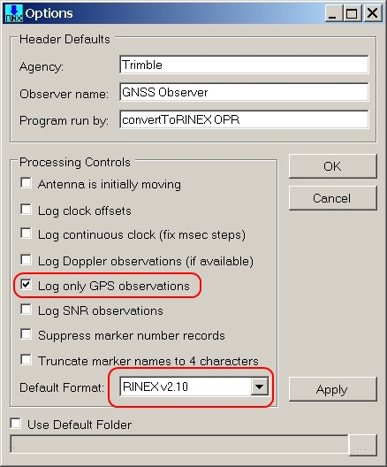

So, update the conversion software, run the configuration utility, and select RINEX v2.10.

