.

**About this Write Up**

This workflow is to explain the process of getting a ORD Alignment XML file from ORD to the Trimble TSC7 controller.

**Perry Semones produced this workflow**

Please send all questions, errors or overall complaints to [KYTCCaddSupport@ky.gov](mailto:KYTCCaddSupport@ky.gov) or call 502-564-3280. Produced on November 5, 2021

You will need ORD and Trimble Business Center to use with this Document

Open ORD, go to Geometry Tab and then click on Import Geometry as shown:

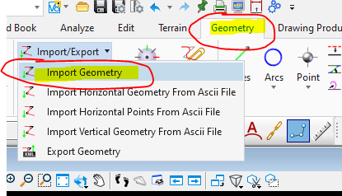

Next, find your file that you want to import. In this case, it is called Geometry.ALG. Click on that.

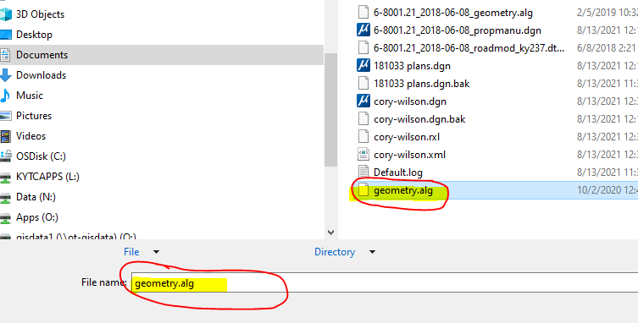

Then this box will open. Put a check mark next to Alignment. By doing this, you will get all Centerlines that are part of the ALG file. For now, leave everything else as is.  Then click on Import.

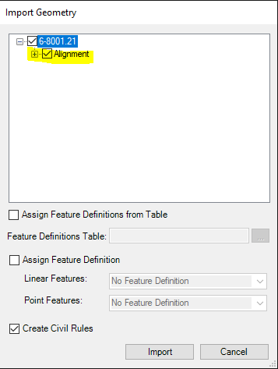

You may see multiple alignments come up on the screen but we are just going to use the Main Center Line. You would use the same procedure for other alignments as well.

The alignment should now be on the screen. At this point, click on and highlight the alignment you want exported. if you don’t do this step, the saved file may not contain any data.

Then go back to the Geometry Tab, and click on Export Geometry. Just click thru the default options. Be sure to follow the command prompt for this part of it.

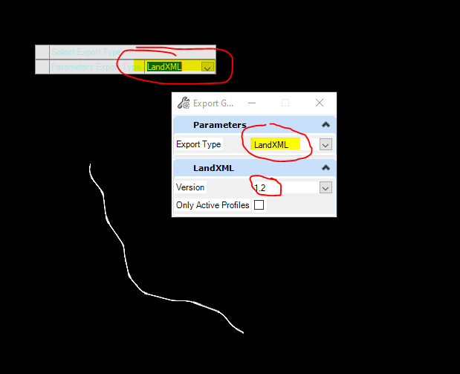

There is another option at this point but we will stick with this for now. You need to have Trimble Business Center open from here.

Next, we need to bring the file into TBC to get the file we need to download into the TSC7 controller. The final file will have a rxl extension.

Inside TBC, go to Home Tab >Import

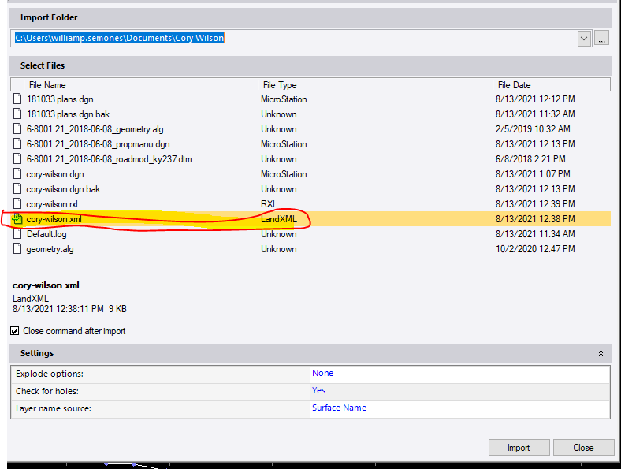

After selecting the correct LandXML file, click on Import at the bottom right hand corner.

Upon Import, the Alignment should now be on the screen.

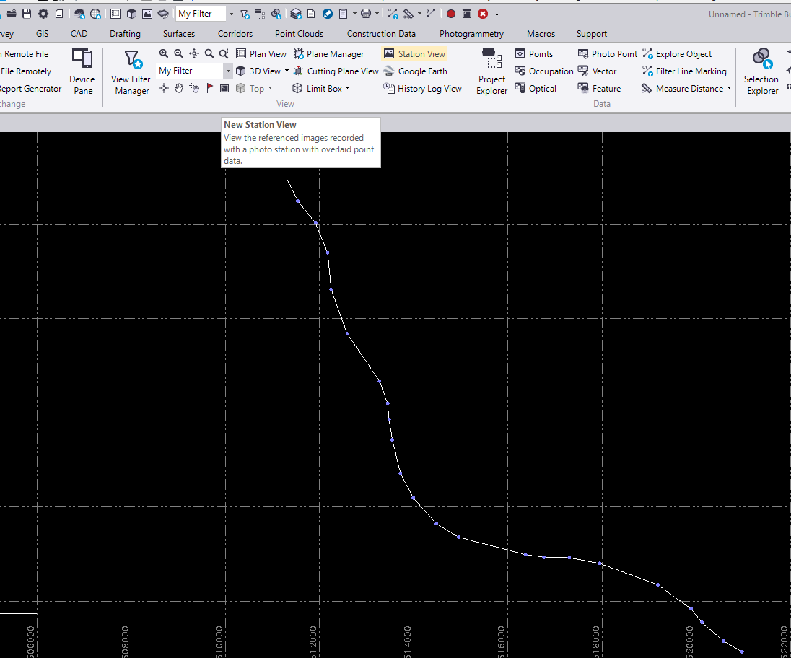Now, to get the RXL file we need. Go to Home Tab and the click on Export. This box will appear. Click on Corridor, then RXL Alignment option, and then give it a road name. Click on pull down on Horizontal Alignment. Pick your Horizontal Alignment from the list. The vertical that is associated with the Horizontal will fill in automatically and if you do not need a vertical, just select none. Be sure to give it a filename and to do that, click on the 3 little dots over to the right side of the screen as shown by arrow. Click those dots and place the file where you want it.

r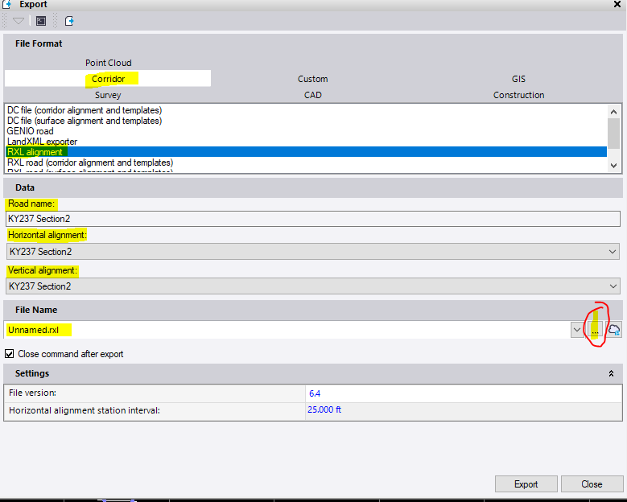

You should now have a RXL file to be loaded inside the Trimble TSC7 Controller. It should be placed under the Project File inside of the Projects folder.

