About this Write Up
This workflow is to explain the process of getting a Surface XML file from ORD to the Trimble TSC7 controller.

Contact Information
Perry Semones produced this workflow. Please send all questions, errors or overall complaints to KYTCCaddSupport@ky.gov or call 502-564-3280. Produced on November 5, 2021.

This document assumes that the user already has a surface created inside of ORD and that the surface is the active surface inside od ORD.

This is what the survey site looks like in ORD.
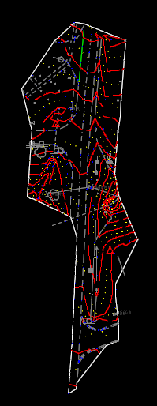

. From inside of ORD, using the Survey Workspace, click on the Exploer Folder

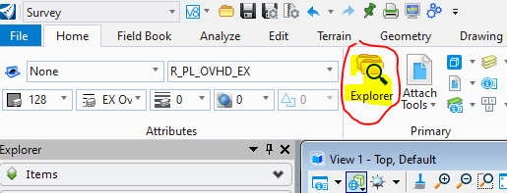

Next, navigate to the Survey Tab as shown below. Highlight the “Red Cross Elem” folder that contains the active Surface name.
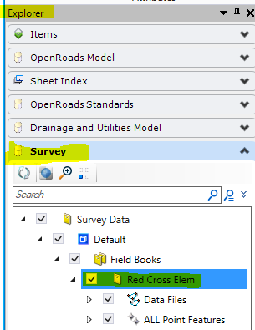

Right click mouse on the highlighted field.
Next, navigate to the “LandXML Format and click on it.

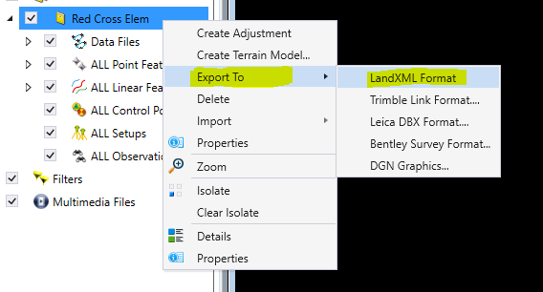

You will see a dialog box as shown below on where you want to save the xml file. The “Save as Type” should come up automatically.

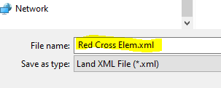
After you do this, you should have a Red Cross Elem.xml saved on your hard drive

Note: At this point, you now have a xml file that you can now load into the TSC3 or TSC7. The main reason for going thru TBC is if your file is very large, you will want to process it in TBC because it will cut the file size down to a more manageable size. The TSC7 should be able to handle large file sizes but the TSC3 will not. DTM File size can bog down the TSC3 controller to render it almost useless. In this example, the xml file size is very small so it may not require going thru TBC. However, I still want to run thru that process.
The next few steps will require the user to have Trimble Business Center. Again, these steps are only needed if the xml files size are very large.

Start Trimble Business Center.
Pick New Project as shown below.
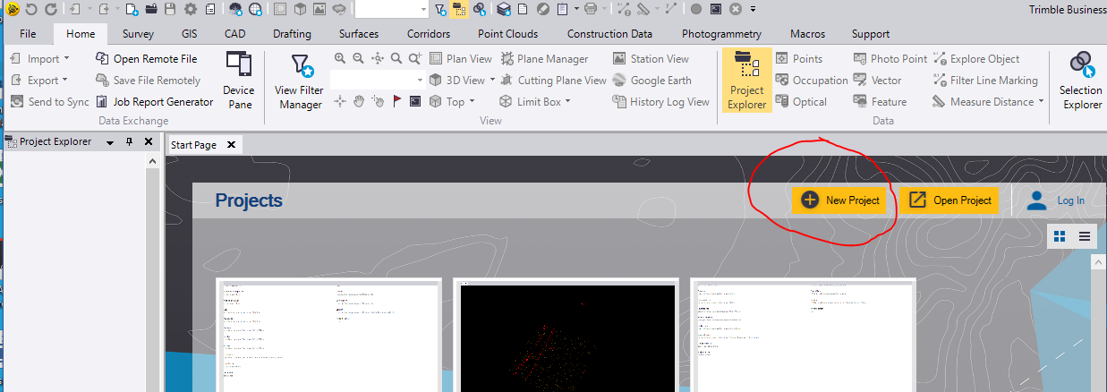

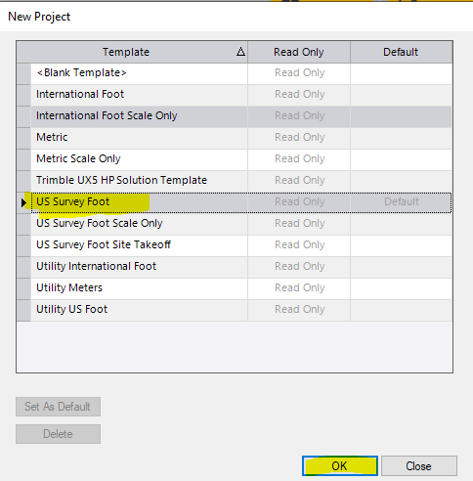
Choose US Survey Foot then click OK

Before the xml file is brought into TBC, be sure to setup the Coordinate System first. You can do it after the fact, but I recommend doing this before any data is brought into TBC.
Click on the “cog” as shown on the TBC menu.
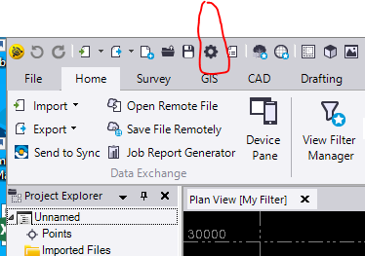

This is the Project Settings Dialog Box. Click on OK.
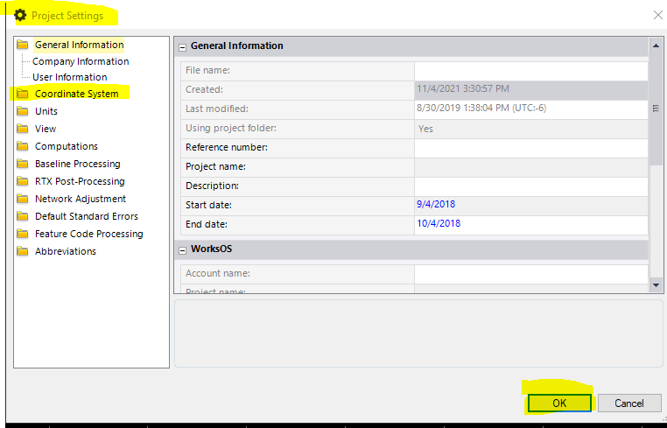

Click on the Coordinate System folder. This dialog will appear. Then click on the Change button as shown below.
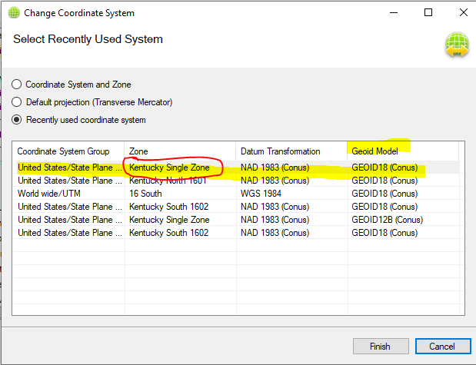
After you click on Finish, you will see all of The Coordinate information filled in as shown below. Double check everything before proceeding. If all the information looks good, then click on OK in the bottom right hand corner.
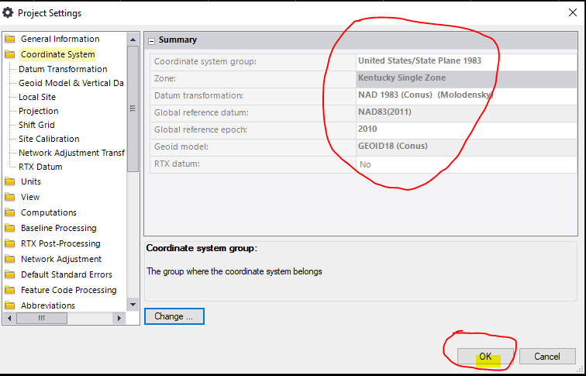
Now we are ready to import that xml file that contains the surface we exported from ORD.
Inside TBC, click on the Import button in the upper left corner.

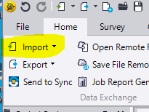
Next, navigate to where you stored the surface xml file. Remember, it is called Red Cross Elem25.xml as shown below. I saved mine in the Documents folder.

Pick the appropriate file. Leave the options that are circled in red as they are. Click on the three dots that are shown with red arrow. They can be hard to see. This allows you to navigate to where you put the xml file. Then click on Import in the bottom right corner.
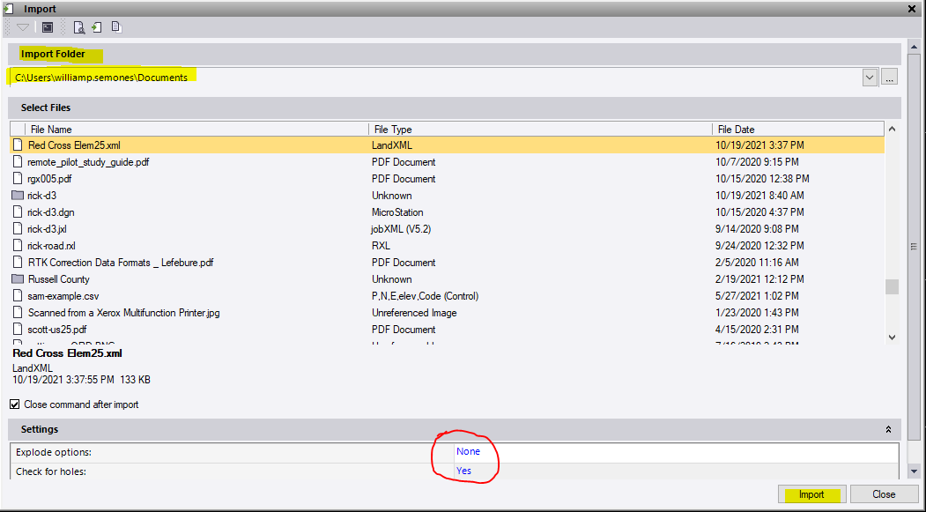

After you click Import, you will have the following dialog come up:
Since our surface is made up of Triangles “built” by the field survey, I will choose the Option that as shown below. Then Click on Import.
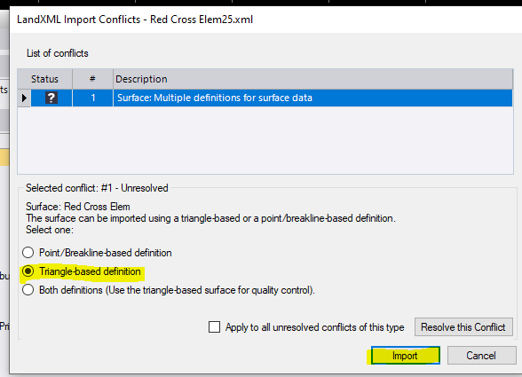

Now, we can see the triangles that were produced in ORD are now inside of TBC
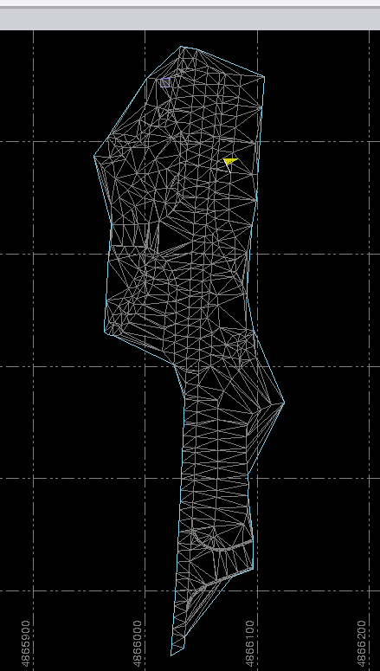

You can do 3D views as well to make sure you do not have long narrow spikes that sometimes surfaces will contain. The data for this file looks clean.
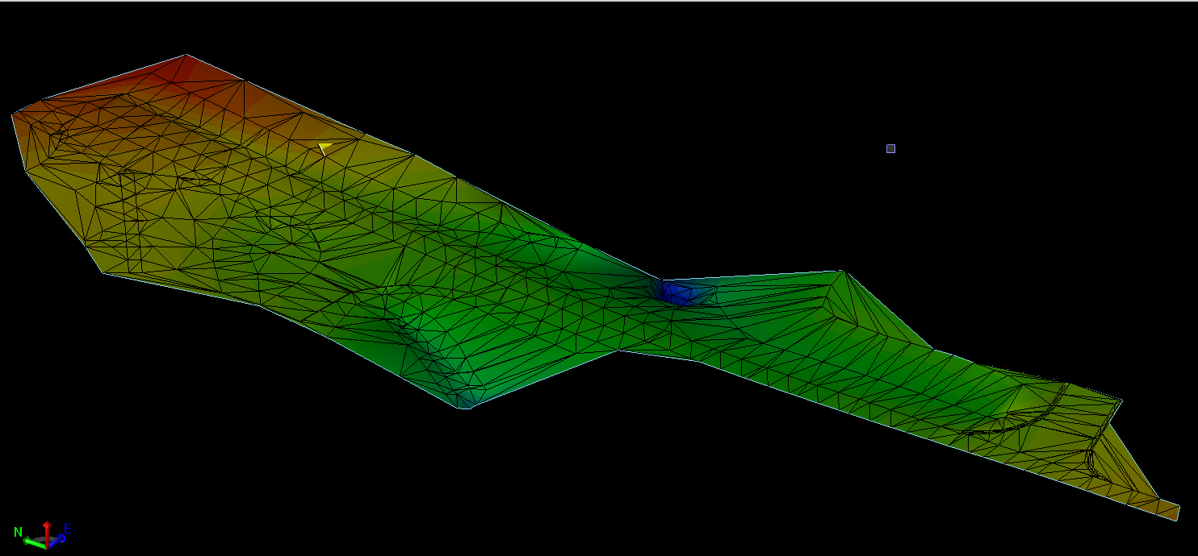

You will now copy the xml file to the appropriate job folder onto the Trimble controller. You can do this by using a thumb drive to get the file from your hard drive to the controller. Normally, the file will go under the Project folder on the TCS7.

Here is the file as seen from the Trimble TSC7 Controller.
