## Topic ##: How to Import Lidar into ORD Revised

Reason for Revision

Recent releases of some browsers (e.g. Chrome, Edge) are blocking FTP access to all KyGeoNet downloadable data resources. It is likely that all browsers will block FTP access in the future.

ORD Version

This workflow is intended for OpenRoads Designer version 10.09.00.91. The directions outlined below may respond differently in other versions of the Program.

Contact Information

This workflow was produced by Patrick Stone. Please send all questions, errors or overall complaints to [KYTCCaddSupport@ky.gov](mailto:KYTCCaddSupport@ky.gov) or call 502-564-3280.

Workflow

STEP 1

Here are workarounds that should allow access to the KYGeoNet downloadable data resources:

1. Use an ftp client to access the files. There are free ftp clients including FileZilla, Cyberduck, and Classic FTP. Links for the free ftp clients are listed below.

Links to Free FTP Clients

1. FileZilla - <https://filezilla-project.org/download.php> state employees should use the software center to avoid any installation issues to load FileZilla. The software center can be accessed by using the windows search command as shown below.

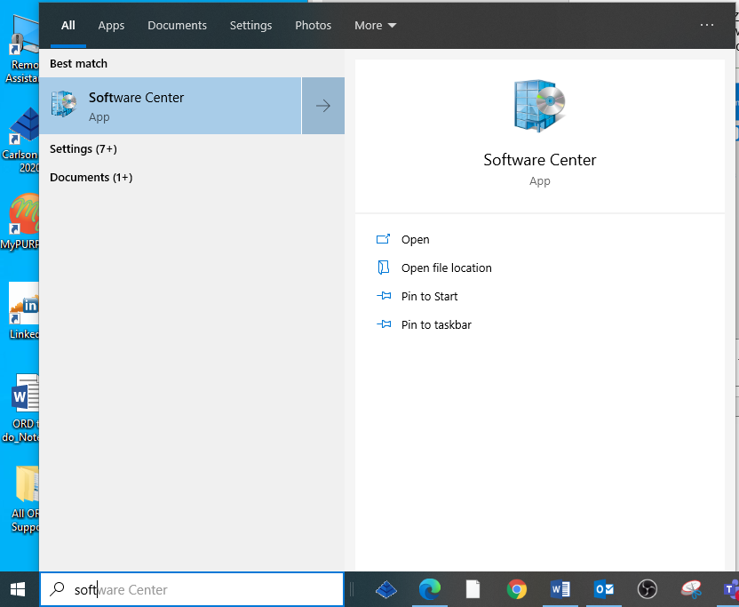

With the software Center up and running you may type in the Search field FileZilla.

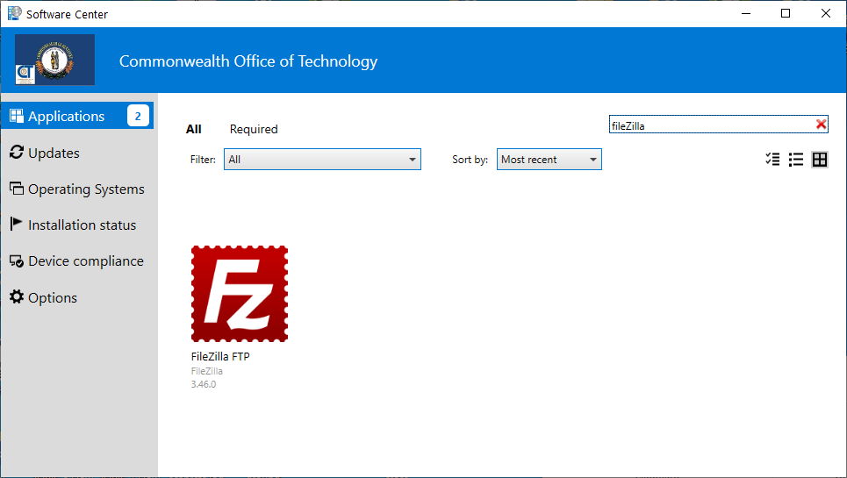

Double click on the Icon and the program will load a reboot may be required.

1. Cyberduck - <https://cyberduck.io/download/>
2. Classic FTP - <https://www.nchsoftware.com/classic/download-now.html>

Consultants may use any FTP client they like.

**Navigating to the FTP Site**

Go to: <https://kygeonet.ky.gov/govmaps/KyFromAboveGallery/> and click on “Kentucky LiDAR Point Cloud Data”.



You should now see an image similar to the one below.

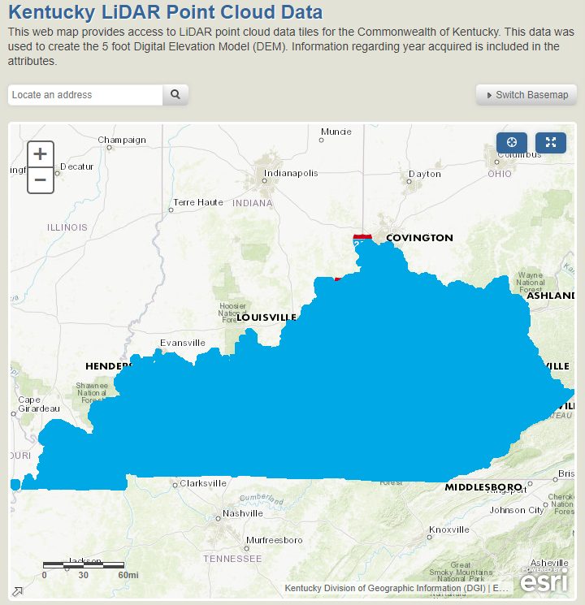

Navigate to your area and find the square(s) that you need for your project. You can do this by entering an address or you can simply zoom in and find your desired Tile.

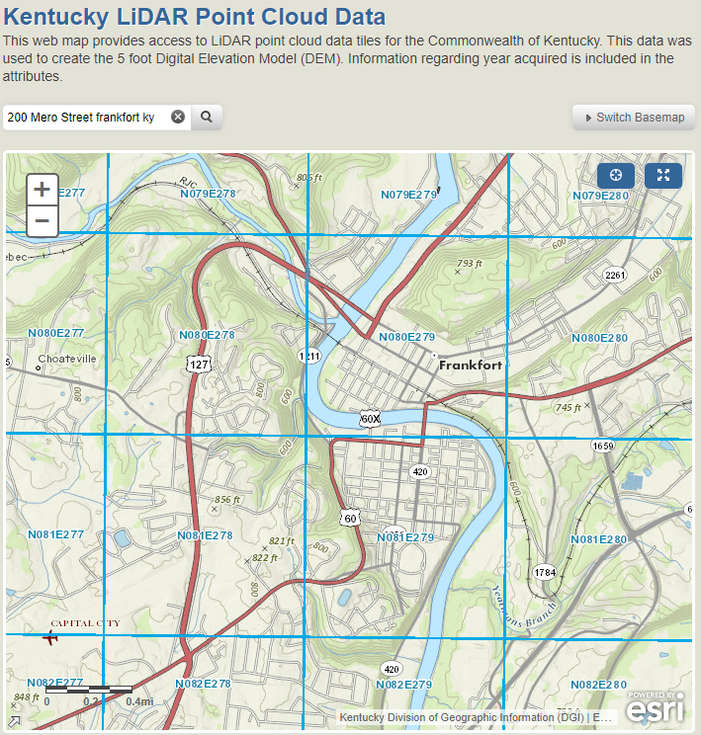

Click on the Square and get your tile name or write it down, Copy to clipboard however you prefer. For this example we will be using tile N080E279.

**Using the FTP Client FileZilla**

Open FileZilla or the FTP client you installed. For this example we will be using FileZilla.

Copy the link below and copy it into the Host this is the address of the server.

<ftp://ftp.kymartian.ky.gov/kyaped/LAZ/>

After the above link has been pasted or typed into the Host block select the Quick connect button.

You should now see the LAZ files.

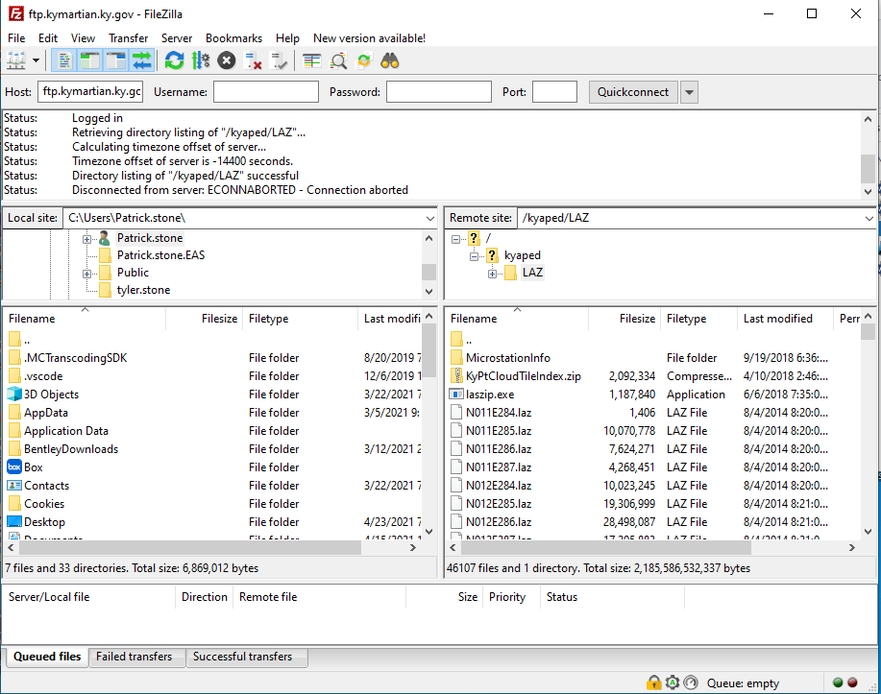

Select the tile or tiles you need. Right Click and you will get the Download and Add files to queue options. If you are downloading one file use the Download if you have multiple files to download us the Add files to queue.

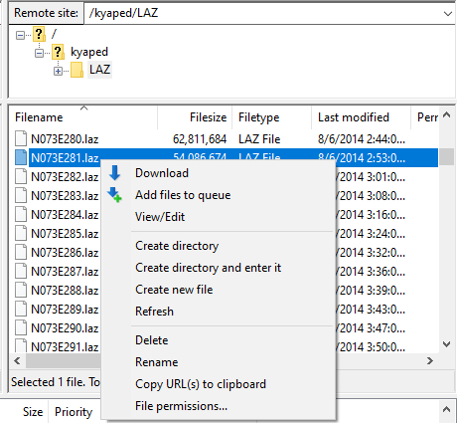

With the files added to the queue.

Define the location for your download to somewhere you know you can browse to. Right Click on your laz files and right click and process queue. Your files will now be downloaded to the path you have defined for your Local site as shown below.

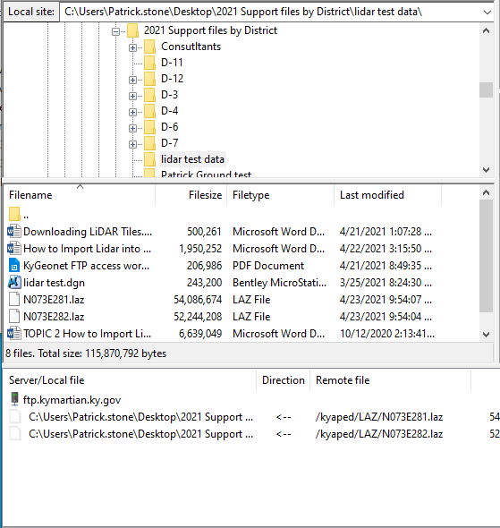

STEP 2

Open the desired file in ORD. I recommend you start a new file for your terrain with a 3D seed and mimic the workflow in the ORD Class Handbook.

Once open, locate the OpenRoadsModeling Workflow and the Primary Ribbon.

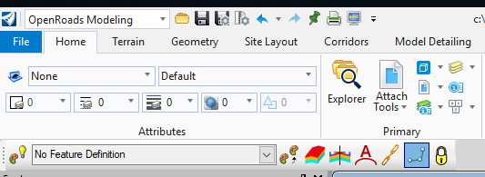

Under the Attach Tools, click the down arrow and select Point Clouds. It should look like this:

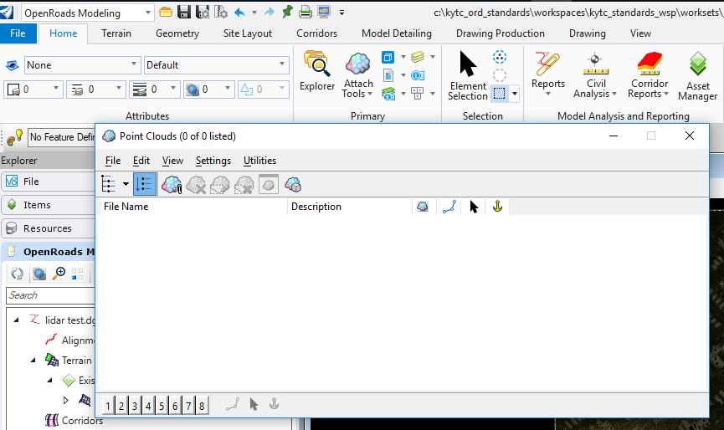

Click File-Attach or the attach icon and find the location you saved the .LAZ and select it. You may need to change the file type to .LAZ as well.



Set your settings to the ones shown below:

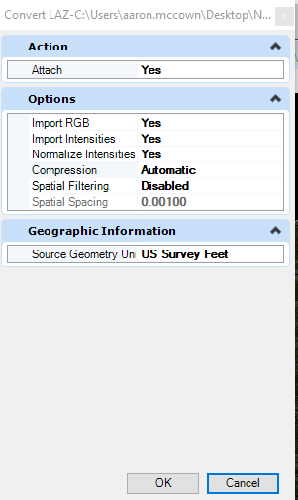

It will prompt you to save in ProjectWise, if you do not wish to, hit “Cancel” and it will refer back to your local machine. Save the File with correct file name; it should be a .pod file. Save the File.

Your Pod file should attach as shown in the image below:

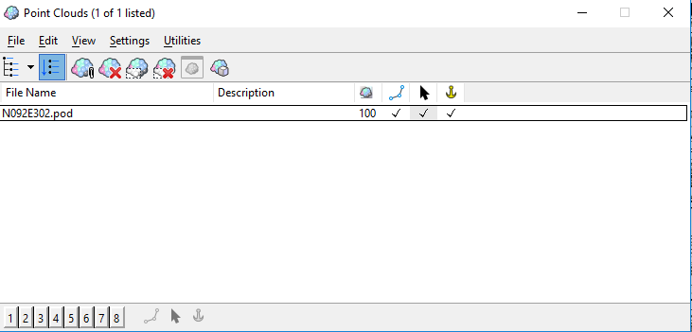

We have an additional step. You will need to set the Coordinate Geographic System. Right click on the .pod file to set the Coordinate Geographic System.

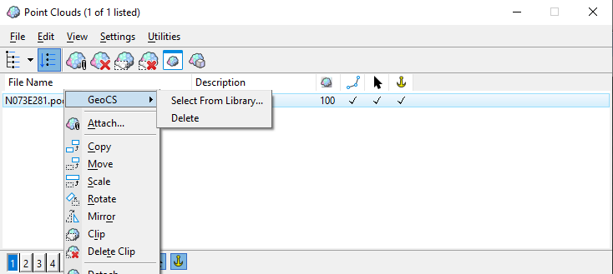

Select the appropriate Geographic Coordinate System, in this case Kentucky Single Zone:

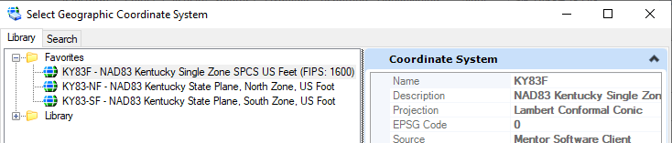

Select the Pod file – File – Export:

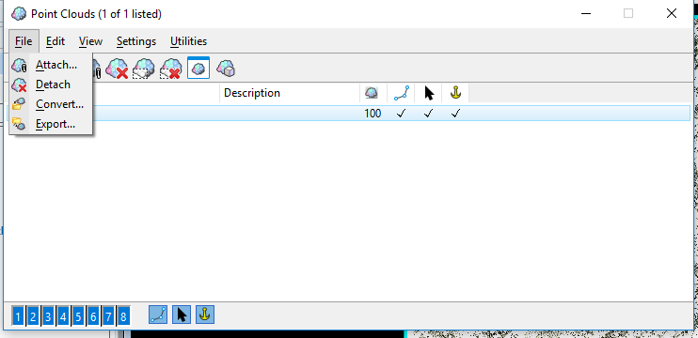

Make sure your settings match the same as the ones below:

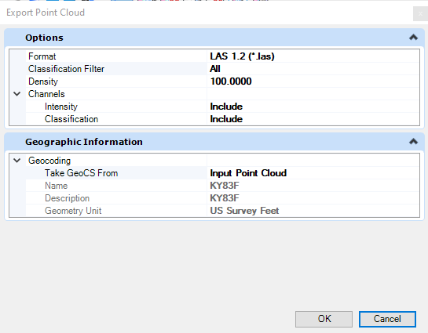

It will prompt you for ProjectWise; again, “Cancel” for local machine. Save the file with the correct name with the .las file extension. Save the file.

Go back to ORD and Re-Open the Point Clouds application. Select the Point Cloud and detach it.

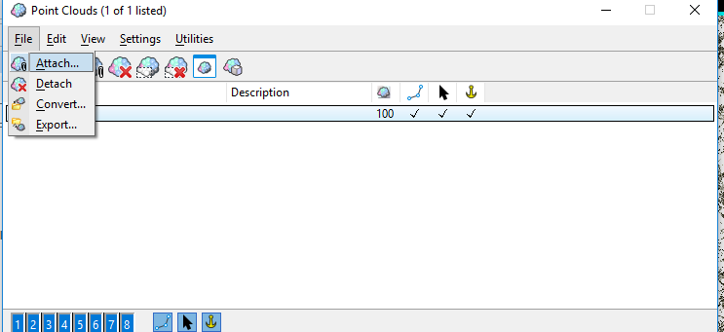

Close the Point Cloud Application.

Navigate to the OpenRoads Modeling Workflow – Terrain Ribbon – Create Tab – From File:

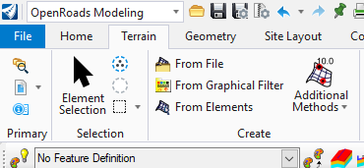

Open the “From File” application and browse to the location where you saved the exported .las file.

Select the file to open and wait; this may take several minutes for the application to get the file and import all the information.

Make sure all your settings are the same as the ones shown below – make sure to check off all classifications except for Ground

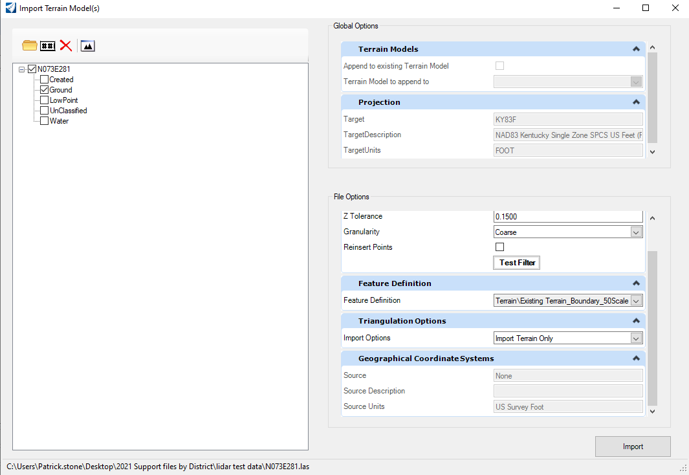

Once you have the settings set correctly, select “Import”. This can take a few moments as well for the program to import all of the data and convert it over to a Terrain file. You will see the screen flash and it will be done.

Close the Import Terrain Model(s) application.

View Extents and you should be able to see your boundary of your terrain model.

It will look like the image below:

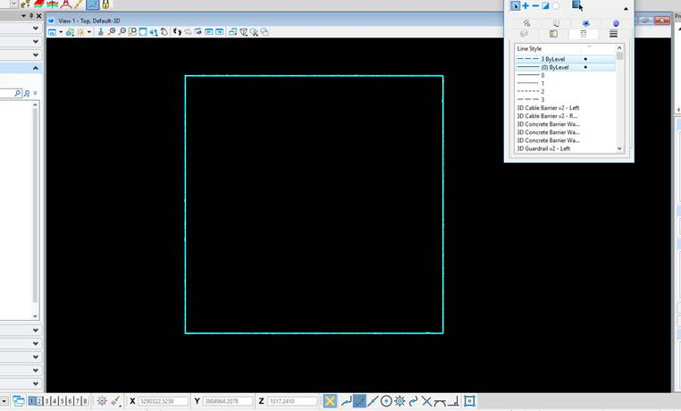

If you are wanting to see triangles or contours you will need to open the properties of the Terrain and turn them on as shown below:

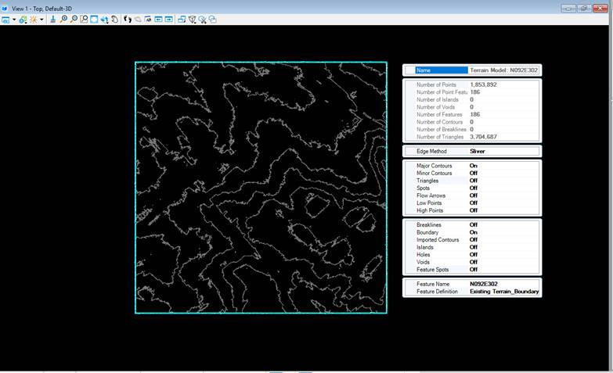

You can turn on whatever you want to see in this file.   
  
Follow the ORD Workbook on how to reference this file into your other files and how to set it active.