Topic ##: How to Import Field Data Using a CSV File in ORD

About this Write Up
We will be outlining a few workflows to aid in importing different file formats of survey data into ORD. Multiple file types can be imported. This workflow is going to concentrate on the CSV file format, which has been a Bentley file format for many years. KYTC requires this file as one of our deliverables when a survey is completed.

ORD Version
This workflow is intended for OpenRoads Designer version 10.08.00.88 (2020 R2). The directions outlined below may respond differently in other versions of the Program.

Contact Information
This workflow was produced by John Sudduth. Please send all questions, errors or overall complaints to KYTCCaddSupport@ky.gov or call 502-564-3280.

Getting Started
Once you are in the ORD software, be sure you are in the “Survey Workflow” as seen in the pull down menu in the upper left corner. The first thing we will need to do is to create a new field book file. There are two ways to import field data into ORD from a CSV file; we will cover both methods.
It is of critical importance that you create a new DGN file from the KYTC_ORD_3D.dgn seed file before you import your Field Book. This seed file is located in the ORD workspace folders on your local install.
The field book will contain all the point and line data from the imported CSV file. For this example, we will call the new Field Book: US25. First thing to do is click on the Field Book Tab. Next, click on the “New Field Book” icon, shown below.
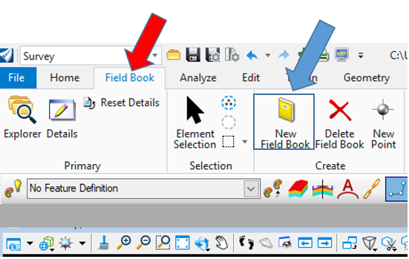
Key “US25” into the prompt below and then hit Enter. The blue text will appear as well; you can click the left button on the mouse, and the box will go away. You will now have a field book called US25.
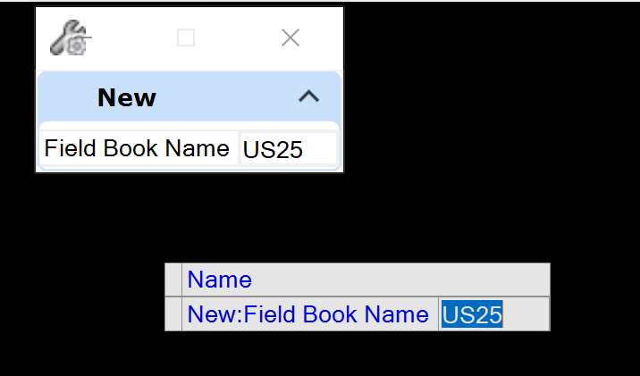
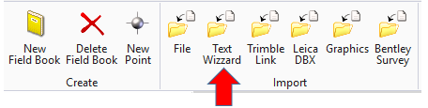
Step 1: Click on the Text Wizard folder as shown above. You will notice that this folder is part of the IMPORT Group of commands.
Step 2: Pick the US25 field book and a screen will appear for you to pick the file you want to import. Click on the pull down arrow to set the files of type to All Files (*.*).
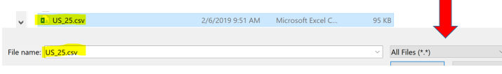
You will notice that sometimes a CSV file will look like an Excel spreadsheet, but as long as the extension of the file is CSV, it is a valid file for importing.
You will want to make sure your Record Format is set to Uniform, the Data Type to Delimited and your Start Row to 1. Then hit Next.
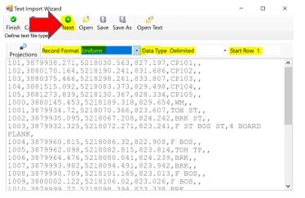
Make sure you set your Delimiters to Comma. Then select Next.
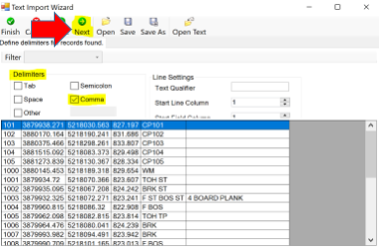
Set your columns to Point Name, Northing, Easting, Elevation, Code, and Note. Select Save As.
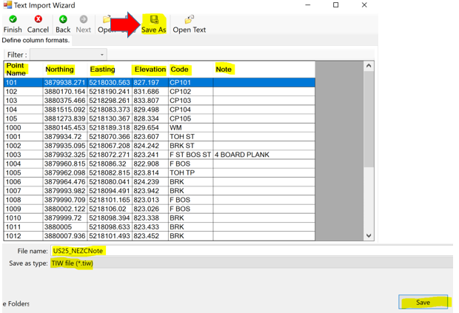
Once you have saved the TIW file where you want it, select Finish.
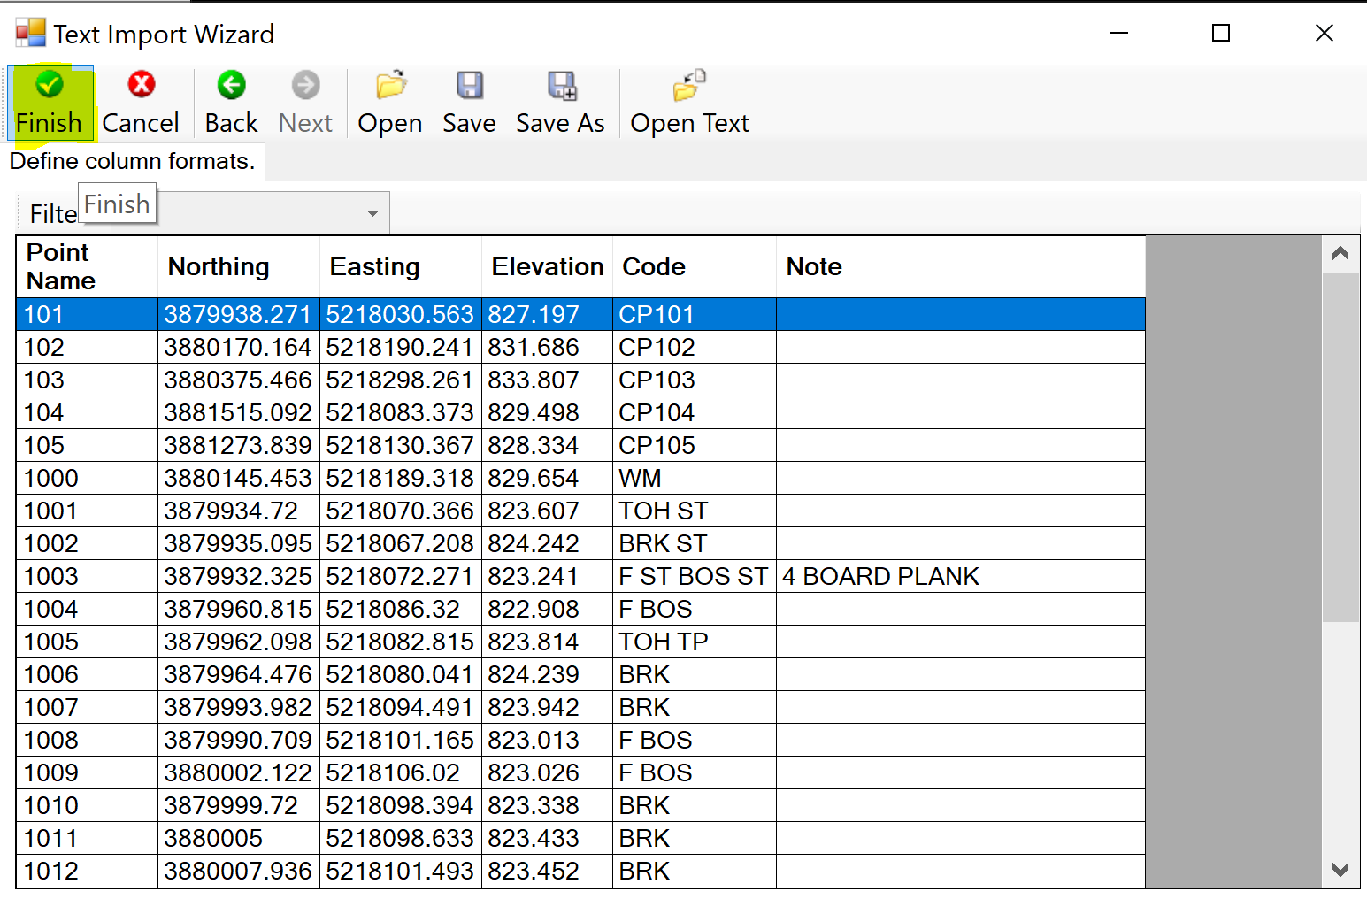
***NOTE: KYTC has a TIW file that is delivered with our standards. You can find this here:
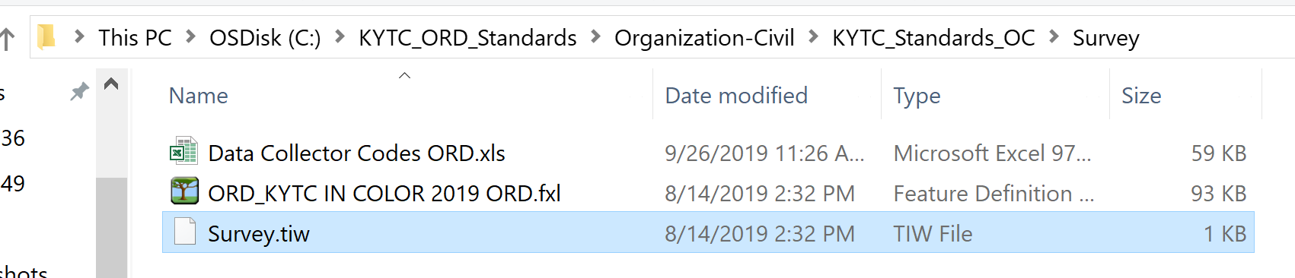
Fit your view, and you will notice that the survey data now appears on the screen inside ORD.
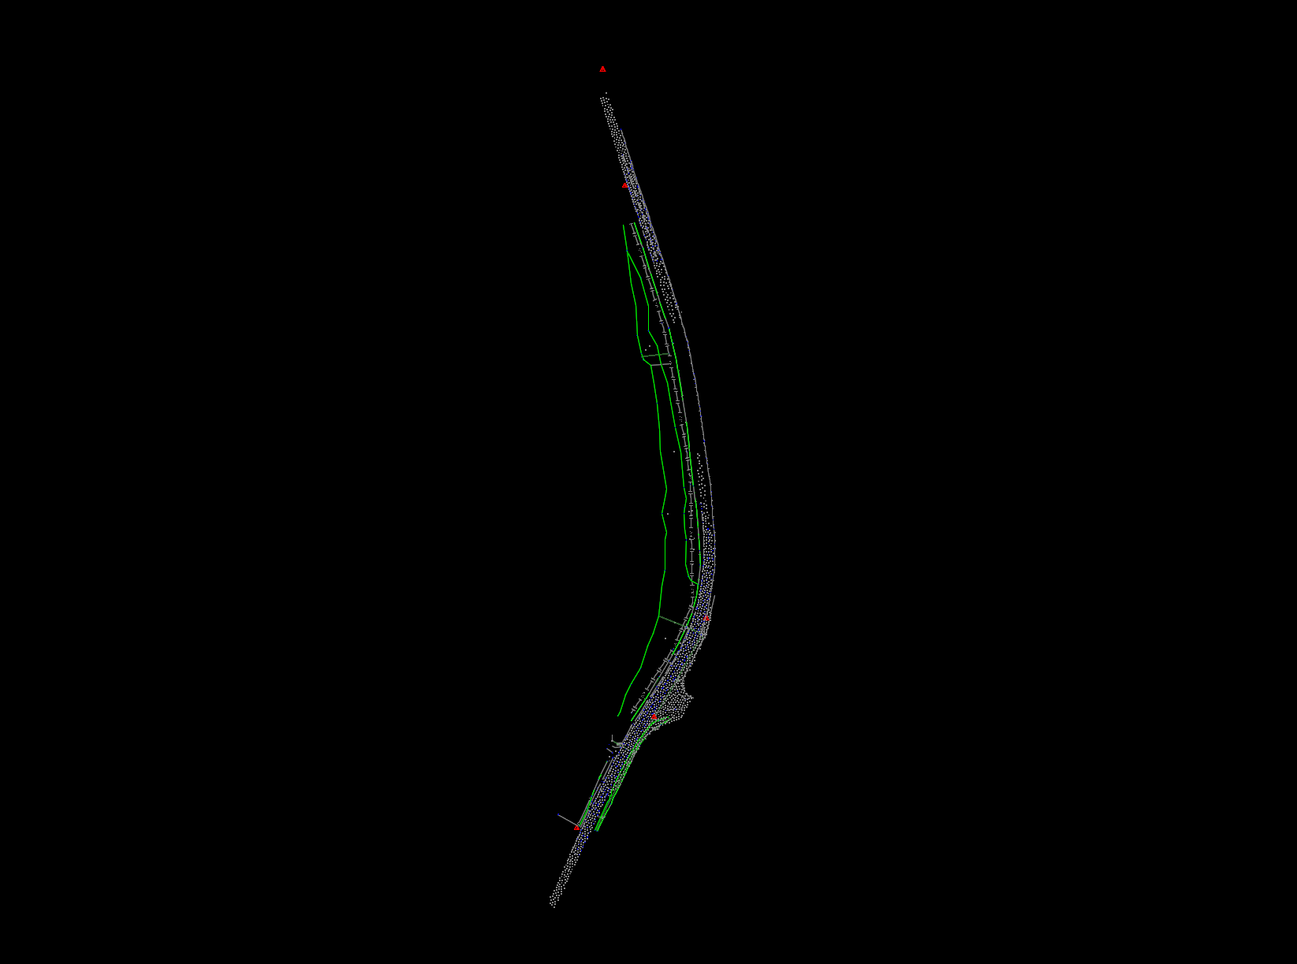
You will notice that there are no point numbers or other data in the drawing. Let us look at how to show them.
One way to do this is go to the Analyze Tab as shown and the click some of the items that are highlighted to get the data you want displayed. After clicking on the different decorations, you can now see the associated information that comes with each point collected in the field. You can also see the different line styles created by the survey data as well.
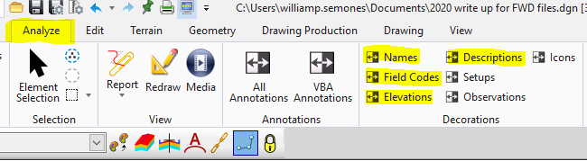
After clicking on the different decorations, you can now see the associated information that comes with each point collected in the field. You can also see the different line styles created by the survey data as well.
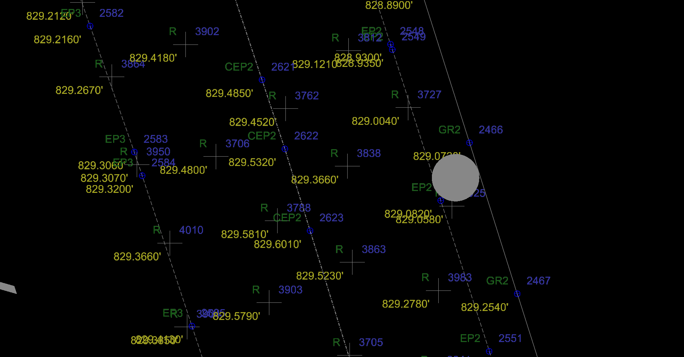
Keep in mind that a CSV file is just one way to bring in survey data.
Here is a list of Import formats that ORD can read:
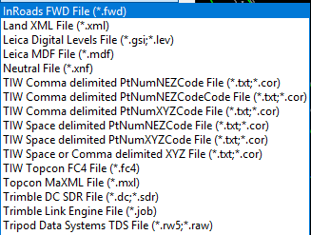
You can bring multiple survey files into ORD and they can be different file formats as well. For example, we could bring in a CSV file and a FWD file at the same time. Just be sure that they are all on the same coordinate system.

