Topic ##: How to Import Field Data Using a FWD File in ORD

About this Write Up
We will be outlining a couple of workflows to aid in importing different file formats of survey data into ORD. While there are multiple types of files that can be imported, this workflow is going to concentrate on the FWD file, which has been a Bentley file format for many years. KYTC still makes this file as one of our deliverables and that is why we put this workflow together.

ORD Version
This workflow is intended for OpenRoads Designer version 10.08.00.88. The directions outlined below may respond differently in other versions of the Program.

Contact Information
This workflow was produced by Perry Semones. Please send all questions, errors or overall complaints to KYTCCaddSupport@ky.gov or call 502-564-3280.

Getting Started
Once you are in the ORD software, be sure you are in the “Survey Workflow” as seen in the pull-down menu in the upper left corner. The first thing we will need to do is to create a new field book file. There are two ways to import field data into ORD from a CSV file; we will cover both methods.
It is of critical importance that you create a new DGN file from the KYTC_ORD_3D.dgn seed file before you import your Field Book. This seed file is in the ORD workspace folders on your local install.
This is Method Number #1 to import a FWD file into ORD.
The field book will contain all the point and line data from the imported CSV file. For this example, we will call the new Field Book: US25. First thing to do is click on the Field Book Tab. Next, click on the “New Field Book” icon, shown below.
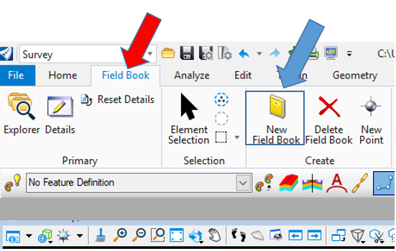
Key “US25” into the prompt below and then hit Enter. The blue text will appear as well; you can click the left button on the mouse, and the box will go away. You will now have a field book called US25.
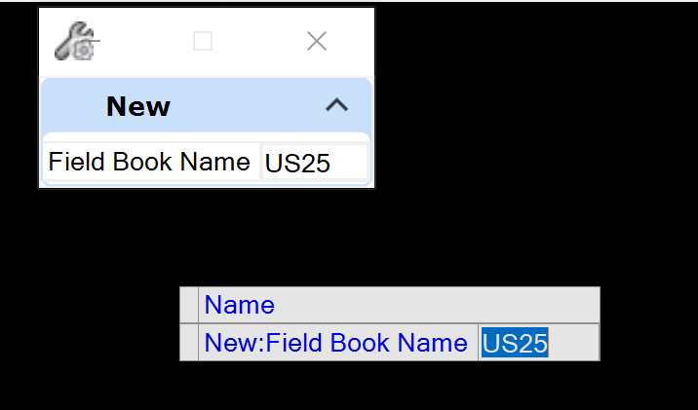
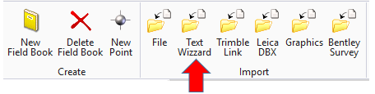
Step 1: Click on the Text Wizard folder as shown above. You will notice that this folder is part of the IMPORT Group of commands.
Step 2: Pick the US68 field book and a screen will appear for you to pick the file you want to import. Click on the pull-down arrow to set the files of type to *.fwd.
You will notice that sometimes a FWD file will be a Notepad looking file but if the extension of the file is FWD, it is a valid file for importing.
You will notice that the survey data now appears on the screen inside ORD.
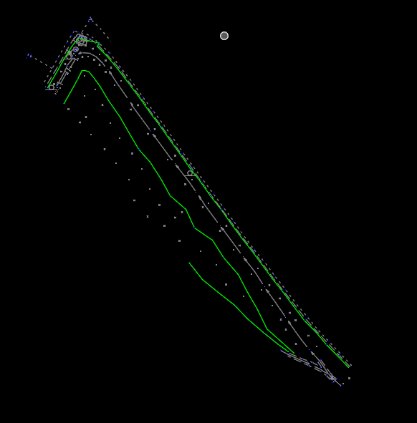
You will notice that there are no point numbers or other data in the drawing. We will address this after we go thru Method #2 on importing a FWD file into ORD.
While the procedure we just did is a good way to import survey data, there is another way to do it as well. Either way will get you to the same result.
This is Method Number #2 to import a FWD file into ORD.
Step 1: Create a new field book the same as we did above in Method #1.
Step 2: Click on the Explorer folder, as shown below.
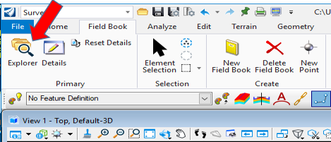
The Explorer will open and choose the Survey tab as shown.
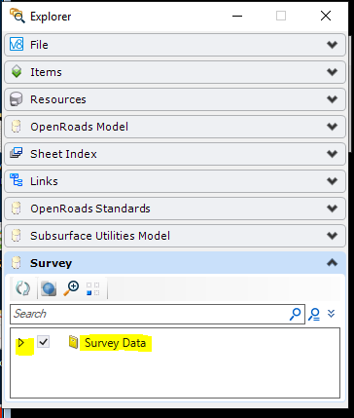
Step 3: Drill down into the survey folder to get to the following screen:
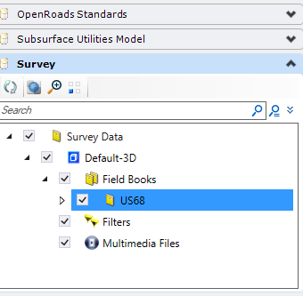
Step 4: Highlight the US68 folder and then right mouse click to bring up the following:
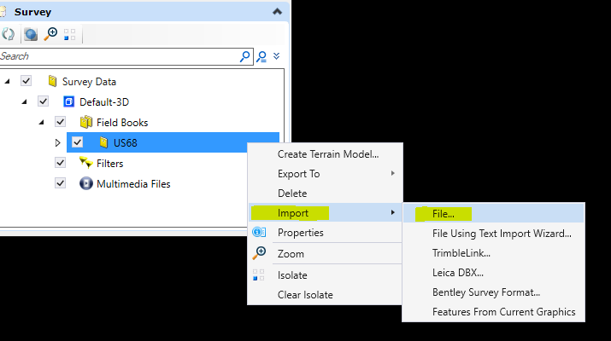
The next step is the same for Method #1. You will pick your FWD file that you want to import and again, you should see Graphics as shown below. You may have to do view extents to get the graphics to display.
As we mentioned earlier, there are no point numbers displayed.
One way to do this is go to the Analyze Tab as shown and the click some of the items that are highlighted to get the data you want displayed.
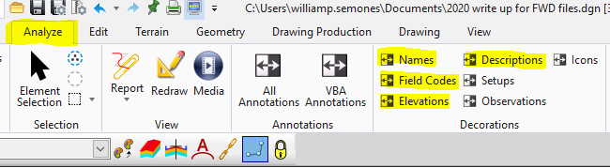
After clicking on the different decorations, you can now see the associated information that comes with each point collected in the field. You can also see the different line styles created by the survey data as well.
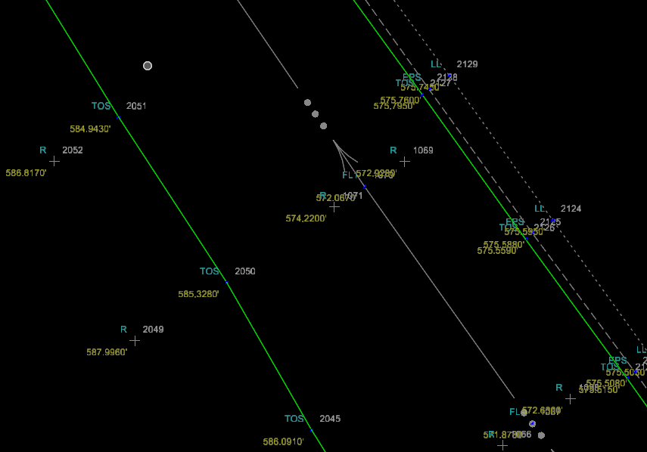
There is another way to turn Decorations on and off as well. Drill down inside the US68 Survey folder as shown. You can experiment by clicking on other options in here as well.
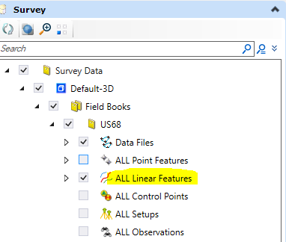
With just ALL Linear Features checked on, you will just see the linear items picked up by the field survey.
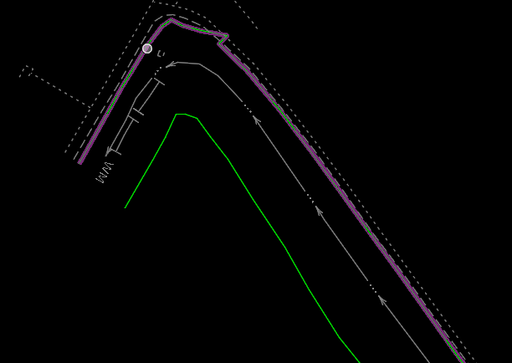
With just ALL POINT Features checked on, you will just see the Point items picked up by the field survey. You will also notice that some of the other decorations such as Point Number, Survey Code and Elevations will be all displayed too.
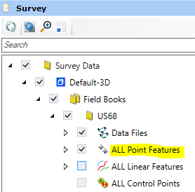
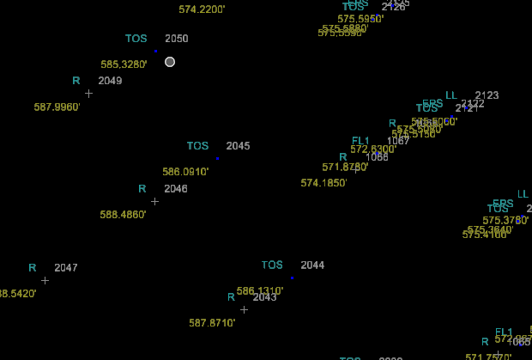
With ALL POINT Features and ALL LINEAR Features checked on, you will see most of the information picked up by the field survey.
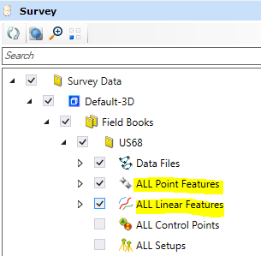

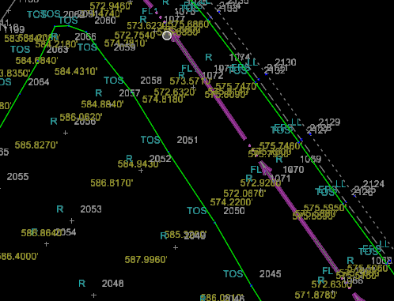
Keep in mind that a FWD file is just one way to bring in survey data.
Here is a list of Import formats that ORD can do:
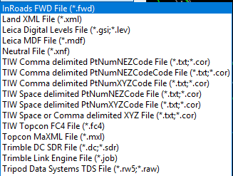
You can bring multiple survey files into ORD and they can be different file formats as well. For example, we could bring in a FWD file and a CSV file at the same time. Just be sure that they are all on the same coordinate system.
Now, if you want to see a listing of Points that are in your ORD file, follow this workflow.
First, drill down into the Survey folder as shown and highlight ALL Point Features:
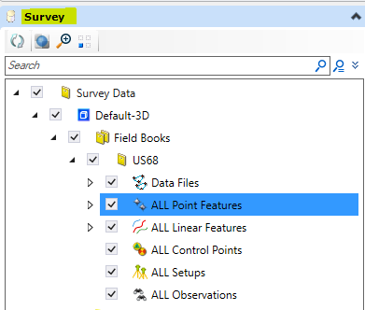
Next, go to the Details Option as shown below:
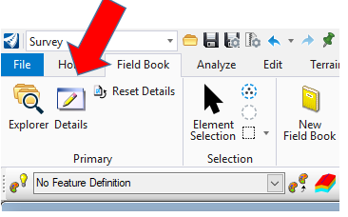
Click on Details and you should now see a point listing of the data that was collected in the field:
