Topic 3: HOW TO GET STARTED IN ORD

ORD Version
This workflow is intended for OpenRoads Designer version 10.08.02.05. The directions outlined below may respond differently in other versions of the Program.

Contact Information
Aaron McCown, EIT, produced this workflow. Please send all questions, errors or overall complaints to KYTCCaddSupport@ky.gov or call 502-782-4898.

Installing KYTC CADD ORD Standards
Begin by making sure you have the lasted CADD Standards loaded on your machine. These are located at https://transportation.ky.gov/CADD-Standards/Pages/default.aspx or on the software center (shown below). Open the Software Center from the local machine.
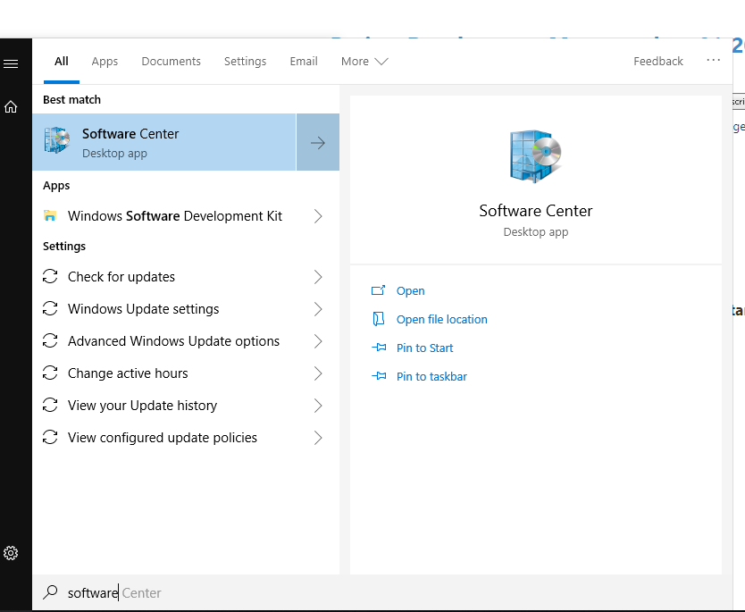

Once the KYTC ORD Standards have downloaded, you will begin the install. Follow the prompts (shown next).

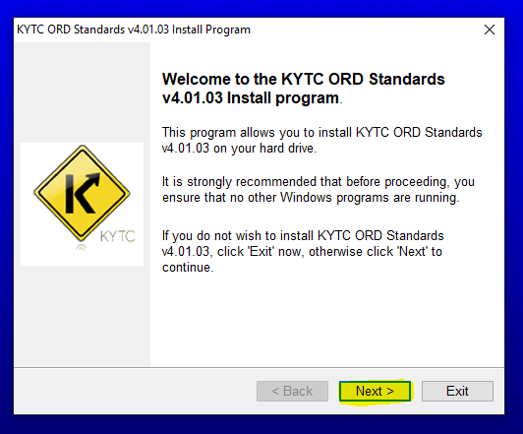
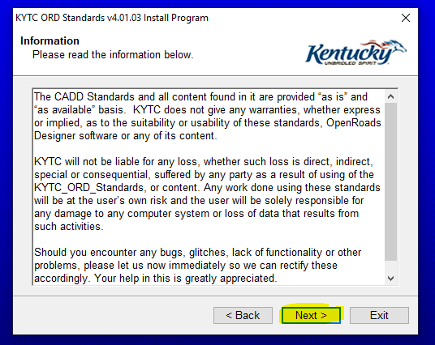

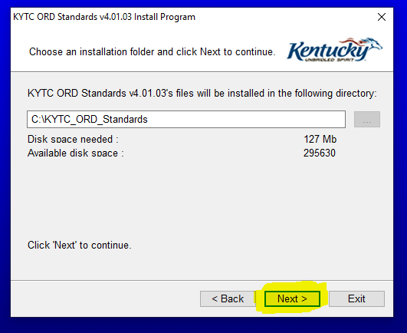
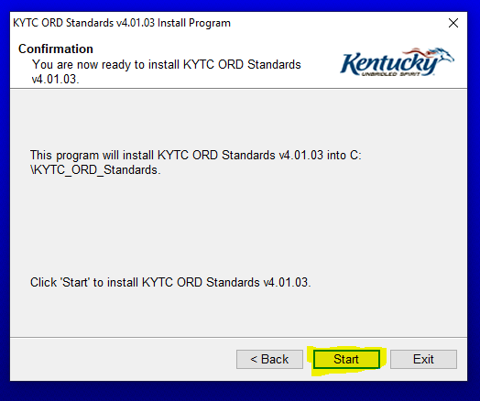

Above is where the installation of the standards will begin.
NOTE: If you already have an older copy of the standards installed, this will over-write any files stored inside of the KYTC Standards Configuration files. We encourage users to save any custom configuration on their own backed up storage area.
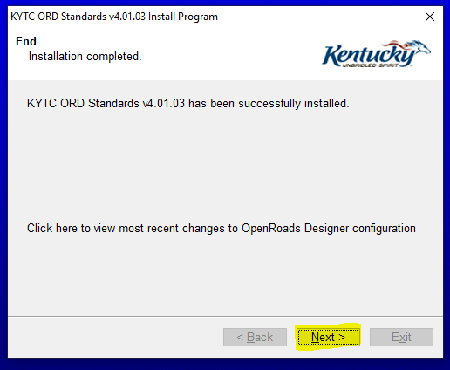
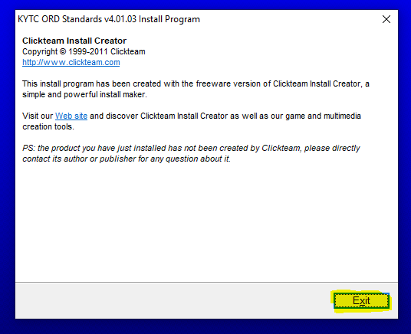

Exit the installer.

Opening OpenRoads Designer – Workspace Setup
Contact the KYTCPROJECTWISEADMIN@KY.GOV to have the appropriate ProjectWise Workspace setup for your project.
Open ORD from your local machine. (Our current workflow has the standards located on the local machine. This may change in the future.)
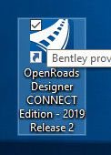
The front page of ORD will look like the following, for the first time upon opening. You will get these errors. You can “Okay” them now. They are just referring to the RSS Feed for ORD.
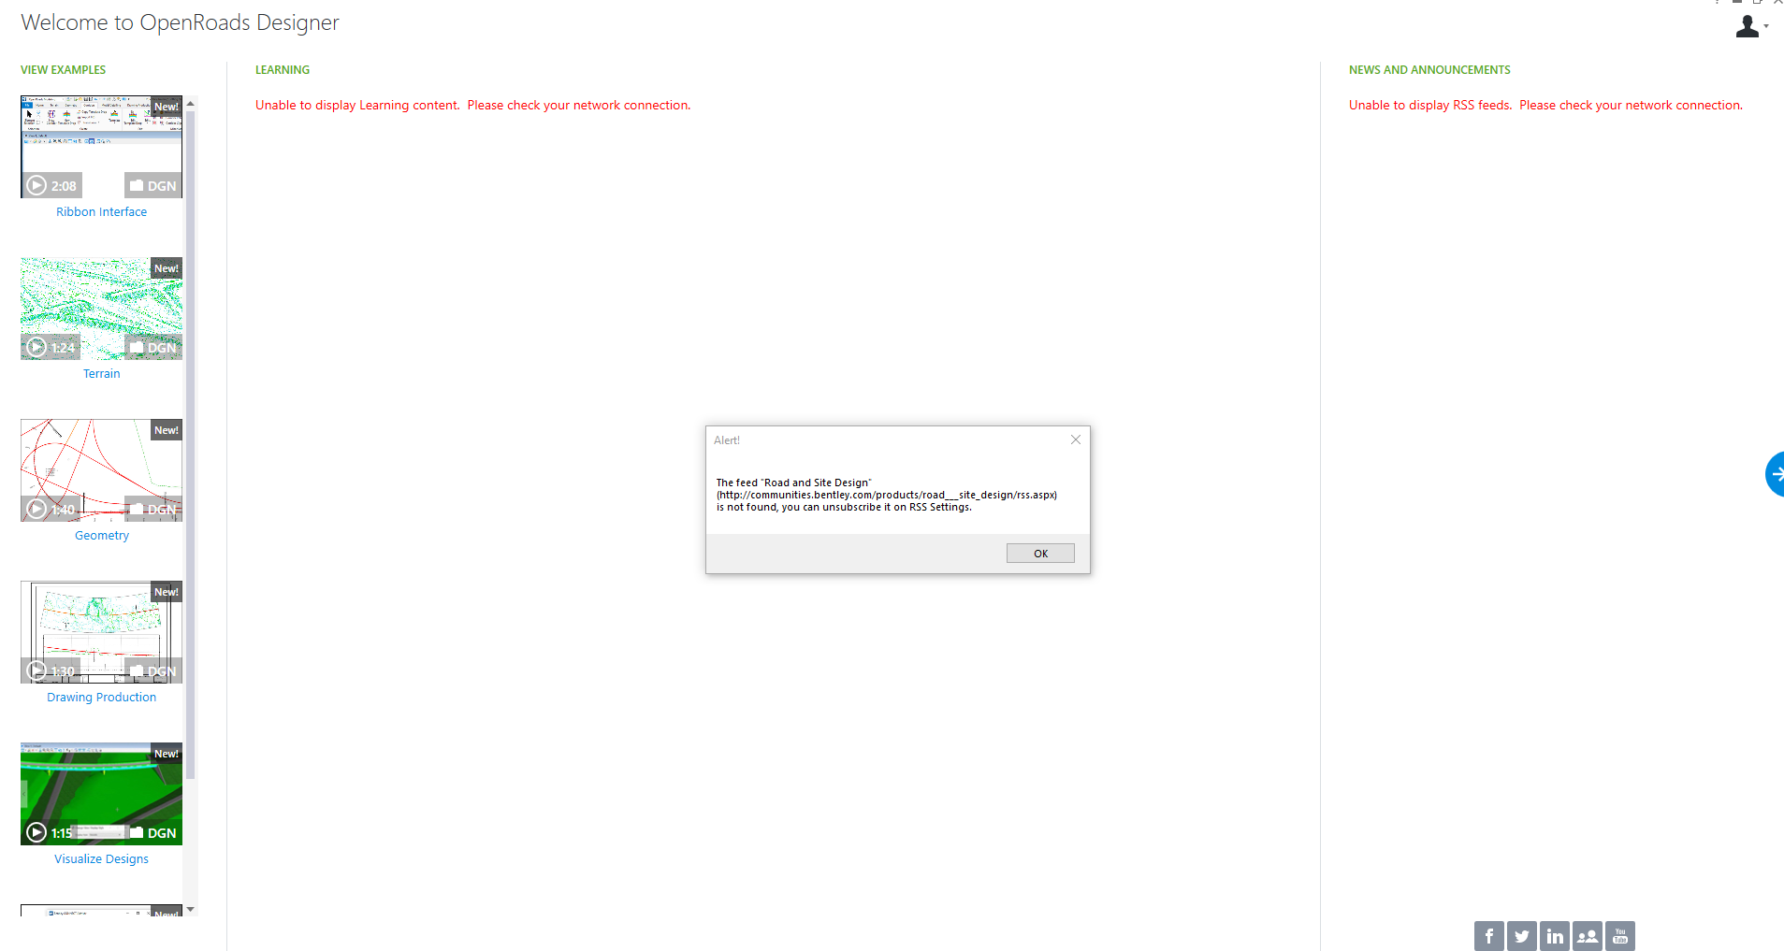
To get to the main work session, click on the arrow on the right center of the screen, shown below.
The main OpenRoads Designer work session is below. This is where you will want to set your Workspace and Workset. Then, select KYTC_STANDARDS_WSP.
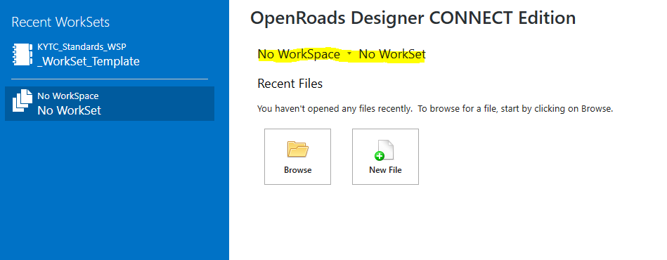
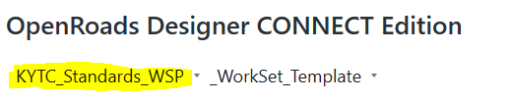
Open the _WorkSet_Template and select Create Workset.
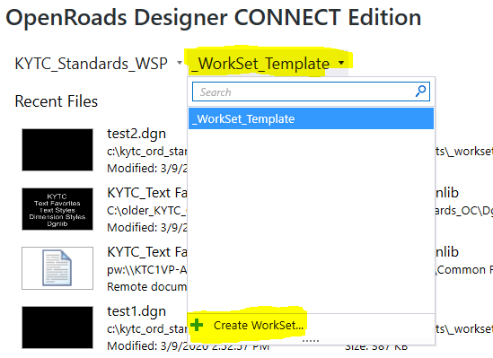
The Workset will contain the project information that we can harvest to use in automation of the plan set. You will want to make a copy of the Workset and place it in the project folder in ProjectWise.
Follow the path: C:\KYTC_ORD_Standards\WorkSpaces\KYTC_Standards_WSP\WorkSets.
Here you will find the stored files for the Workset. Copy the highlighted files to ProjectWise, seen below.

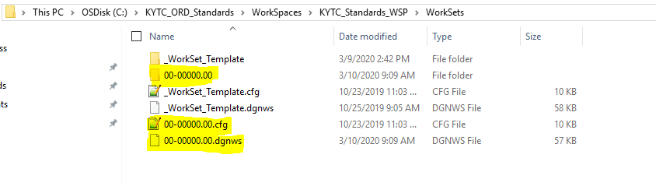

OpenRoads Work Session should now resemble the image below. You will have KYTC Standards set as your workspace and the project number as the Workset.
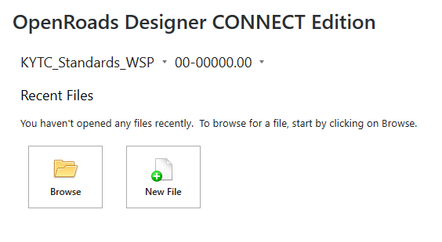

Navigate to the right of the OpenRoads Work session and select the “Properties” tab for the Workset. Select “Advanced Properties”.
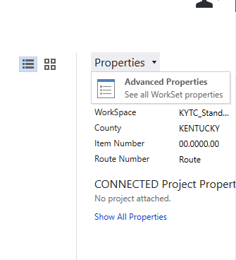
Under the Advanced Properties, you can fill out the information (shown below) that is related to the project.
The fields, shown below, can be harvested to automate sheet information. The “County” and “Item Number” will be harvested and put into the top right corner block of the plan sheets.
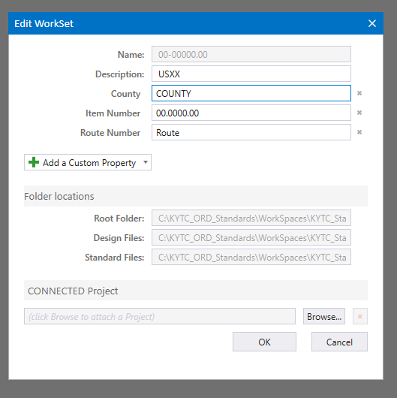
After setting Workset priorities, you are going to want to create a new file. The file will be placed into ProjectWise when you create it. Set your Folder in ProjectWise where you want it saved with the “Change” command. Edit the Name/Description/Filename accordingly to your project. Set your application to OpenRoads Designer.
Source File: This is where you will either set a 2D or 3D seed depending on what your are doing specially. If you are using the Workset Template that is provided, the seed will automatically be set to the KYTC 2D Seed. If you want to change that, you are going to select “Import” and go to the following path (this will allow you to select either a 2D or 3D as well as structures2D or 3D.):
C:\KYTC_ORD_Standards\Organization-Civil\KYTC_Standards_OC\Seed
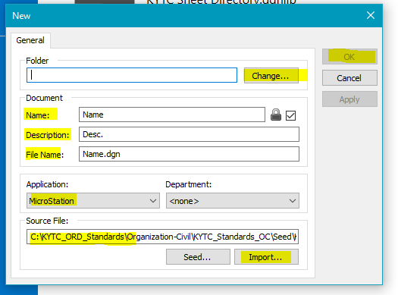
Select “OK” to create the file and it will create your file in ProjectWise. This may take a few seconds as well, so please be patient.

