PUBLIC INFORMATION MEETING
Public Meeting concerning Improvements to US 60 (Lexington/Versailles Road)
from Bluegrass Parkway to Pisgah Pike
Woodford County, Kentucky, Item # 7-117
Tuesday July 7, 2026
5 P.M. to 7 P.M.
King’s Way Church
4175 Lexington Road, Versailles, KY 40383

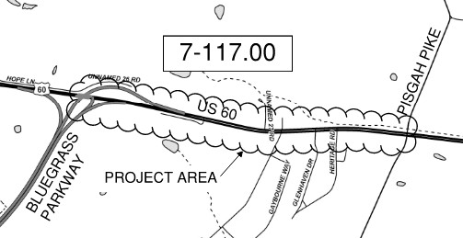

The Kentucky Transportation Cabinet has scheduled a public information meeting concerning improvements to US 60 (Lexington/Versailles Road) from Bluegrass Parkway to Pisgah Pike. The purpose of this meeting is to provide the opportunity to review alternatives currently being considered for Design and to obtain public input.

The public meeting will take place from 5 p.m. to 7 p.m. on Wednesday, July 7, 2026. Transportation Cabinet representatives will be available to receive comments and respond to questions. Handouts containing information about the project, comment sheets and displays will be available at the meeting. The meeting will be conducted in an open format, meaning that the interested parties may attend at any point in the meeting’s duration, no formal presentation will be provided. Both written and oral statements will be accepted at the meeting. A recording device will be made available for those who desire to make oral statements and a comment sheet will be distributed to make it more convenient to provide written comments.

Written statements will be accepted at the meeting and for a period of 15 days after the public information meeting. Written statements should be addressed to Rob Sprague, Project Manager. All written and oral comments from this meeting will become a part of the official project record. Once compiled, the meeting record will be made available for review and copying after an Open Records Request has been received and approved. All Open Records Requests must be submitted to the Office of Legal Services, Kentucky Transportation Cabinet, 200 Mero Street, Frankfort, Kentucky 40622.
In accordance with the “Americans with Disabilities Act”, if you have a disability for which the Transportation Cabinet needs to provide accommodations, please notify Rob Sprague no later than Friday, July 3, at the below address or call (859) 246-2355.
Please address any questions regarding this meeting or project to:

Rob Sprague, P.E.
Kentucky Department of Highways
Highway District 7 Office
800 Newtown Court
Lexington, KY 40511

