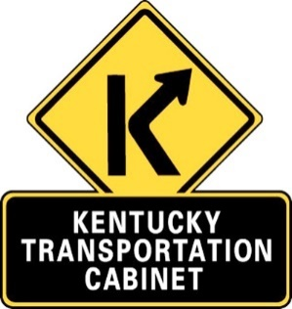
16th Street (KY 748 and CS 1047) -
Public Meeting
Calloway County
KYTC Item No. 01-8952

Purpose of Public Meeting
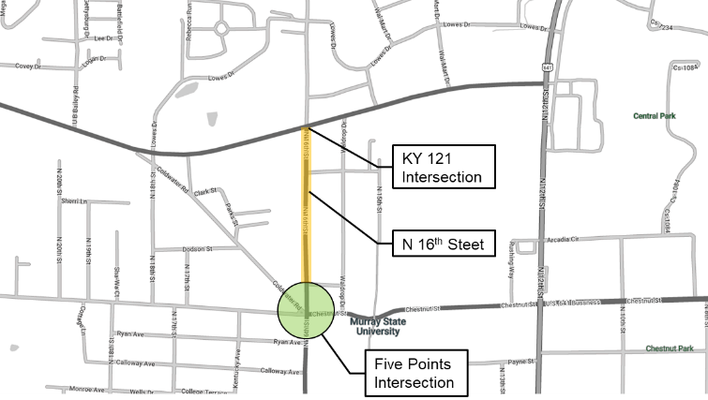
The purpose of this meeting is to present information regarding the proposed N 16th Street project, which will widen N 16th Street to three lanes and improve the Five Points intersection. The Kentucky Transportation Cabinet (KYTC) is requesting your input on preliminary engineering alternatives.
Chestnut St
N 16th St
Coldwater Rd
KY 121
College Farm Rd

Exhibits for the proposed alternatives and a questionnaire that provides the opportunity to provide comments will be made available on the project website at projectwebaddress.com. We are interested in your input and encourage you to share your concerns on the proposed project. Please visit the project website to view the exhibits and complete the questionnaire to provide valuable feedback for the project team.
Project Location

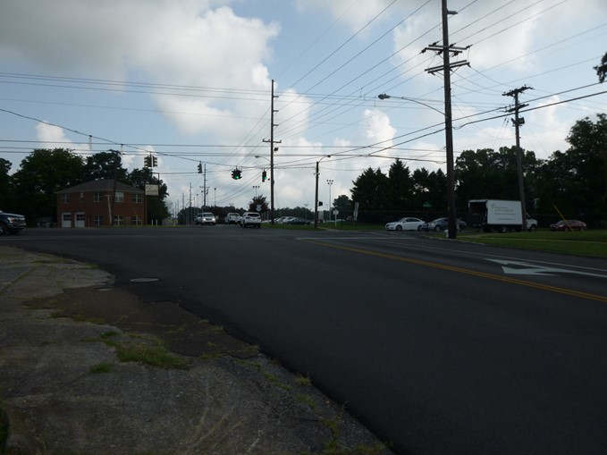
Project Purpose and Need
16th Street is a direct route to the heart of the Murray State University Campus and the corridor currently experiences congestion, including queueing at the unconventional Five Points intersection. Crash data also shows clusters of crashes at the intersections with KY 121, Valentine Street, and with Chestnut/College Farm/Coldwater (Five Points). This project will widen 16th Street to a three-lane corridor, improve pedestrian and bicycle facilities, and improve the Five Points intersection.
Existing Five Points Intersection

Comparison of Intersection Alternatives

Three alternatives have been developed for the Five Points intersection. The design team is seeking public input on the alternatives.

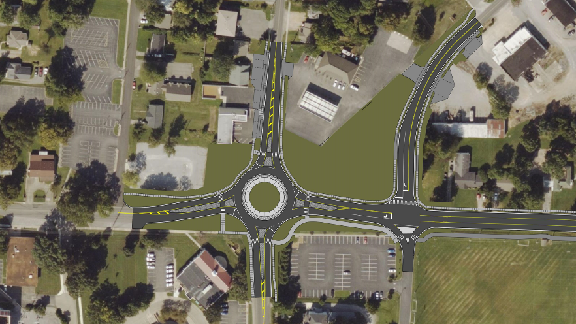
College Farm Rd.
Chestnut St.
Coldwater Rd.
N 16th St.
Alternative 1 - Four Leg Roundabout
- Coldwater Road relocated with stop control at N 16th St
- 16th St/College Farm Rd/Chestnut St approaches centered at roundabout
- Right-in-right-out on Short Drive
- Overall LOS B (14.2) in 2045 AM Peak Hour
- Overall LOS C (17.6) in 2045 PM Peak Hour

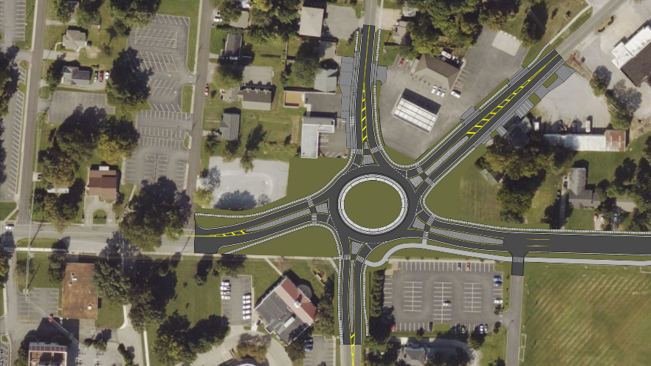
N 16th St.
Coldwater Rd.
College Farm Rd.
Chestnut St.
Alternative 2 - Five Leg Roundabout Alternative
- Oval shape to accommodate all five legs
- Trucks must travel through whole roundabout to complete right turn movement from southbound N 16th St to Coldwater Rd
- Overall LOS C (19.5) in 2045 AM Peak Hour
- Overall LOS C (20.6) in 2045 PM Peak Hour

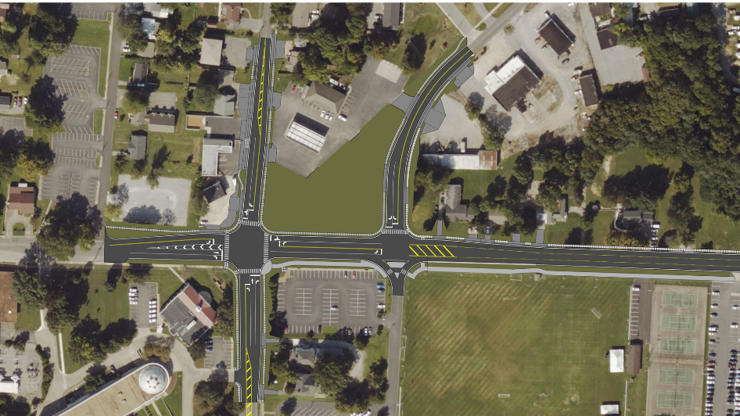
Chestnut St.
College Farm Rd.
Coldwater Rd.
N 16th St.
Alternative 3 - Signalized Intersection
- Dedicated left turn lanes for all approaches
- Dedicated right tun lanes for northbound N 16th St and Chestnut St
- Coldwater Road relocated with stop control at N 16th St
- Right in/right out on Short Dr
- Overall LOS B (17.5) in 2045 AM Peak Hour
- Overall LOS C (24.7) in 2045 PM Peak Hour

Comparison of N 16th Street Widening Alternatives
Two alternatives have been developed for the N 16th Street widening. The design team is seeking public input on the alternatives.

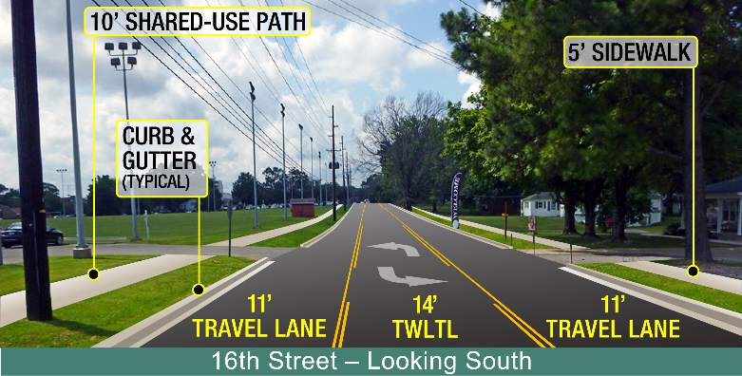
Typical Section
- Urban 3-Lane Typical Section
- Two 11-ft Travel Lanes, 14’ Two-way Left Turn Lane
- 10’ Multiuse Path to East
- 5’ Sidewalk to West

Alternative 1 - Widening Only Alternative
- Widen N 16th Street to include a two-way left turn lane
- Includes curb and gutter with storm sewer
- Multiuse path and sidewalk from Five Points intersection to KY 121

Alternative 2 - Widening and Vertical Curve Correction Alternative
- Widen N 16th Street to include a two-way left turn lane
- Includes curb and gutter with storm sewer
- Multiuse path and sidewalk from Five Points intersection to KY 121
- Vertical curve correction near Valentine Street

Estimated Project Cost:
- Includes Intersection and Roadway Improvements
- Similar for All Alternatives
- $4,000,000 - $4,500,000

Project Schedule
- Selection of Preferred Alternative (2022)
- Right of Way Acquisition (2023)
- Utility Relocations (2024)
- Construction (2026)

Contact Information
If you have any questions regarding the project, please feel free to contact:

James Tilley, P.E. Chad Bourke, P.E., PTOE
KYTC Project Manager Consultant Project Manager
KYTC District 1 Strand Associates, Inc.
5501 Kentucky Dam Road 325 West Main Street, Suite 710
Paducah, KY 42003 Louisville, KY 40202
James.Tilley@ky.gov Chad.Bourke@strand.com
(270) 898-9322 (502) 583-7020

