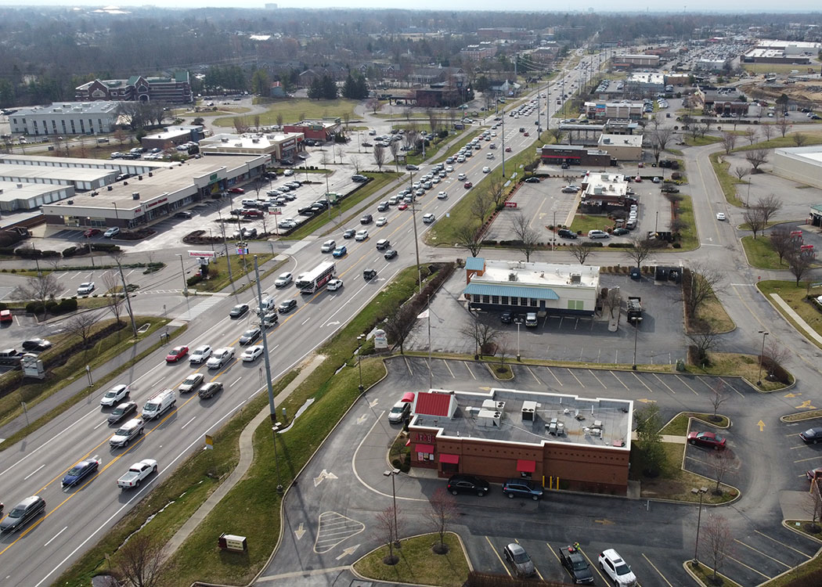
5-80001 US 60 (Shelbyville Road)
Designing corridor improvements along US 60 (Shelbyville Road) in Jefferson County, KY. Scroll through with your mouse to navigate the page.

Welcome!
The Kentucky Transportation Cabinet is developing a project to improve US 60 (Shelbyville Road) from Old Shelbyville Road to N. English Station Road/Urton Lane. As part of that process, the design team is requesting input from the public about the proposed improvements along the corridor.
Project Information
The purpose of the proposed US-60 project is to decrease congestion and improve safety, operations, and roadway traffic capacity as a result of the expected increased traffic due to major transportation and development changes in the Louisville Metro area. The need is expressed through high critical crash rate factors, continued land development, and congested traffic operations.
KIPDA travel modelling has identified this segment of roadway as currently being one of the Top 10% of the “worst congested” in the region, and forecasts suggest that the congestion will worsen over time. In addition to the congestion issues, high crash rates hamper mobility as well. A 2015 KYTC study calculated a 2.72 CRF for the area, and roughly two crashes are occurring each week. 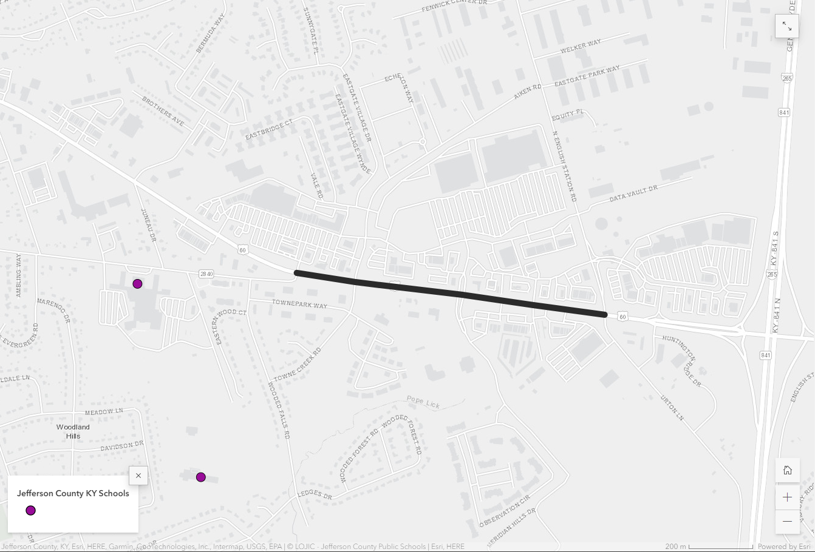
Project Location
The project (highlighted by the black line to the right) is located along US 60 (Shelbyville Road) between Old Shelbyville Road and N. English Station/Urton Lane in Jefferson County, KY. The design process for this project also includes a high-level planning review of the adjacent signals near Kroger and the interchange with I-265 (Gene Snyder) to understand the impacts related to the project corridor.
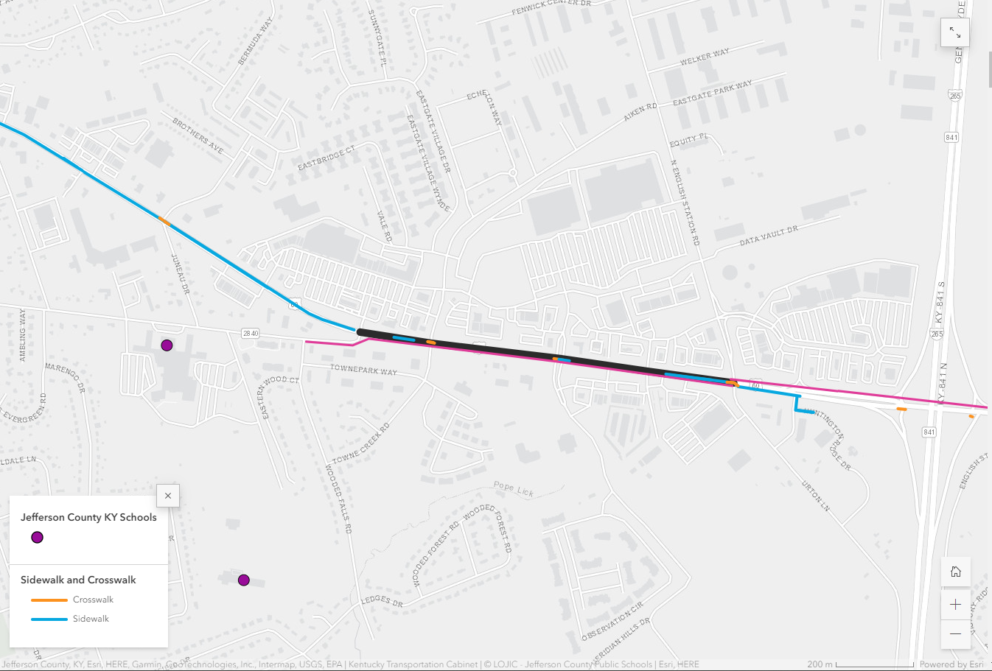
Pedestrian and Bicycle Facilities
Sidewalks (highlighted in blue to the right) are located intermittently along the north side of the project corridor. The Louisville Loop shared-use path (highlighted in pink to the right) is located along the south side of the project corridor.
Crosswalks (highlighted in orange to the right) are located at the signalized intersections of Towne Creek Rd./Aiken Rd., Data Vault Dr./Meridian Hills Dr., and N. English Station Rd./Urton Ln. to cross US 60.
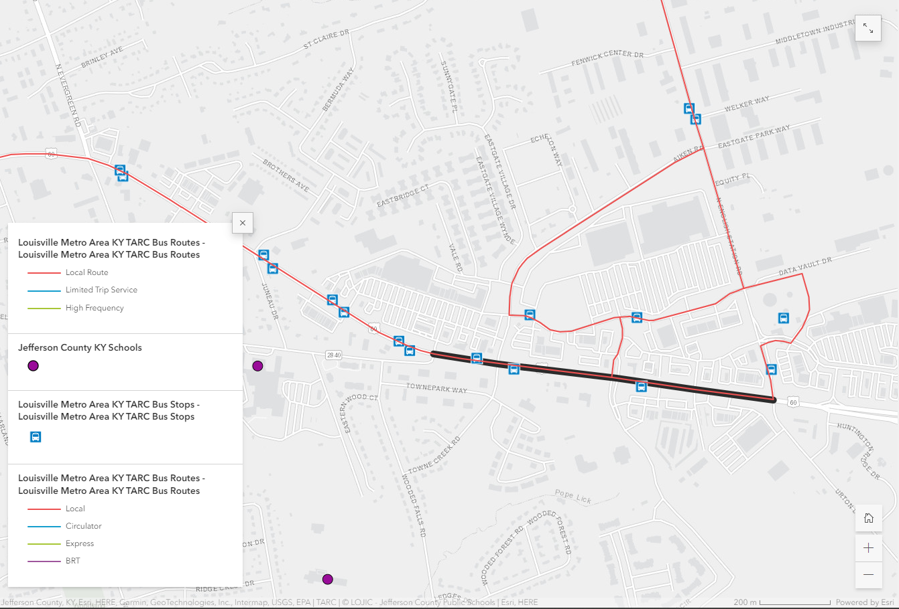
Bus Routes and Stops
The map to the right shows the local bus routes along the corridor and on adjacent roadways. Bus stops are indicated by the blue icons. TARC Local Route 31 is shown in red. TARC Express Routes 31X and 61X are shown in green.
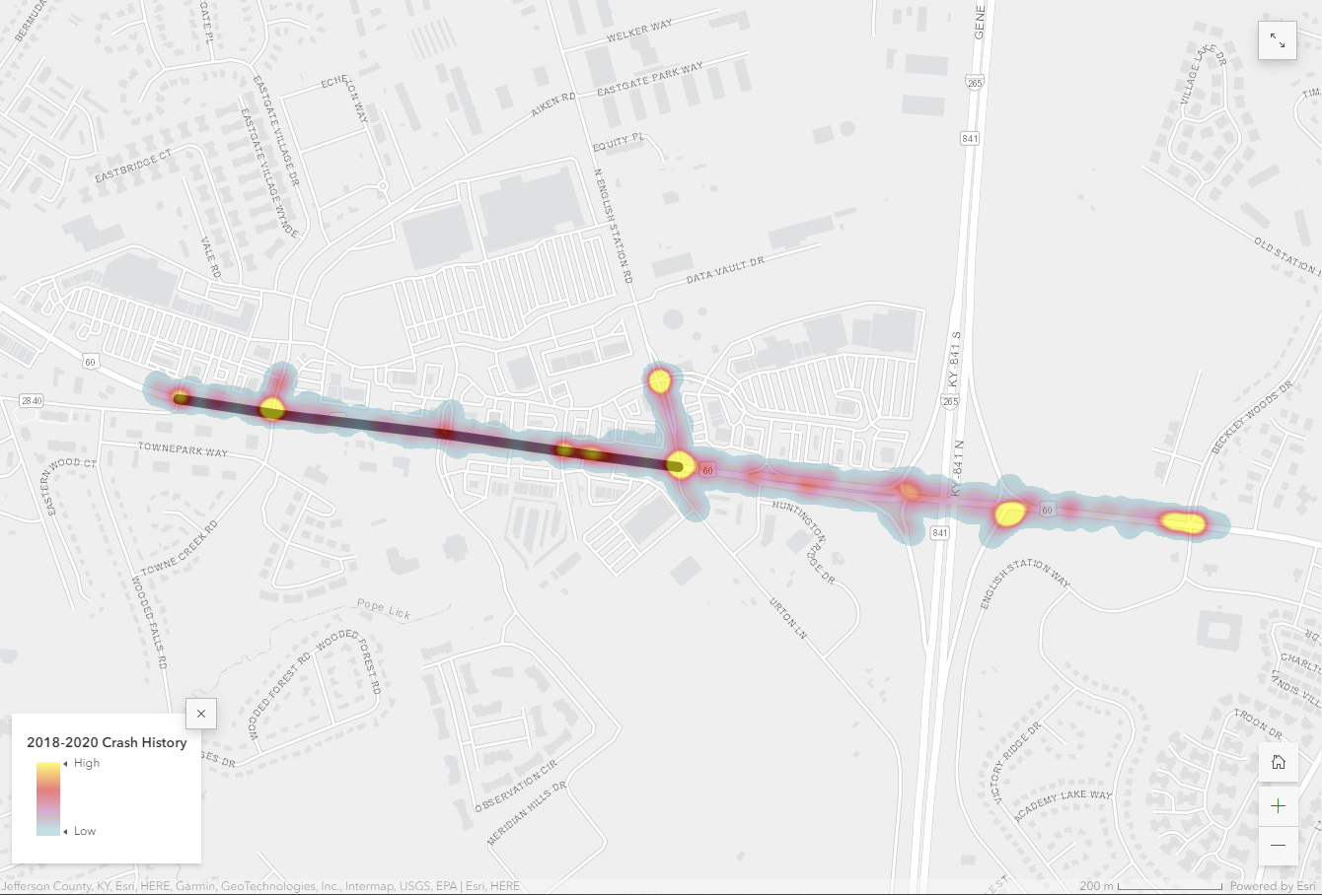
Crash Heat Map
In the map to the right, yellow represents a high concentration of crashes in an area, and blue a low concentration of crashes.
Signalized intersections are crash hotspots along the corridor. However, crash hotspots also occur in areas with multiple entrances onto US 60. In these locations, vehicles turning onto US 60 are in conflict with through traffic on the corridor and left-turning traffic in the two-way left turn lane.

Existing Typical Section
The existing typical section of US 60 is shown in the image below. Currently, US 60 is five lanes wide, with two 11-foot-wide travel lanes in each direction and a 14-foot-wide center two-way left turn lane (TWLTL). The Louisville Loop shared-use path is located on the south side of the road (right side of the image located below).
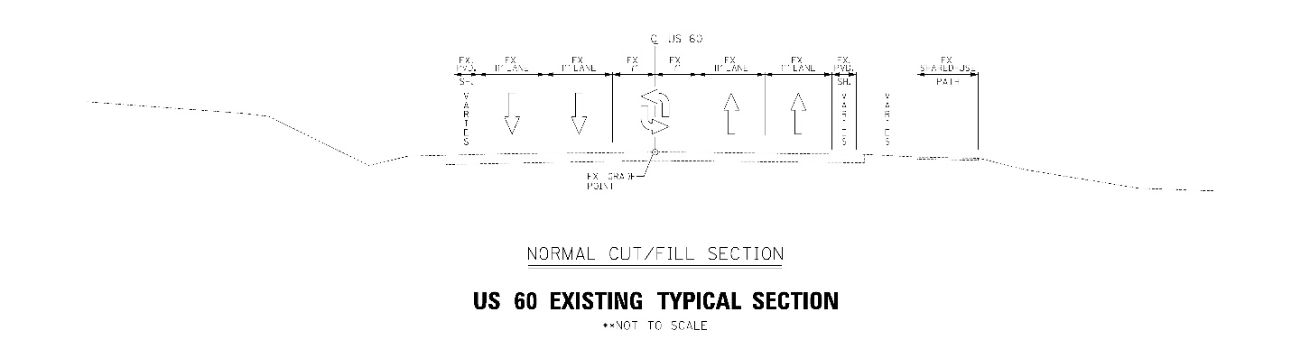
Existing US 60 typical section. Click the image to enlarge in a computer browser or pinch to zoom on a mobile browser.

Proposed Improvements
The project consultant team is currently working with KYTC, stakeholders, and the public to identify the preferred alternative for US 60. Several proposed improvements were evaluated, including corridor-wide improvements, intersection-specific improvements, and a no-build option.
The following proposed alternatives were evaluated for the US 60 corridor:

Alternative 1 - Widen to Six (6) Lanes
Alternative 1 includes the addition of a through lane in each direction (for a total of six lanes) to increase capacity along the corridor and through each signalized intersection. A portion of the existing two-way left-turn lane (TWLTL) in the middle would be used for the additional through lanes. Sidewalks are proposed on the north side to connect gaps in the existing sidewalk network.
Alternative 1 also proposes a raised median between signalized intersections to prohibit left turns into entrances, which eliminates conflicts between vehicles turning left, reduces crashes, and improves safety between signalized intersections.
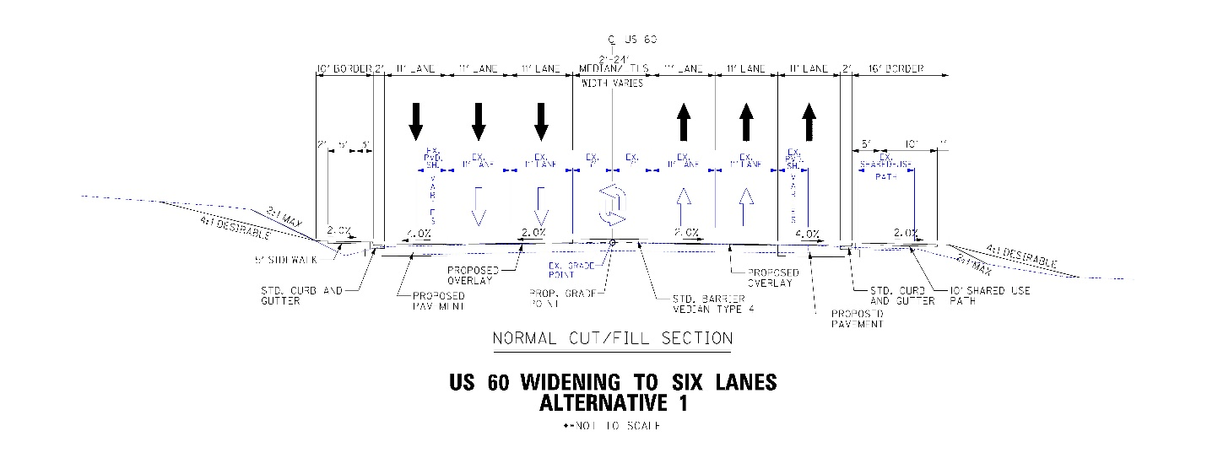
Alternative 1

Alternative 2 - Widen to Five (5) Lanes
Alternative 2 consists of an additional eastbound through lane only for a total of five lanes. The combination of higher traffic in the eastbound direction and the opportunity to convert the existing 12’ paved shoulder along part of the southern side of the road to a through lane led the design team to consider this alternative. This alternative eliminates the impacts of widening along the north side of US 60 from Alternative 1, while addressing the more heavily congested direction of traffic. Similar to Alternative 1, this alternate includes a proposed raised median between signalized intersections to eliminate conflicts with left-turning vehicles and improves safety. Sidewalks are also proposed on the north side to connect gaps in the existing sidewalk network.
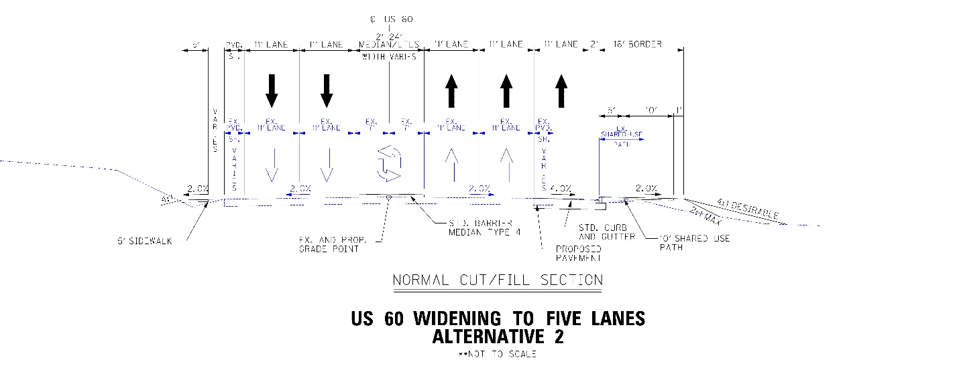
Alternative 2
Alternative 3 - Dual Left Turn to North English Station Rd. and Additional Lane on I-265 South Ramp
Alternative 3 is specific to the North English Station Road and Urton Lane intersection on US 60. This alternative proposes dual eastbound left turn lanes from US 60 to North English Station Road. In this alternative, the current lane configuration remains the same, except for reduced lane widths and widening of North English Station Road to provide an additional northbound lane.
This alternative was removed from consideration since the widening required on North English Station Road did not provide improvement to traffic flow at the intersection when compared to Alternative 4 below.
Alternative 4 - Dual Left Turn to North English Station Rd. and Additional Lane on I-265 Southbound Entrance Ramp
Alternative 4 is similar to Alternative 3 and proposes protected-only dual left turn lanes from eastbound US 60 onto North English Station Road. However, North English Station Road is not widened, and instead the less frequent through and right turn vehicles are combined into a single lane. Widening of North English Station Road is avoided by combining these southbound lanes.
In this alternative, an additional lane is also added to the I-265 Southbound entrance ramp. With this alternative, both existing southbound dual left lanes from North English Station Road would now be able to use the I-265 Southbound entrance ramp from eastbound US 60 without a lane change. Currently, only one left turn lane from North English Station Road can access this ramp without changing lanes. The I-265 Southbound entrance ramp from eastbound US 60 would need to be widened to accommodate another lane. This change improves the capacity of the signalized intersection at North English Station Road.
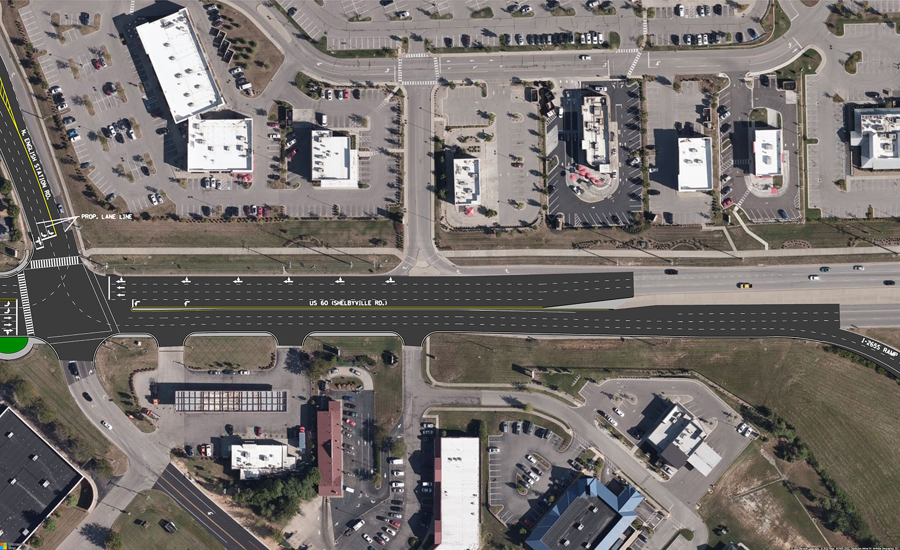
Detail of Alternative 4, with combined through and right on North English Station and I-265S ramp widening.
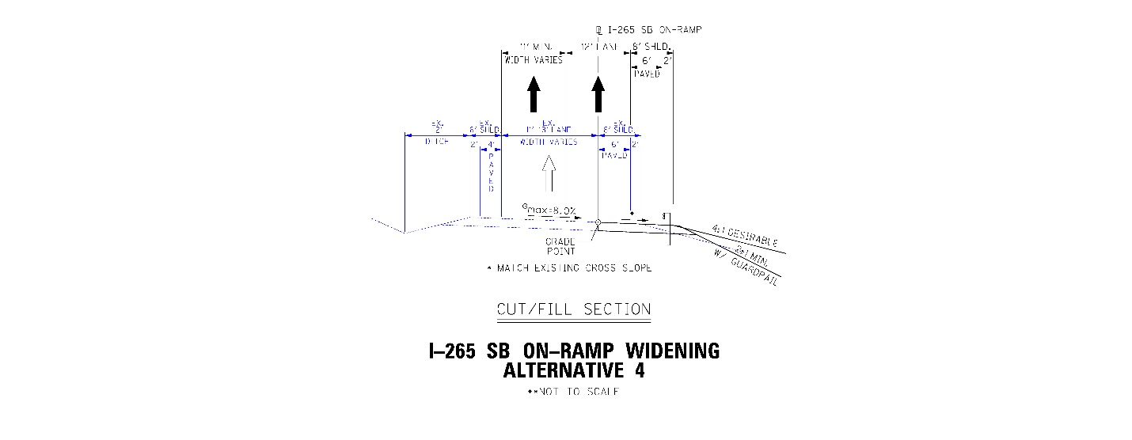
Alternative 4 -
Alternative 5 - Restricted Through Movements at Some Intersections
Alternative 5 applies to the US 60/Aiken Road/Towne Creek Road and US 60/Data Vault Drive/Meridian Hills Drive intersections and would eliminate through movements on the side streets of these intersections. The low volumes of traffic making these movements would make either a right turn followed by a left turn at the next intersection east, or a left turn followed by a right turn at the next intersection west to get to their destination. U-turn movements could also be utilized if they are not restricted. The removal of through movements allows left turning and right turning traffic from both side street approaches to operate as protected under a signal phase.
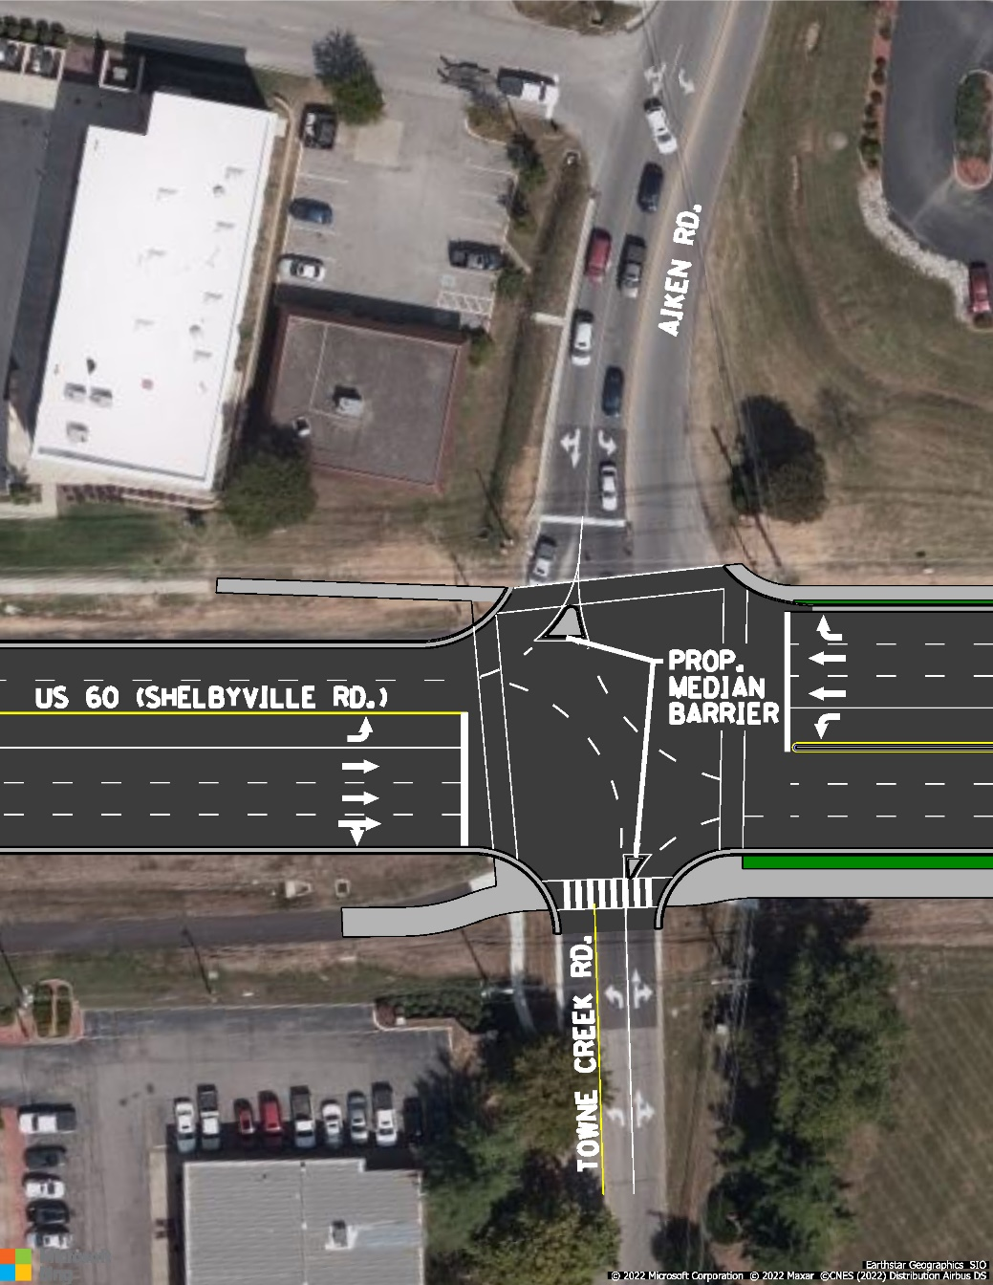
Detail of Alternative 5, shown combined with Alternative 1.

Proposed improvements were ultimately combined into four potential alternatives for the entire project area. Alternative 1-4-5 and Alternative 2-4-5 are shown below. Both alternates include dual left-turn lanes from US 60 to N. English Station Road and an additional lane on the I-265 South ramp. Eliminating improvements from Alternative 4 between North English Station Road and the I-265 Southbound ramp results in Alternatives 1-5 and 2-5.
Alternative 5 is included on all combined alternatives because it allows left turning and right turning traffic from both sides of the intersection to free flow onto Shelbyville Road at the same time. The removal of the few drivers going straight across US 60 from the side streets greatly improves the flow of traffic and prevents higher delays.
Alternative 1-4-5
This alternative will widen US 60 (Shelbyville Road) to 6 through lanes with a raised median between signalized intersections, add dual left turns from US 60 onto North English Station Road, add an additional lane onto the I-265 southbound entrance ramp, and restrict through movements at the US 60/Aiken Road/Towne Creek Road and US 60/Data Vault Drive/Meridian Hills Drive intersections.
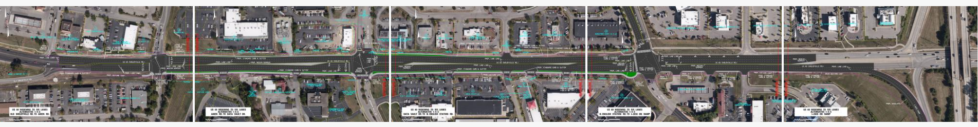
Alternative 1-4-5.
Alternative 1-5
This alternative will widen US 60 (Shelbyville Road) to 6 through lanes with a raised median between signalized intersections and restrict through movements at the US 60/Aiken Road/Towne Creek Road and US 60/Data Vault Drive/Meridian Hills Drive intersections.
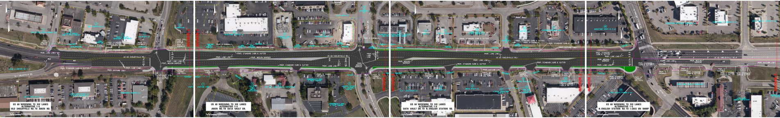
Alternative 1-5.
Alternative 2-4-5
This alternative will widen US 60 (Shelbyville Road) to 5 through lanes with a raised median between signalized intersections, add dual left turns from US 60 to North English Station Road, add an additional lane onto the I-265 southbound entrance ramp, and restrict through movements at the US 60/Aiken Road/Towne Creek Road and US 60/Data Vault Drive/Meridian Hills Drive intersections.
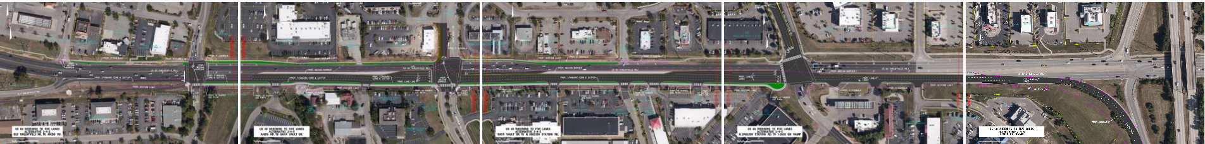
Alternative 2-4-5.
Alternative 2-5
This alternative will widen US 60 (Shelbyville Road) to 5 through lanes with a raised median between signalized intersections and restrict through movements at the US 60/Aiken Road/Towne Creek Road and US 60/Data Vault Drive/Meridian Hills Drive intersections.
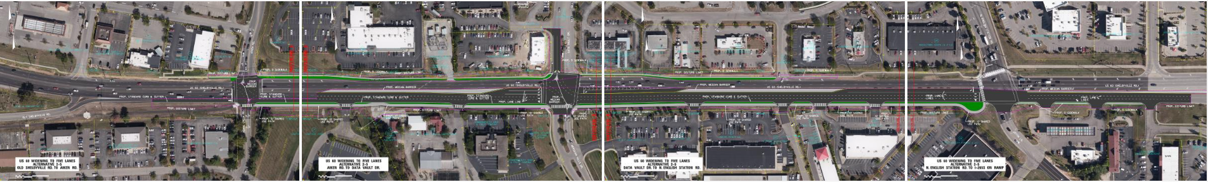
Alternative 2-5.

Traffic Analysis
The table below summarizes the traffic analysis for each proposed alternate at signalized intersections in the project corridor. The analysis includes the Level of Service (LOS) and average delay in seconds for the morning (AM) and evening (PM) commuting hours. Alternatives with the same LOS and delay outcomes for both AM and PM are combined in the table for ease of comparison. A diagram explaining LOS is located below the traffic analysis table results.
The No Build Alternative causes higher delays for each intersection than the build alternatives for two of the three signalized intersections. Although all alternatives, including the No Build alternative, provide a LOS of F for the intersection, the build alternatives provide significant reduction in delay in the PM commute than the No Build alternative.
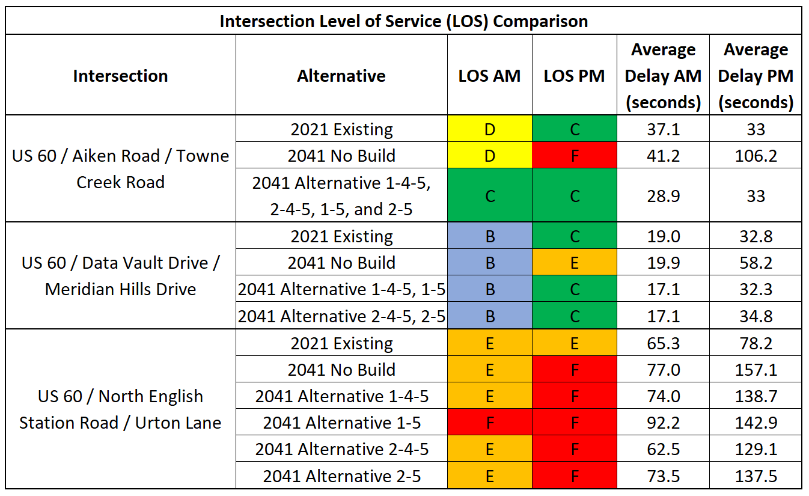
See Level of Service (LOS) descriptions in the below image.
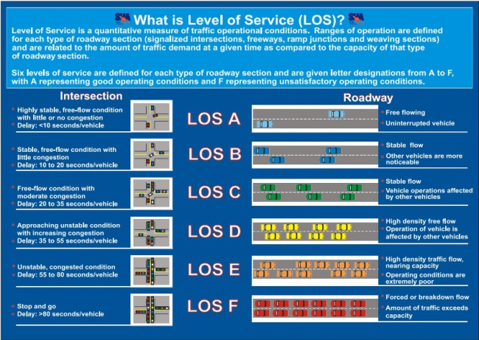
Source: Maryland Department of Transportation (MDOT) Policy Manual

Cost Estimates
A summary of cost estimates for each alternative is located below. Cost estimates include roadway improvements and sidewalk on the north side to connect gaps in the existing sidewalk network.
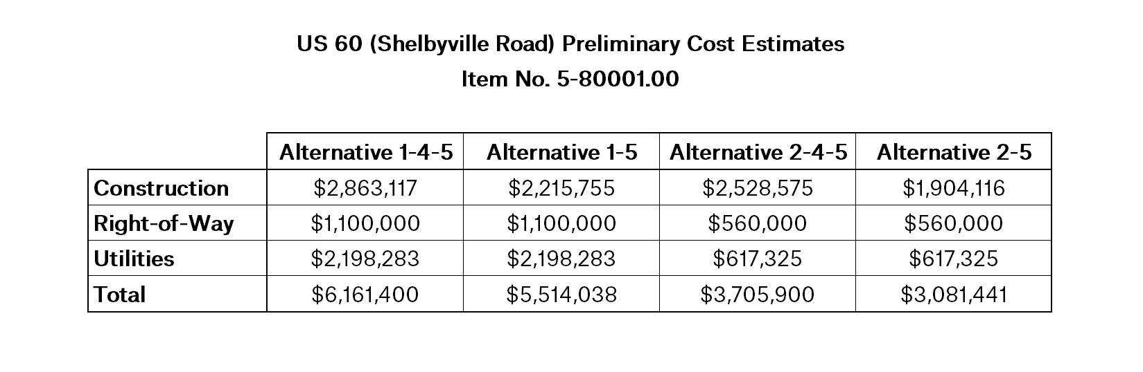

Survey
We appreciate your time and input! The survey is currently closed.

