Joining and Participating in the Broadway Bridge Virtual Public Meeting

If you have not registered for the Broadway Bridge Virtual Public Meeting, please do so here: https://zoom.us/webinar/register/WN_O1eVZNZSTQuTqNvHJzlnTA
Please find instructions below on how to participate in this public meeting via Zoom. You will need to download Zoom if you do not already have it. You can download it in advance at their website: https://zoom.us/.
If not downloaded prior to joining the meeting, you will be prompted to download Zoom at that time. It is recommended to download the software in advance so as not to be delayed joining the meeting.
Upon registration, you will receive a message showing the date and time of the meeting. Check the date and start time of the meeting, including the time zone. Make sure to join when the meeting starts.
Overview
You are registering for the meeting as an attendee. You cannot share audio or video but you can ask questions that the hosts will address using the Q&A feature.
To join the meeting, click the link that you received in the confirmation email after you registered. If the host sent a registration confirmation email, the link can also be found there. This meeting may also be referred to as a webinar in the emails you receive.
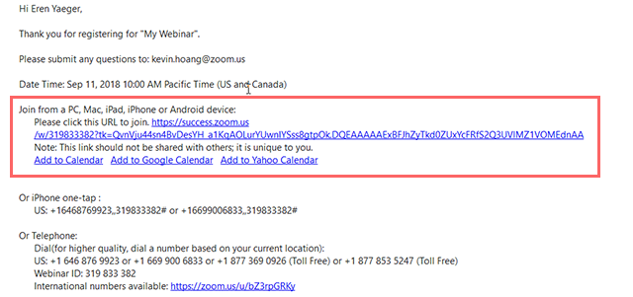
Waiting for the host to start the meeting
If the host hasn’t started broadcasting the meeting, you’ll receive the following message:
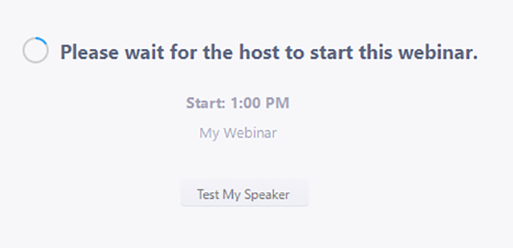

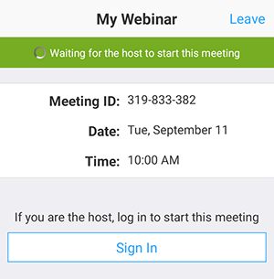

Question & Answer
Open the Q&A window, allowing you to ask questions to the host and panelists. They can either reply back to you via text in the Q&A window or answer your question live.
To ask a question:
- Type your question into the Q&A box. Click Send.
- If the host replies via the Q&A, you will see a reply in the Q&A window.
- The host can also answer your question live (out loud). You will see a notification in the Q&A window if the host plans to do this.
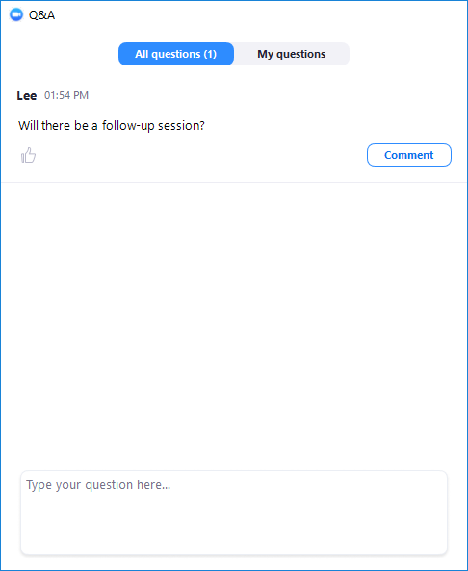
Leave meeting
Click Leave meeting to leave the meeting at any time. If you leave, you can rejoin if the meeting is still in progress.

