Go to the Start button and pick the run line.

Type in odbcad32 (if you are running windows 7 type odbcad32.exe)

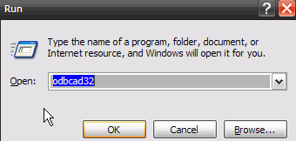

Make sure you have the op6tsmp driver in the system dsn folder

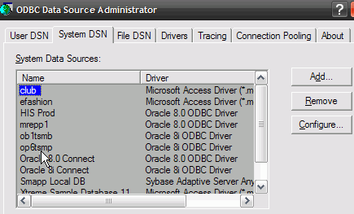

If not, click add and choose the Oracle 8i driver
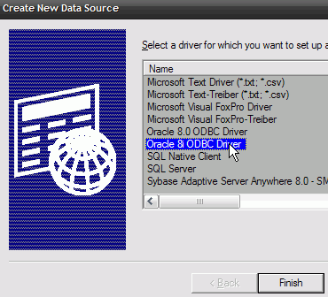
Then make the screen look like…
